FACILITATOR’S GUIDE – Do-It-Yourselves Membership Plan
Time | Talking Points | AV/Other Needs
:00 - :05  (5 min) | Welcome & Introduce Selves:  Now tell us about you:  - Local PTA leaders? Local PTA trainers?  - First-Timers? Long-Timers?  Today we will host an interactive session to teach you a new approach to designing your membership plan. | PPT – Welcome  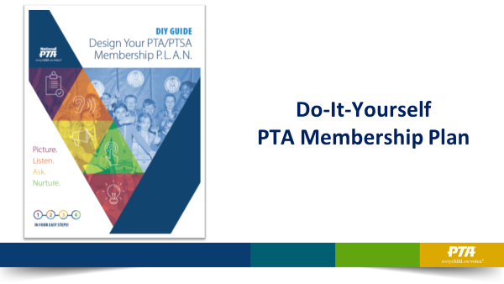  PPT -- Objectives  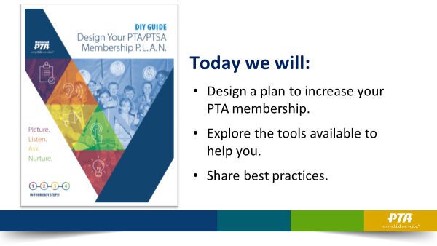
:05 - :10  (5 min) | Before we begin, let’s talk about our WHY.  - Have you seen this mission before?  - What does it mean to you?  - How do you bring it to life in your PTA?  - Why do you personally care so much?  - Knowing why helps you explain why it’s so important later | PPT - Mission  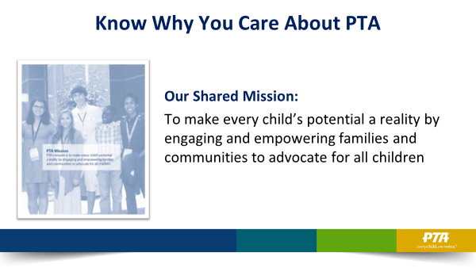
:10 - :12  (2 min) | It’s tempting to assign the duties of membership to one or two people. But it’s not a 1-2-person job. It’s every board member’s job.  - Why do you think that we say that?  - Membership is a relationship not a transaction.  - There is a web of relationships in a school/community and no one person is the holder of all.  - By growing membership, you are growing the web of influence your PTA has – and the power of your voices to achieve change for kids. | PPT - Team  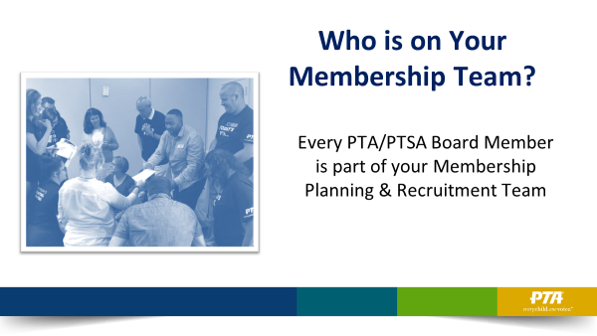
:12 - :15 (3 min) | Introducing a new tool to help you get your whole team focused on growing membership – DIY Kit for Membership Growth  - Show kits  - Explain what’s inside the kit:  - DIY Planning Guide helps you to facilitate a planning discussion with your PTA board and help them to engage in its implementation  - Sample membership forms with talking points; customizable versions available at PTAKit.org  - A Thermometer poster to get everyone excited about your goal  - A pocket guide for remembering key messages  - All of this is in English & Spanish  - We added a bonus poster – promoting Reflections in the Fall and Family Engagement Tips for Teachers year-round | PPT - DIY KIT  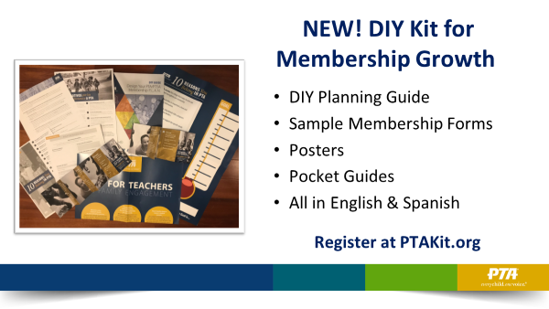
:15 -:18  (3 min) | DIY Membership P.L.A.N.  - Encourage them to open their DIY Planning Guide  - Share each step of the design-it-yourself membership plan  - Picture who, what, where  - Listen to what matters most  - Ask by aligning efforts to what matters most  - Nurture relationships year-round  - Encourage each person to start planning as we discuss | PPT – DIY Plan  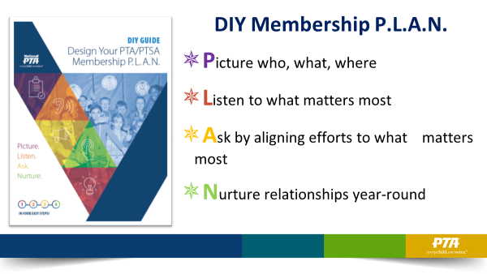
:18 - :23  (5 min) | Step 1: Picture who, where, how  - Facilitate large group conversation about:  - Who are prospective members  - Where you can reach them  - How you reach them – so much more than PAPER; leverage and grow relationships  Use flip chart to generate ideas | PPT – Who, Where, When  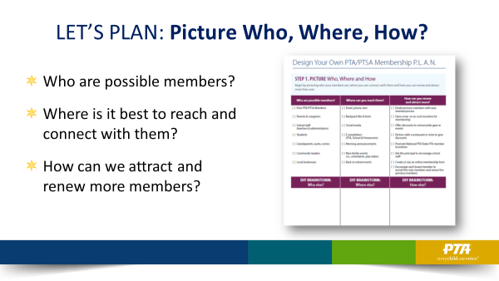
:23 - :28  (5 min) | Now that you have identified WHO, think about setting a goal  - If you want substantial growth – think about your potential to grow!  - Consider total #s of:  - Teachers/staff  - Students enrolled  - 1 Parent/caregiver per student (or aim for 2!)  - Other supporters?  - Set a target # or % of totals to determine your goal  - Think about who you know who could help you achieve those goals and start mapping out your web of relationships  - Then promote the goal – use the thermometer poster as one tool  - If you want incremental growth – use prior year trends  - Consider the breakdown of last year’s membership – do you know those numbers?  - Then determine where you have the greatest potential for growth. Examples: You may want to emphasize dads joining – or grandparents – or students who want to earn community service hours  - Determine a stretch goal for increasing each relationship type – then add it all up to get your goal  - Use the thermometer poster and promote your goal | PPT – Substantial Growth  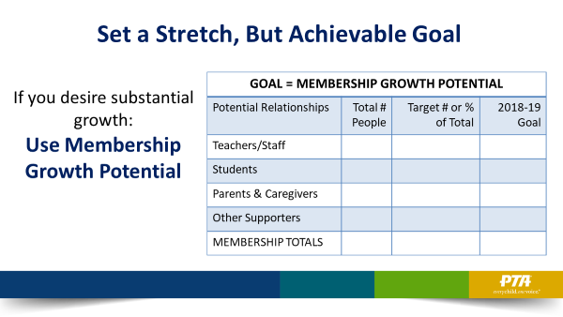  Handout: Goal-setting Worksheet with both options  PPT – Incremental Growth  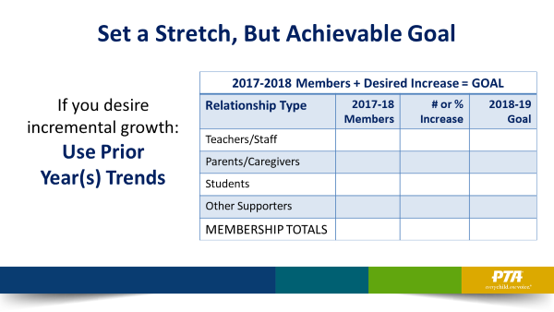
:28 - :33  (5 min) | Step 2: Listen to what matters most  - How do you get feedback? (Kit contains several suggestions)  - What will you ask? (Kit contains several suggestions)  - Explain that what you hear defines what you need to do to FOCUS on what matters most…which is next step  Use flip chart to generate ideas | PPT: Listen  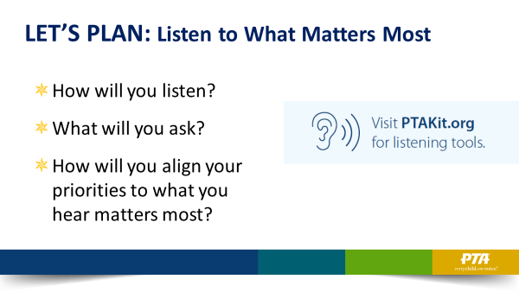
:33 - :43  (10 min) | Step 3: Ask & Align  CHALLENGE QUESTION:  - What’s the best way to start a membership conversation with someone and get to ask?  Use flip chart to generate ideas  Answer: by LISTENING. Ask a prospect questions, like “What do you think PTA could do to improve the school for our students?”  You will probably hear what resonated most with parents. Probe until you hear something that directly connects with your focus areas. Then, align your answer.  Start with, “You’re not alone – a lot of parents have told us that. That’s why…”  - Include 1-2 PTA mission objectives and 2-3 desired outcomes  Let’s play that out.  - At your tables, read results from a survey and feedback collected.  - Take a few minutes to work together and craft an ASK that shows your PTA is listening and aligning your efforts. Include 1-2 PTA mission objectives and 2-3 desired outcomes.  - Ask 1-2 to share what they heard and how they aligned efforts to reflect what matters most to their PTA school and community.  - If time, move on to scenario 2. Or, have some tables focus on scenario 1 and others focus on scenario 2.  This two-way conversation is the difference when you think of membership as a relationship versus a transaction. In a transaction, you’re merely asking them to join – to complete a process. Not to be part of supporting a cause they care about. | PPT – Ask & Align  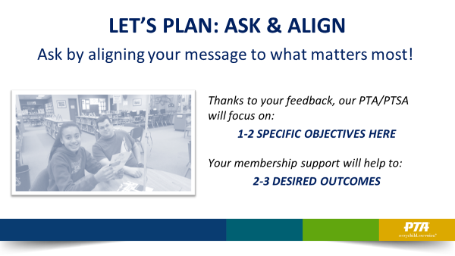  Handout:  Scenario(s)
:43 - :50  (7 min) | How Do You Respond to Frequent Nos?  - Facilitate conversation about each answer  - I don’t have time. No time is needed, ask question to get you to align your message to what they care about.  - I don’t like fundraising. You don’t have to fundraise. Ask question to get you to a place in the conversation where you can align your message to what they care about most.  - My wife joined. Dads are so important and care just as much as moms about school improvements. What do you think PTA should be focusing on in that area? …Your support will help us to …  - What else?  Use flip chart to generate ideas | PPT – How will you respond  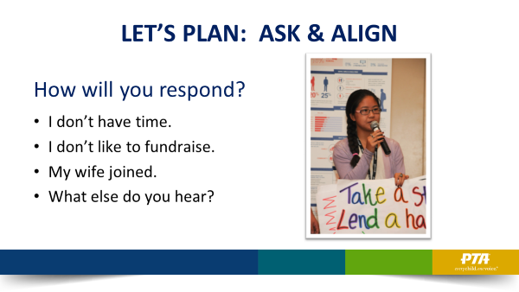
:50 - :55  (5 min) | Step 4: NURTURE  - Like Any Relationship – It Takes 2-Way Effective Communication  - National PTA’s market research fueled these bullets – this is what parents nationwide said they wanted from PTA:  - They want transparency with spending and budget.  - They want to know what impact you are making and see you brand. Toot your own horn!  - They want quick, mobile messages.  - They want to feel included and welcomed to contribute – but not pressured.  - When they do show up, they want it to value their time and to focus on what they’ve said matters most  Use flip chart to generate ideas | PPT – Nurture  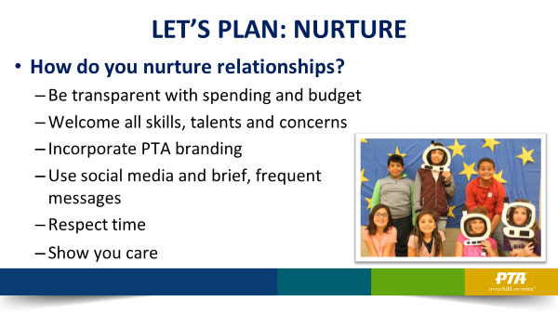
:55 - :56  (1 min) | Find more Tips & Tools at PTAKit.org | PPT – PTAKIT.org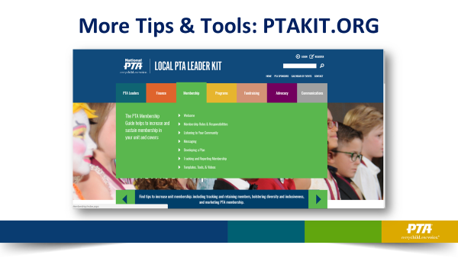
:56 - End | What are your ideas to grow membership?  - Facilitate sharing and Q&A  Use flip chart to generate ideas | PTA: Let’s Talk  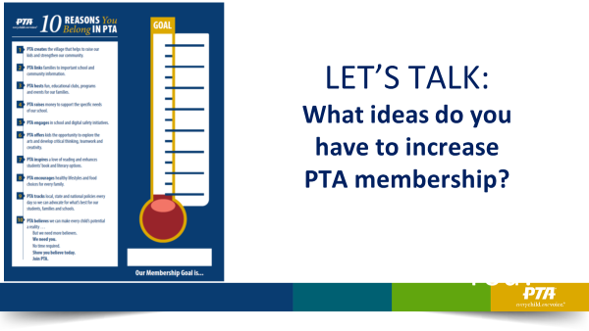
THANKS | Remember to P.L.A.N.:  - Picture  - Listen  - Ask & Align  - Nurture  Thank you for all you do to achieve PTA’s mission! | PPT – Thank You  