Strengthening Family-School Partnerships:
A Reference Guide for School Administrators
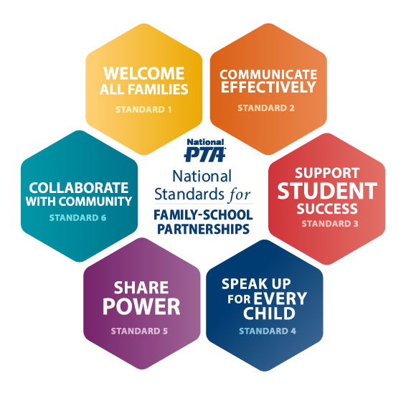
The National Standards for Family-School Partnerships highlight the key tenets of effective family engagement practices that support student success and well-being. Read on to learn how you can put the National Standards into action in your work. For more resources, visit PTA.org/Standards.

Welcome All Families
- Communicate school-wide goals for developing personal relationships with students and their families
- Allocate time in teachers’ schedules to implement relationship-building practices with families.

- Prepare instructional coaches to lead reflective conversations with teachers about teachers’ relationships with families in routine coaching and/or observation/feedback cycles
- Encourage front office staff, security, custodians etc. to attend trainings provided to teachers around family-school partnerships

- Conduct focus groups with families to gather feedback on their experiences with the school to understand any barriers to full participation in the school community

- Ensure the building is fully accessible to individuals who use wheelchairs and to other people with disabilities
Communicate Effectively
- Communicate to staff school-wide expectations for communication with families

- Offer guidance for how teachers develop individualized communication plans with families aligned to each families’ preferred mode of communication

- Audit communication practices to ensure that all written and spoken school communication, including routine forms, zoom meetings, and in-person conversations are translated for all languages spoken in your school community

- Identify a team of staff and families to create communications plans for times of crisis

- Designate an individual or individuals who are tasked with ensuring that all communication outlets utilized by families in your school community are streamlined in messaging

- Assess the impact of streamlined information-sharing efforts by determining if the message was received and understood by the intended audience

Support Student Success
- Provide teachers with templates and resources for co-constructing social, emotional, and academic goals with families and students

- Support teachers in providing students and families with regular, formative progress reports inclusive of sample student work

- Provide teachers with opportunities to practice having conversations with families about student progress, particularly when conversations may be difficult

- Develop and communicate a clear process/protocol for families so they know how to plan to observe or initiate participation in their child’s classroom

- Adjust outreach practices to ensure that underrepresented families have equitable opportunities to contribute to classroom learning

- Provide workshops for families to build their capabilities and confidence to support their child’s learning and socio-emotional well-being at home

Speak Up for Every Child
- Audit school and district operations and adjust policies and practices that create disparities in adverse impact on underrepresented students and families

- Ensure that information sharing about families’ rights under federal and state law is communicated using multiple communication modalities (school handbook, conspicuous posting, etc.) to reach all families

- Provide families with a FAQ guide with answers to common questions, contact information for school and district personnel, and general guidance on school and district operations

- Develop and communicate norms and expectations for responding to family requests for resources and answers to their questions

- Engage staff in reflection on the role bias may play in building strong family-school partnerships, particularly across lines of difference

- Share data with families and teachers on school discipline practices and make adjustments to practices that disproportionately impact a demographic group or subgroup

Share Power
- Cultivate an environment that positions families as equals collaborators with schools for improved outcomes

- Establish specific goals to promote equity within the family/parent organization and the school community at large

- Co-design decision making protocols that incorporate the viewpoints and perspectives of families, staff, students and community constituents

- Develop systems for tracking and cataloging information to create a comprehensive picture of representation in decision making

- Identify and/or create opportunities for to build families’ capabilities and confidence for civic engagement, and share these opportunities with students and families

Collaborate with Community
- Ask families about issues affecting the community and how the school can contribute to community-wide solutions

- Communicate a clear “why” for engaging with community partners, and a vision for what can be achieved through community partnerships

- Build relationships with “official” and “unofficial” community leaders to learn about the needs, assets and priorities of community partners

- Invite community partners to have a physical presence (office space, information desk, participation in school etc.) in the school community so that families can make connections and build relationships

- Engage in continuous feedback cycles with families, staff and community leaders to evaluate the impact of strategic partnerships and address shifting priorities

