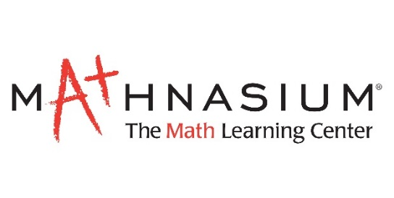
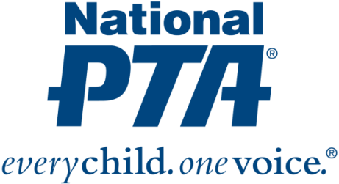
{Insert PTA Logo}

Contact:
{Insert Name and Contact Info}

{Name of PTA} Engages Families in Math Education

{City, State} (Date)— {Name of PTA} is hosting a STEM + Families Math Night, in partnership with Mathnasium, at {Location} to engage families in math education and promote awareness of STEM education and careers.

“Families play a critical role in children’s academic success and have the biggest influence on a child’s educational and career decisions, especially when it comes to STEM,” said Leslie Boggs, past president of National PTA. “We are pleased to provide {Name of PTA} with resources to engage families in math education, show children how much fun math can be and educate families about math careers and education pathways.”

Mathnasium and {Name of PTA} will:
- Engage families using fun, hands-on learning experiences at math nights
- Educate families about math careers and empower them to support their children’s success in math
- Connect families and students to math enrichment opportunities and professional mentors

{Insert quote from PTA President or School Principal}

The program is part of National PTA’s STEM + Families initiative. STEM + Families is a national effort to engage entire families, inspire interest and support student success in STEM with experiences at school, at home, in the community and through digital learning. Mathnasium is a founding sponsor of the initiative. For more information about the STEM + Families, visit PTA.org/STEM.

About PTA
PTA® comprises millions of families, students, teachers, administrators and business and community leaders devoted to the educational success of children and the promotion of family engagement in schools. PTA is a registered 501(c)(3) nonprofit association that prides itself on being a powerful voice for all children, a relevant resource for families and communities, and a strong advocate for public education. Membership in PTA is open to anyone who wants to be involved and make a difference for the education, health and welfare of children and youth. For more information, visit PTA.org.

About Mathnasium
North America's leading math-only supplemental education franchise, Mathnasium teaches math so that children understand it, master it, and love it. The result of 40+ years of hands-on instruction and research, the Mathnasium Method'" has transformed the lives of children in grades 2-12 since 2002. With more than 1,000 learning centers worldwide, Mathnasium is ranked No. 2 in Forbes' "Best Franchises to Buy" in the U.S. for 2019.

