Student Guide to Participating in the STEM + Families Propelling Our World Program at Home

Materials Needed*
*You can add any materials that you find in your house. This list is not a comprehensive list.

Cookie Bridge | Cookies (any kind)  One cup of milk  Empty cup
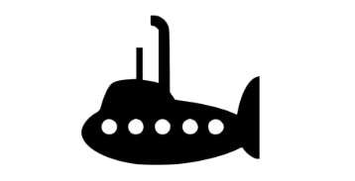  Sam’s Submarine Knowledge | Gummy Worms  One Plastic Cup  Imagination
Sam’s Raft Adventure + Rescue  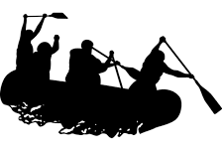 | One 8 oz. clear, plastic cup  Gummy Worms  Paper Clips (One box per family member)  A Lifesaver  Imagination
Sam’s Parachute Misadventure  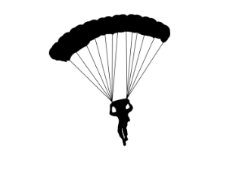 | Gummy Worms  Coffee Filters Cups  String  Tape  Construction Paper  Card Stock Paper  Imagination

What is STEM?

What does STEM stand for?

What do you know about careers in STEM?

Engineering Design Process
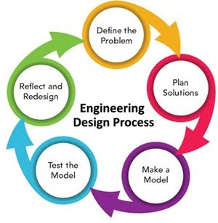
The Engineering Design Process (EDP) is a series of steps that help guide engineers as they solve problems.

Why might we use the EDP?

How could the EDP help us tonight?

Cookie Bridge: Background Knowledge
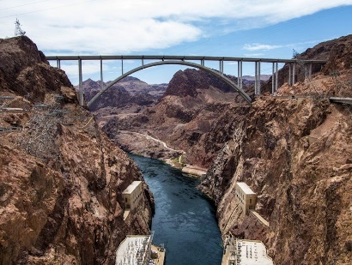
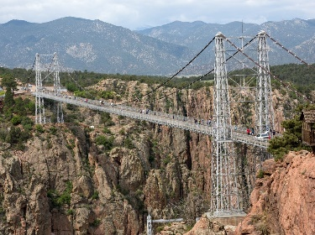
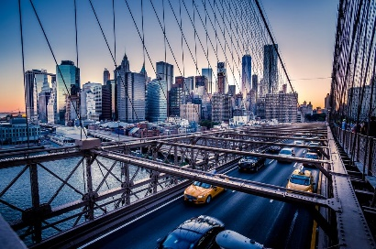
Question: What do you notice about these bridges?

Cookie Bridge Experiment
Challenge: Cookie Bridge
Challenge: Create a free-standing bridge using cookies. The cookie bridge must be able to support at least 1 cup of milk. Use the Engineering Design Process to solve the problem.
Materials: Cookies 1 cup of milk
Directions
Build a cookie bridge. The bridge must support 1 cup of milk.

- Make sure your cup and bridge are far away from your computer!
- Put a cup on top of your bridge.
- Slowly fill the cup.

Cookie Bridge: Challenge Yourself
How can you design your bridge to hold more weight?

How can you design your bridge to be taller?

What changes can you make to your bridge?

What other cookies can you use? How would that change your bridge?

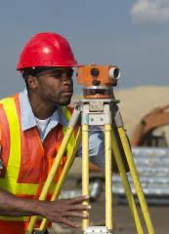
Cookie Bridge: STEM Career Connections
Possible careers: Civil engineer, architect, crane operator, surveyor, drafter

Skills needed: Knowledge of building and construction, critical thinking skills, technical skills, mathematics, teamwork and engineering design thinking.

Question: How did you use those skills during your building and designing of the bridge?

Sam’s Submarine Challenge: Background Knowledge

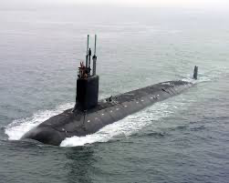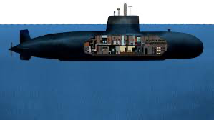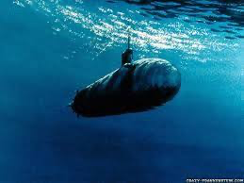

Question: What do you notice about these submarines?

Sam’s Submarine Challenge
Sam the gummy worm has traveled all the way to Norfolk, Virginia to see the Atlantic Ocean for the first time! To explore the ocean, he will need a submarine to keep him dry! He has to go all the way underwater to the ocean floor in his makeshift submarine from materials he found littered on the beach.
Challenge: Sam’s Submarine Challenge
Challenge: Design and build a submarine to safely transport Sam on his ocean adventure AND keep him dry! He still can’t swim!
Materials
Gummy Worms, 1 plastic cup, Imagination, any other materials you find in your house
Directions
Sam (gummy worm) must be placed inside the submarine during all trials and cannot get wet or fall out! Sam cannot swim, he’s a worm!

Only the submarine you create can be used to help Sam explore the Atlantic Ocean. But be careful not to drown Sam!

Look at your materials and sketch your ideas on a piece of paper. Be creative–don't just use a water bottle as a submarine. Can you create a submarine with household materials?!

Use the 5 steps of the Engineering Design Process (EDP).

Sam’s Submarine Knowledge: Challenge Yourself
- Redesign the challenge! Add a gummy worm friend for Sam that loves to explore, too!
- Make the submarine larger or smaller.
- Can you add propulsion to the submarine?
- How can you design the submarine to dive deeper?

Sam’s Submarine Knowledge: STEM Career Connections

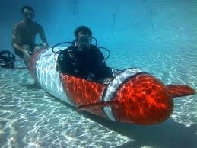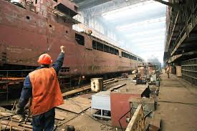
Possible careers: Naval Architect, Modeling and Simulation Engineer, Ocean Engineer, Chemist
Skills needed: knowledge of measurement, problem-solving skills, ecological/conservation knowledge, engineering design thinking, leadership.

Question: How did you use those skills during this challenge?

Sam’s Raft Adventure + Rescue: Background Knowledge

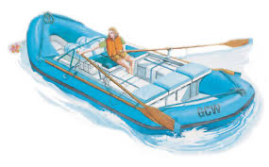
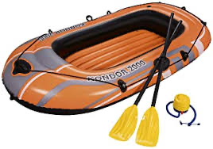

Question: What do you notice about these rafts?

Sam’s Raft Adventure + Rescue
Sam is an adventurous little worm! He decided to try whitewater rafting on the Eagle River in Colorado. Whitewater rafting is a sport where people navigate swift currents and rocks in a raft down a fast-moving river. Sam’s raft tipped over! His life vest slipped off and now Sam is stuck on top of the capsized raft! He needs to go get his life vest, but he can’t swim! He’s a worm, not a fish!

Challenge: Sam’s Raft Adventure

Materials
One 8 oz. clear, plastic cup; Gummy Worms; A lifesaver; Imagination! Any other materials you find in your house.
Challenge: Design and build a device to rescue Sam’s life vest from inside his capsized raft. To do that, we need to use the engineering design process to build a device to rescue Sam’s life vest from inside a capsized raft!
Directions
Sam (the gummy worm) is placed on top of the raft (cup) and the life vest (the lifesaver) is under the cup.

Sam cannot swim. Only the rescue device you create can be used to “move” Sam around (meaning if Sam falls off the raft, the rescue device needs to be used to save him, not your hands!) But be careful not to hurt Sam!

Also, only the rescue devices can be used to move the other materials, such as the raft and life vests.

Sam’s Raft Adventure: Challenge Yourself
- Once the life vest is safely retrieved, talk as a team about how you will use your rescue device to put the life vest on Sam without hurting him.
- Redesign the challenge! Add a gummy worm friend for Sam that needs to be rescued!
- Try to make the raft larger.
- Change the size of the life vest.
- How can you design the rescue device to group more gummy worms together?

Sam’s Raft Adventure: STEM Career Connections
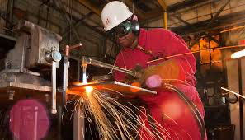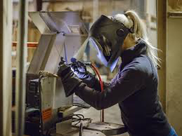

Careers: Welder, Marine Engineer, Shipfitter, Mechanical Engineer, Environmental Scientist

Skills needed: Knowledge of physics, design skills, leadership, attention to detail, creativity, engineering design thinking and collaboration.

Question: How did you use those skills during this challenge?

Sam’s Parachute Misadventure: Background Knowledge
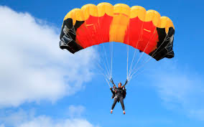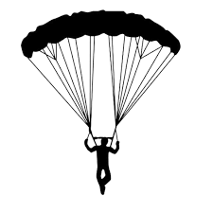

Question: What do you notice about these parachutes?

Sam’s Parachute Misadventure
Sam the worm caught the adventure bug! He headed to southwest Arizona—full of mountains and a desert climate! He climbed to the top of a mountain to see the beautiful desert below—but now can’t get down! He is trapped on top of Superstition Mountain and needs to get down to the ground to his campsite. How on earth can he get down safely without injuring himself?!
Challenge: Sam’s Parachute Misadventure
Materials
Gummy Worms; Tape; Construction Paper; Coffee filters; Cups; String; Cardstock paper; Any other materials you find in your house
Challenge: Design and build a device to transport Sam safely down a mountain to his campsite on the ground.
Directions
Sam (gummy worm) must be placed inside the parachute during all trials and cannot fall out!

Sam cannot fly, he’s a worm! Only the parachute you create can be used to help Sam get to his campsite. But be careful not to hurt Sam!

Use the 5 steps of the Engineering Design Process (EDP).

Sam’s Parachute Misadventure: Challenge Yourself
- Redesign the challenge! Add a gummy worm friend for Sam that needs to be rescued!
- Make the parachute larger or smaller.
- Change the height of the mountain.
- How can you design the parachute to support more weight?
- How would the parachute perform if the climate and/or weather changed: add wind, rain, or other variables?

Sam’s Parachute Misadventure: STEM Career Connections
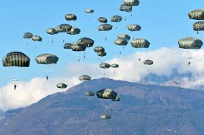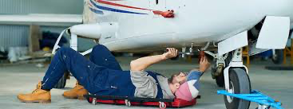

Careers: Paratrooper, Pilot, Aerospace Engineer, Data Analyst, Geographer, Information Technology Expert

Skills needed: Knowledge of physics, design skills, leadership, attention to detail, inquiry skills, engineering design thinking, teamwork, data-driven decision making.

Question: How did you use those skills as you built and designed the parachute?

