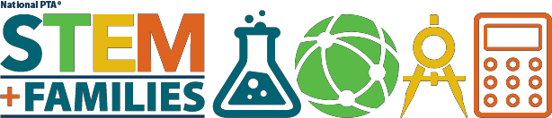

Events

List of organizations with STEM events throughout the country. Check out our State Resources for local events in your state!

Discover-E
Ages 5+ Activities searchable by type, topic, age and duration. http://www.discovere.org/

Maker Camp Project Paths
Ages 6+ Printable activities, online community and events from MAKE magazine http://makercamp.com/project-paths/

iDTech Summer Camps
Ages 6-18: STEM summer camps in various locations https://www.idtech.com/stem-summer-camps-resources/

NASA Students K-8 Current Opportunities
Ages 5-13. Current STEM events and contests throughout the country https://www.nasa.gov/audience/forstudents/stu-k-8-current-opps.html

National STEM Video Game Challenge
Ages 10-18. Individual or group competition in video game design and development. http://stemchallenge.org/

Teenlife STEM Programs for Teens
Ages 12-18 Comprehensive list of STEM summer camps https://www.teenlife.com/category/stem/

U.S. News STEM Solutions
Ages 18+ Annual STEM Conference presented by U.S. News http://usnewsstemsolutions.com/

