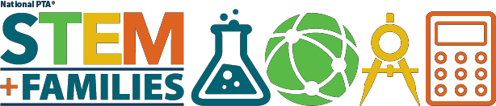

Careers

List of websites and resources to help your family explore STEM careers

STEMWorks Cool Jobs
Curated Blog of interviews with people who work in STEM fields. https://web.archive.org/web/20141017071011/http://stem- works.com:80/search?search_class=CoolJob

All STEM Occupations
Comprehensive list of occupations in STEM fields https://www.onetonline.org/find/stem?t=0

Techonology, Jobs and the Future of Work
May 2017 Executive Briefing from the Mckinsy Global Institute http://www.mckinsey.com/global-themes/employment-and-growth/technology-jobs-and-the- future-of-work?cid=other-eml-alt-mgi-mgi-oth-
1705&hlkid=1fd3cd627b8d447d87a89470cff433f7&hctky=2623712&hdpid=a09516c8-7f82-
472b-aaa9-320f2a194dd2n

Engineer Your Life
A guide to engineering and careers for high school girls http://www.engineeryourlife.org/

eGFI Dream Up the Future
A guide to engineering majors with profiles of current students http://www.egfi-k12.org/

STEM Occupations: Past, Present, Future
January 2017 U.S. Bureau of Statistics STEM Report https://www.bls.gov/spotlight/2017/science-technology-engineering-and-mathematics-stem- occupations-past-present-and-future/pdf/science-technology-engineering-and-mathematics- stem-occupations-past-present-and-future.pdf?utm_source=SSTI+Weekly+Digest&utm_ca
Society of Women Engineers
Membership organization dedicated to supporting women in engineering http://societyofwomenengineers.swe.org/k-12-outreach

