PROPELLING OUR WORLD FACILITATOR’S GUIDE
Sam’s Parachute Misadventure

- Make sure you have the materials you need. need.
- Gummy worms
- Coffee Filter Cups
- String
- Tape
- Construction paper
- Card stock paper

- Watch this video on Exploring the Engineering Design Process and Sam’s Parachute Misadventure

- (https://youtu.be/mHNYFWUD0JQ) Exploring the Engineering Design Process and Sam’s Parachute Misadventure (https://youtu.be/0QPox10K1jc).
- Here is a sample visual representation of the activity. Please note, participants will build various interpretations of the prototype.

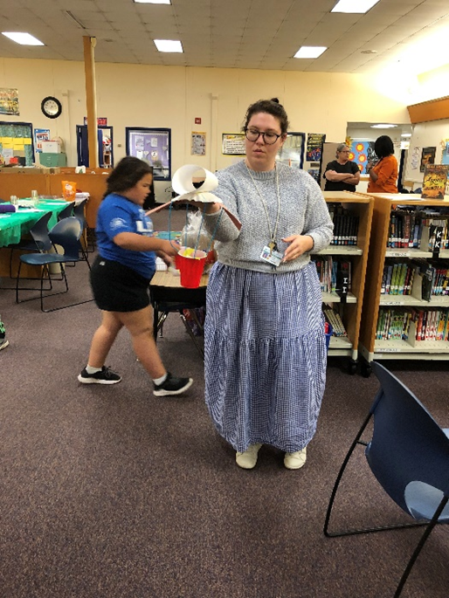

- Prepare your activity station.
- Set out your materials and have the video ready to play.

- Explaining the Engineering Design Process.

NOTE: Please read the below out loud before starting the activity.

- Sam the worm caught the adventure bug! He headed to southwest Arizona—full of mountains and a desert climate! He climbed to the top of a mountain to see the beautiful desert below—but now can’t get down! He is trapped on top of Superstition Mountain and needs to get down to the ground to his campsite. How on earth can he get down safely without injuring himself?!

- You will work together as a family to use the EDP, the Engineering Design Process, and try to help Sam. The process is “iterative”, meaning we repeat the steps as many times as needed to make improvements to our prototypes! Mistakes and failures within STEM are accepted, cherished, and desired! If a mistake is made, it just means we repeat the steps of the EDP to improve our prototypes!

- The steps of the EDP are: Define the problem, plan solutions, make a model, test the model, and reflect and design.

- Facilitator instructions to read aloud to families:

Please read each set of instructions out loud. Provide time for families to reflect and discuss the questions and go through the steps.

- Sam must be placed inside the parachute during all trials and cannot fall out! Sam cannot fly, he’s a worm! Only the parachute you create can be used to help Sam get to his campsite. But be careful not to hurt Sam.

- Now that you have your materials and know how EDP works, collaborate as a family to use the EDP, the Engineering Design Process, and try to save Sam. Define the problem, plan solutions, make a model, test the model, and reflect and redesign.

- Step 1 is to define the problem. What is the problem in this challenge? What do we need to figure out?

- Step 2 is to Plan solutions: Discuss as a family how gravity can affect the path of your parachute and what materials you can use to safely help Sam fly without falling out of the parachute!

  - Look at your materials and sketch your ideas on a piece of paper. What design of your transportation device will keep Sam secure? How can your team design the device to float/fly?

- Step 3 Using the solutions you have planned, try to make a model and start to experiment with combining materials to create your parachute design. Take five minutes to build it anyway you see fit. Would anyone like to share their model?

- Step 4 Now it’s time to test your design. If it fails to float gently from different heights, redesign. Did it work? Does anyone want to share their model?

- Step 5 is to reflect and redesign. If your parachute is not working for all steps, create new solutions, use different materials and change the design of the parachute.
  - What are different ideas you used as a family? Did you learn from mistakes? What happened when you tried again?
  - Here are some challenge questions and ways to redesign the challenge
  - Add a gummy worm friend for Sam that needs to be rescued!
  - Make the parachute larger or smaller. Change the height of the mountain
  - How can you design the parachute to support more weight?
  - How would the parachute perform if the climate and/or weather changed (you can add wind, rain or other variables).

- STEM Career Connections:

NOTE: Please read the below after the activity.

The skills we used in Sam’s Parachute challenge are skills that you would use in your career. You could be a Paratrooper, Pilot, Aerospace Engineer, Data Analyst, Geographer or work in Information Technology.

In Sam’s Parachute Challenge, you used your knowledge of physics, design skills, leadership, attention to detail, inquiry skills, engineering design thinking, teamwork and data-driven decision making.

Can you think about HOW you used those skills during your building and designing of your parachute?

