Caretaker Guide to Participating in the STEM + Families Propelling Our World Program at Home

This guide will help you lead your family through these STEM + Families Propelling Our World activities. You can give the “Student Guides” to your children to do alongside you (they’re more like worksheets!)

Program Goals
- Make real-world connections with the engineering design process and STEM principles (problem-solving, critical thinking, etc.).
- Inspire students and families to explore careers in STEM, the skilled trades and advanced manufacturing.
- Provide students and families with the knowledge and resources to continue exploration of STEM careers and the skilled trades.

Table of Contents
- Frequently Asked Questions for Caretakers
- Materials Needed
- What is STEM?
- Engineering Design Process
- Cookie Bridge
- Sam’s Submarine
- Sam’s Raft Adventure
- Sam’s Parachute Misadventure

Frequently Asked Questions for Caretakers

What is included in this guide?
In this guide, you will find resources to use as you facilitate this event and the activities for your family. Each activity has a video you can watch, a list of the materials needed, instructions to follow and questions/things to think about for each of the steps in the Engineering Design Process. After you’ve conducted the activity, you can try the activity over and over, using the “challenge yourself” questions. As a family, you can learn about potential careers connected to each of the skills used in each activity. In addition, there is a handout for your children to use to follow along. In the handout, you will find blank space for your family to write what they have learned and to answer questions.

How should I facilitate this event for my family?
This event is an opportunity for your family to engage in fun STEM activities. It is a hands-on program with four different activities. The goal is to complete the activities, learn about STEM and learn about ways STEM can be done at home. The activities will also increase awareness of STEM education and careers. The four activities are hands-on and require materials that you most likely already have at home.

Should I do all of the activities at one time?
That is up to you. Each activity can be done on its own and should take about 15-20 minutes to complete. You can decide as a family if you would like to do all of the activities at one time or over multiple days. In addition, you can select which of the activities you and your family would like to do. You do not have to do all four of them. You can also adjust the challenges to best fit the needs of you and your family.

Each activity has a video, should I watch the videos?
Each activity has a video to provide an opportunity for you to learn exactly how the activity is conducted or to show your family the activity. You can choose to do the activity, or you can watch the video. You can also watch the video before or after your family conducts the activity.

For your reference only, here is a sample visual representation of each activity. Please note, your family should build various interpretations of the prototypes.

Develop a materials plan.
- Before you send registration information, determine if your PTA will be providing supplies or print materials to families in your school community.
- Some PTAs may choose to assemble kits using grant funds for families who might not have the funds to purchase these materials themselves. Most of these experiments use ingredients people commonly have at home. Check out the activity materials list.
- Find volunteers to order and assemble kits. Encourage social distancing and follow all CDC recommendations. Distribute through contactless delivery and wear a mask. Check with the school or district to distribute or host a distribution day. If you choose to supply materials, use the registration information to determine who to send kits to and where they need to be sent.
- Your PTA may choose not to distribute materials to any or all families. Be sure to still communicate to families what materials they need to participate at their own pace.
- For your reference, here is a sample visual representation of each activity. Please note, your family should build various interpretations of the prototypes.

Sam’s Parachute Misadventure:

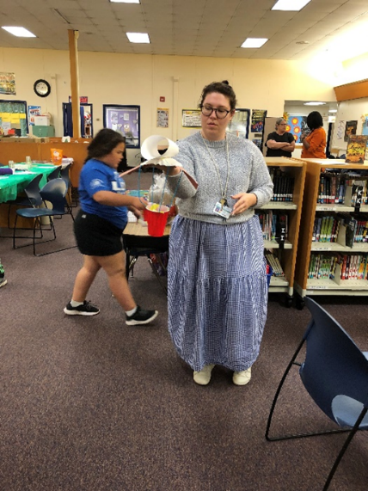

Sam’s Raft Adventure + Rescue:
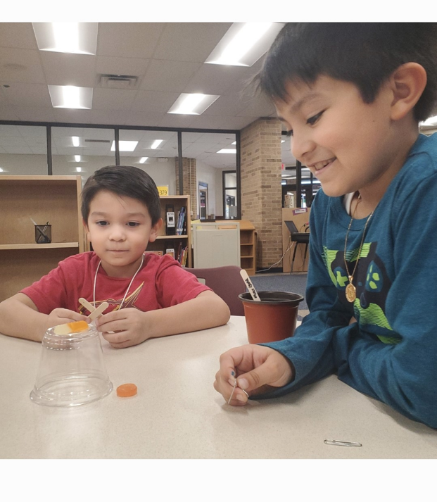
Cookie Bridge Challenge:
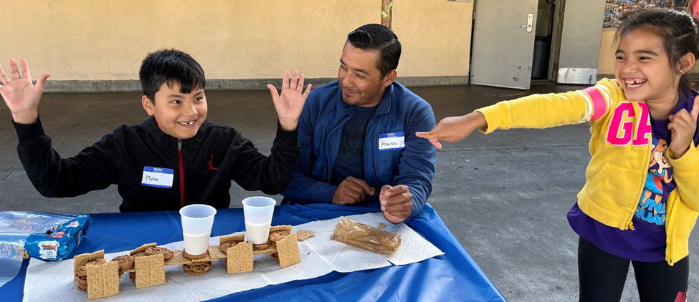
Sam’s Submarine Challenge:
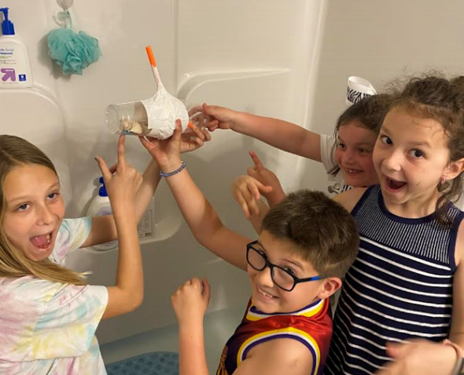

Should I let my child conduct the activities?
Each activity is designed for children to do with your family, so everyone should be involved!

What is the Engineering Design Process (EDP)?
The Engineering Design Process (EDP) emphasizes open-ended problem solving and encourages students to learn from mistakes. This process nurtures a student’s ability to create innovative solutions to challenges in any subject. The Engineering Design Process is a series of steps that guide engineering teams as we solve problems. The design process is iterative, meaning that steps are repeated as many times as needed, making improvements along the way as we learn from mistakes and uncover new design possibilities to arrive at great solutions. The steps in the EDP are:
- Define the Problem
- Plan Solutions
- Make a Model
- Test the Model
- Reflect and Redesign

The steps can and should be repeated as the challenges in the activities are solved. You can watch this video on the Engineering Design Process with your family.

What if my model isn’t good and doesn’t work?
That is okay! This is all about the Engineering Design Process, which means the important part is learning. Sometimes the design you create will work, and sometimes it will not. When it does not work, try again, make changes, and see if it works. A real engineer will try and try and try yet again. It is not always perfect, and that is okay.

How long will each activity take?
Each activity takes about 15 minutes to complete. However, each activity has an additional, optional challenge section, and you can try each activity over and over again, continuously challenging yourself and your family.

How do I share pictures/videos of my family participating?
While you are conducting the activities, make sure to take lots of pictures and videos. You have a couple of options for sharing these pictures/videos. You can email them to your local PTA. If you choose this option, you must also send a signed media release form. This allows the PTA to share these pictures/videos publicly and with National PTA. Or you can post the pictures/videos on social media and tag your PTA. If you do this, you don’t need to submit a signed media release form for your PTA to be able to share them publicly and with National PTA.

How can I share other feedback?
You are asked to complete a participant survey at PTA.org/Survey to share your experience. This will help both your local PTA and National PTA improve this type of programming.

Materials Needed *
*You can add any materials that you find in your house. This list is not a comprehensive list.

Cookie Bridge | Cookies (any kind)  One cup of milk  Empty cup
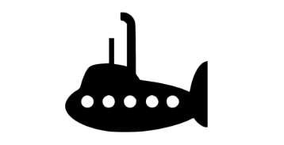  Sam’s Submarine Knowledge | Gummy Worms  One Plastic Cup  Imagination
Sam’s Raft Adventure + Rescue  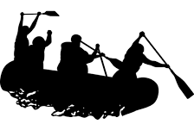 | One 8 oz. clear, plastic cup  Gummy Worms  Paper Clips (One box per family member)  A Lifesaver  Imagination
Sam’s Parachute Misadventure  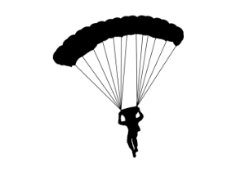 | Gummy Worms  Coffee Filters Cups  String  Tape  Construction Paper  Card Stock Paper  Imagination

What is STEM?

Watch the video at PTA.org/STEM or share the information below with your family.
- STEM = Science, Technology, Engineering and Mathematics.
- STEM careers in the United States are growing faster than other professions.
- The demand for qualified professionals is high, but the supply of workers to fill these positions is low—especially among women, minorities and students from low-income families.
- Not all STEM careers require a four-year degree; many well-paid careers are accessible with a two-year degree or certificate.
Engineering Design Process
The Engineering Design Process (EDP) is a series of steps that help guide engineers as they solve problems. Watch this video with your family to explore the process and learn how it’s different than the scientific method.
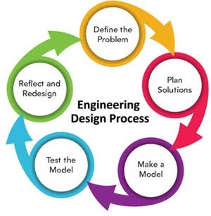

Cookie Bridge: Background Knowledge
Question: What do you notice about these bridges?
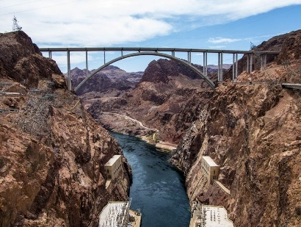
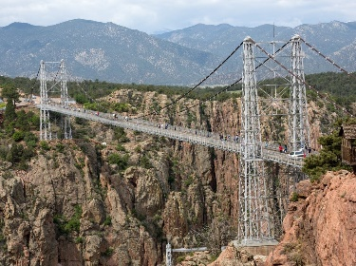
Possible responses: The bridges are above the ground or the water, the bridges are not supported in the middle, the bridges are connected to something above.

Cookie Bridge Activity
Challenge: Cookie Bridge
Watch this video to get started: https://youtu.be/mHNYFWUD0JQ
Challenge: Create a free-standing bridge using cookies. The cookie bridge must be able to support at least 1 cup of milk. Use the Engineering Design Process to solve the problem.
Materials: Cookies 1 cup of milk
Step 1- Define the Problem  What is the challenge we are trying to solve? | Directions  Build a cookie bridge.  The bridge must support 1 cup of milk.  - Make sure your cup and bridge are far away from your computer!  - Put a cup on top of your bridge.  - Slowly fill the cup.
Step 2- Plan solutions
Discuss the shape of your bridge. Think about different designs.

Step 3- Make a model
Take a few cookies and start experimenting with the shape, length, and height of the bridge.

Step 4- Test the model
Put a cup on top of your bridge. Slowly fill it.
Step 5 - Reflect and redesign
Did it work? What part worked?

Cookie Bridge: Challenge Yourself
- How can you design your bridge to hold more weight?
- How can you design your bridge to be taller?
- What changes can you make to your bridge?
- What other cookies can you use? How would that change your bridge?

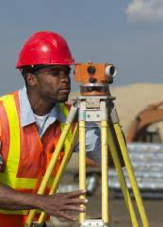
Cookie Bridge: STEM Career Connections
Possible careers: Civil engineer, architect, crane operator, surveyor, drafter

Skills needed: Knowledge of building and construction, critical thinking skills, technical skills, mathematics, teamwork and engineering design thinking.

How did you use those skills as you designed and built the bridge?

Sam’s Submarine Challenge: Background Knowledge

Question: What do you notice about these submarines?
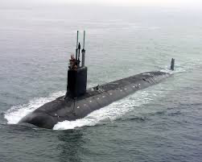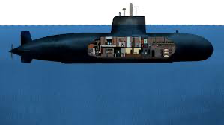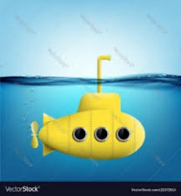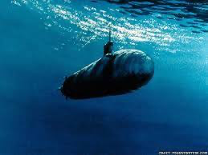
Possible answers: they go underwater, they have an antenna on top that can go above water, they are long but narrow, they can go deep underwater or just a little bit underwater.
Sam’s Submarine Challenge
Sam the gummy worm has traveled all the way to Norfolk, Va., to see the Atlantic Ocean for the first time! To explore the ocean, he will need a submarine to keep him dry! He has to go all the way underwater to the ocean floor in his makeshift submarine made from materials he found littered on the beach.
Challenge: Sam’s Submarine Knowledge
Watch this video to get started: https://youtu.be/Lt9egjeeb24
Materials
Gummy Worms, 1 plastic cup, Imagination, any other materials you find in your house.
Challenge: Design and build a submarine to safely transport Sam on his ocean adventure AND keep him dry! He still can’t swim!
Define the problem: Look at pictures and/or talk with your family team about how submarines are designed and how they can be designed to keep passengers safe from leaks and pressure. | Directions  Sam, the gummy worm, must be placed inside the submarine during all trials and cannot get wet or fall out! Sam cannot swim, he’s a worm!  Only the submarine you create can be used to help Sam explore the Atlantic Ocean. But be careful not to drown Sam!  Look at your materials and sketch your ideas on a piece of paper. Be creative–don't just use a water bottle as a submarine. Can you create a submarine with household materials?!  Use the 5 steps of the Engineering Design Process (EDP).
Plan solutions: Discuss as a team how pressure can affect submarines as they are submerged in deep water. Discuss as a team what household materials would safely help Sam explore the ocean while staying dry.
Make a model: Collect the materials and start the activity with combining items to create your submarine design. Discuss and plan for how your team will work together to test the submarine safely in the house.
Test the model: Test your parachute prototype. If it fails to float, sink or keep Sam dry, then redesign. Save Sam! Use your submarine prototype to help navigate the Atlantic Ocean
Reflect and redesign: If your submarine is not working for all steps, create new solutions, use different materials and change the design of the prototype.

Sam’s Submarine Knowledge: Challenge Yourself
- Redesign the challenge! Add a gummy worm friend for Sam that loves to explore, too!
- Make the submarine larger or smaller.
- Can you add propulsion to the submarine?
- How can you design the submarine to dive deeper?

Sam’s Submarine Knowledge: STEM Career Connections

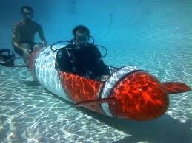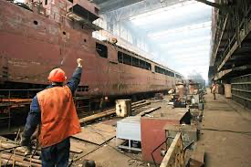
Possible careers: Naval Architect, Modeling and Simulation Engineer, Ocean Engineer, Chemist
Skills needed: knowledge of measurement, problem-solving skills, ecological/conservation knowledge, engineering design thinking, leadership.

How did you use those skills during this challenge?

Sam’s Raft Adventure + Rescue: Background Knowledge
Question: What do you notice about these rafts?

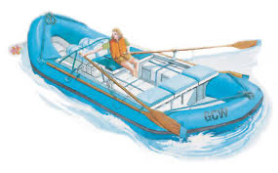
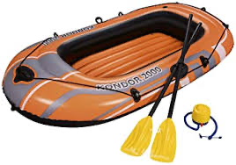
Possible answers: You need something to row, it has space to sit/stand, it floats, the person inside/on it stays dry, it looks flat on the bottom.

Sam’s Raft Adventure + Rescue
Sam is an adventurous little worm! He decided to try whitewater rafting on the Eagle River in Colorado. Whitewater rafting is a sport where people navigate swift currents and rocks in a raft down a fast-moving river. Sam’s raft tipped over! His life vest slipped off and now Sam is stuck on top of the capsized raft! He needs to go get his life vest, but he can’t swim! He’s a worm, not a fish!

Challenge: Sam’s Raft Adventure + Rescue
Watch this video to get started: https://youtu.be/scc81cduPGQ
Materials
One 8 oz. clear, plastic cup; Gummy Worms; a lifesaver; imagination! Any other materials you find in your house.
Challenge: Design and build a device to rescue Sam’s life vest from inside his capsized raft. To do that, we need to use the engineering design process to build a device to rescue Sam’s life vest from inside a capsized raft!
Define the problem: Look at the pictures and/or talk with your family team about how life vests are necessary for boating safety. | Directions  Sam, the gummy worm, is placed on top of the raft (cup) and the life vest, the lifesaver, is under the cup.  Sam cannot swim. Only the rescue device you create can be used to “move” Sam around (meaning if Sam falls off the raft, the rescue device needs to be used to save him, not your hands!) But be careful not to hurt Sam!  Also, only the rescue device can be used to move the other materials, such as the raft and life vests.
Plan solutions: Discuss as a team what household materials you can use to safely move Sam without falling into the Eagle River!
Make a model: Collect the materials and start the activity by combining materials to create your rescue device design. Discuss and plan for how your team will work together to use the rescue device.
Test the model: Test your created rescue device. Save Sam! Use your rescue device to lift the raft without knocking Sam over. As the raft is lifted, one of your team members must use part of the rescue device to pull the life vest from under the raft. Once the life vest is safely retrieved, talk as a team about how you will use your rescue device to put the life vest on Sam without hurting him.
Reflect and redesign: If your rescue device is not working for all steps, create new solutions and change the design of the device. If it fails, redesign!

Sam’s Raft Adventure: Challenge Yourself
- Once the life vest is safely retrieved, talk as a team about how you will use your rescue device to put the life vest on Sam without hurting him.
- Redesign the challenge! Add a gummy worm friend for Sam that needs to be rescued or make the raft larger!
- Change the size of the life vest. How can you design the rescue device to group more gummy worms together?

Sam’s Raft Adventure: STEM Career Connections
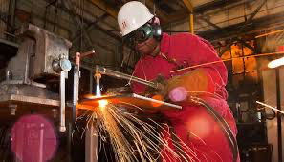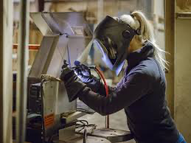

Careers: Welder, Marine Engineer, Shipfitter, Mechanical Engineer, Environmental Scientist

Skills needed: Knowledge of physics, design skills, leadership, attention to detail, creativity, engineering design thinking and collaboration. How did you use those skills during this challenge?

Sam’s Parachute Misadventure: Background Knowledge
Question: What do you notice about these parachutes?
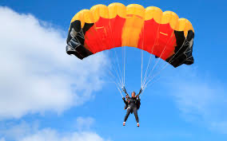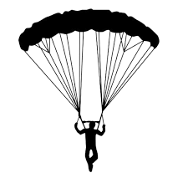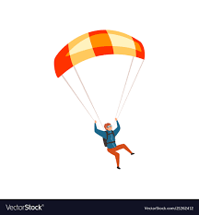

Possible answers: A person or a thing is attached to it, it floats down, it opens up and catches the wind, it is long and wide, it looks like an arch.
Sam’s Parachute Misadventure
Sam, the gummy worm, caught the adventure bug! He headed to southwest Arizona—full of mountains and a desert climate! He climbed to the top of a mountain to see the beautiful desert below—but now can’t get down! He is trapped on top of Superstition Mountain and needs to get down to the ground to his campsite. How on earth can he get down safely without injuring himself?!
Challenge: Sam’s Parachute Misadventure
Watch this video to get started: https://youtu.be/0QPox10K1jc
Materials
Gummy Worms; Tape; Construction Paper; Coffee filters; Cups; String; Cardstock paper; Any other materials you find in your house
Challenge: Design and build a device to transport Sam safely down a mountain to his campsite on the ground.
Define the problem: Look at the pictures and/or talk with your family team about how parachutes are designed and how they can be designed safely. | Sam, the gummy worm, must be placed inside the parachute during all trials and cannot fall out!  Sam cannot fly, he’s a worm! Only the parachute you create can be used to help Sam get to his campsite. But be careful not to hurt Sam!  Use the 5 steps of the Engineering Design Process (EDP).
Plan solutions: Discuss as a team how gravity can affect the path of your parachute. Discuss as a team what household materials would safely help Sam fly without falling out of the parachute! Collect the materials and start to activity with combining items to create your parachute design.
Make a model: Discuss and plan for how your team will work together to use the parachute safely in the house.
Test the model: Test your parachute prototype. If it fails to float gently from different heights, redesign. Save Sam! Use your parachute prototype to help him down the mountain
Reflect and redesign: If your parachute is not working for all steps, create new solutions, use different materials and change the design of the parachute.

Sam’s Parachute Misadventure: Challenge Yourself
- Redesign the challenge! Add a gummy worm friend for Sam that needs to be rescued!
- Make the parachute larger or smaller.
- Change the height of the mountain.
- How can you design the parachute to support more weight?
- How would the parachute perform if the climate and/or weather changed: add wind, rain or other variables?

Sam’s Parachute Misadventure: STEM Career Connections
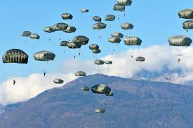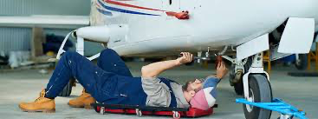

Careers: Paratrooper, Pilot, Aerospace Engineer, Data Analyst, Geographer, Information Technology Expert

Skills needed: Knowledge of physics, design skills, leadership, attention to detail, inquiry skills, engineering design thinking, teamwork, data-driven decision making.

How did you use those skills as you built and designed the parachute?

Extensions
To keep the STEM excitement alive by doing more activities as a family, go to PTA.org/STEM/At-Home.

