Materials List for a STEM + Families Science Festival

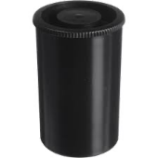  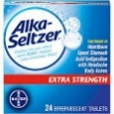  Alka Rockets | - Empty film canister  - Glass of water  - Effervescent antacid tablets
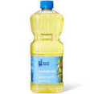  Bubbling Lava Lamp | - Water  - A clear plastic bottle with cap  - Vegetable oil  - Food coloring  - Effervescent antacid tablets
Martian Jelly  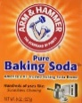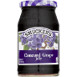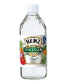 | - 1 tablespoon grape jelly  - 1/8 teaspoon baking soda (not baking powder)  - 1 tablespoon vinegar  - 1/2 cup of warm water  - Popsicle stick to stir solution
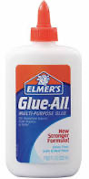  Sticky Icky  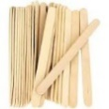  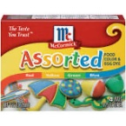  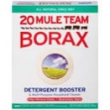 | - White school glue  - Food coloring (various colors)  - Borax (found in the laundry aisle)  - Two pitchers: One labeled “Borax Solution,” one labeled “Water Only”  - Warm tap water  - Plastic Tablespoons (some for water, some for glue)  - Plastic Teaspoons (for Borax solution)  - Six-ounce plastic cups (one for each student-adult pair)  - Popsicle sticks (one for each student-adult pair)  - Safety glasses

