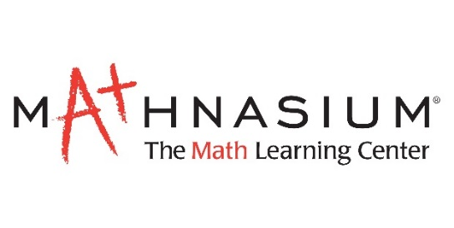
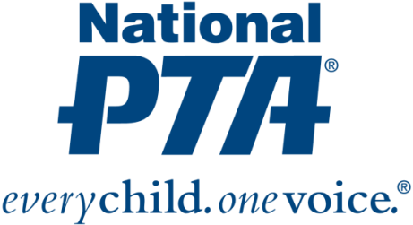
{Insert PTA Logo}

Contact:
{Insert Name and Contact Info}

{Name of PTA} Awarded Grant to Engage Families in Math Education

{City, State} (Date)—National PTA and Mathnasium have awarded {Name of PTA} with a $1,000 grant to engage families in math education. {Name of PTA} is one of only 35 PTAs nationwide selected to receive a grant. The grant recognizes {Name of PTA’s} leadership and commitment to increasing access to STEM—particularly math—experiences for {Name of City} children and families.

“Families play a critical role in children’s academic success and have the biggest influence on a child’s educational and career decisions, especially when it comes to STEM,” said Leslie Boggs, president of National PTA. “We are pleased to provide {Name of PTA} with resources to engage families in math education, show children how much fun math can be and educate families about math careers and education pathways.”

With the grant from National PTA and Mathnasium, {Name of PTA} will:
- Engage families using fun, hands-on learning experiences at math nights
- Educate families about math careers and empower them to support their children’s success in math
- Connect families and students to math enrichment opportunities and professional mentors

{Insert quote from PTA President or School Principal}

The grant program is part of National PTA’s STEM + Families initiative. STEM + Families is a national effort to engage entire families, inspire interest and support student success in STEM with experiences at school, at home, in the community and through digital learning. Mathnasium is a founding sponsor of the initiative. For more information about the STEM + Families, visit PTA.org/STEM.

About PTA
PTA® comprises millions of families, students, teachers, administrators and business and community leaders devoted to the educational success of children and the promotion of family engagement in schools. PTA is a registered 501(c)(3) nonprofit association that prides itself on being a powerful voice for all children, a relevant resource for families and communities, and a strong advocate for public education. Membership in PTA is open to anyone who wants to be involved and make a difference for the education, health and welfare of children and youth. For more information, visit PTA.org.

About Mathnasium
North America's leading math-only supplemental education franchise, Mathnasium teaches math so that children understand it, master it, and love it. The result of 40+ years of hands-on instruction and research, the Mathnasium Method'" has transformed the lives of children in grades 2-12 since 2002. With more than 1,000 learning centers worldwide, Mathnasium is ranked No. 2 in Forbes' "Best Franchises to Buy" in the U.S. for 2019.

