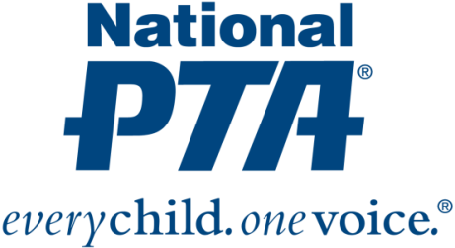
{Insert PTA Logo}

Contact:
{Insert Name and Contact Info from PTA and Bayer}

{NAME OF PTA} Awarded Grant to Engage Families in Science Education

{City, State} (Date)—National PTA and the Bayer USA Foundation have awarded {Name of PTA} with a $500 grant to engage families in science education. {Name of PTA} is one of only a few PTAs nationwide selected to receive renewed funding to continue their work to increase access to STEM—particularly science—experiences for {Name of city} children and families. {Name of PTA’s} was first awarded a grant from National PTA and Bayer in September 2018.

“Families play a critical role in children’s academic success and have the biggest influence on a child’s educational and career decisions. Family engagement is essential to strengthen STEM education, bridge the STEM gap and help all children realize their fullest potential,” said Leslie Boggs, president of National PTA. “We are pleased to provide {Name of PTA} with additional resources to engage families in science education, show children how much fun science can be and educate families about math careers and education pathways.”

With the grant from National PTA and Bayer, {Name of PTA} will:
- Engage families using hands-on learning opportunities and science experiences at science festivals in collaboration with Bayer’s Making Science Make Sense initiative
- Educate families about science literacy and science careers and empower them to support their children’s success in science
- Connect families and students to science enrichment and professional mentorship opportunities

{Insert quote from PTA President or School Principal}

The grant program is part of National PTA’s STEM + Families initiative. STEM + Families is a national effort to engage entire families, inspire interest and support student success in STEM with experiences at school, at home, in the community and through digital learning. National PTA launched STEM + Families with the founding support of the Bayer USA Foundation. For more information about the STEM + Families, visit PTA.org/STEM.

About PTA
PTA® comprises of families, students, teachers, administrators and business and community leaders devoted to the educational success of children and the promotion of family engagement in schools. PTA is a registered 501(c)(3) nonprofit association that prides itself on being a powerful voice for all children, a relevant resource for families and communities, and a strong advocate for public education. Membership in PTA is open to anyone who wants to be involved and make a difference for the education, health and welfare of children and youth. For more information, visit PTA.org.

About Bayer
Bayer: Science For A Better Life
Bayer is a global enterprise with core competencies in the Life Science fields of health care and agriculture. Its products and services are designed to benefit people and improve their quality of life. At the same time, the Group aims to create value through innovation, growth and high earning power. Bayer is committed to the principles of sustainable development and to its social and ethical responsibilities as a corporate citizen. In fiscal 2016, the Group employed around 115,200 people and had sales of EUR 46.8 billion. Capital expenditures amounted to EUR 2.6 billion, R&D expenses to EUR 4.7 billion. These figures include those for the high-tech polymers business, which was floated on the stock market as an independent company named Covestro on October 6, 2015. For more information, go to www.bayer.us.

