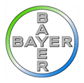
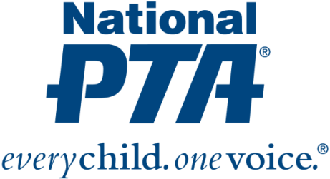
[PTA Logo]

*MEDIA ADVISORY*
[Name of PTA] to Host Science Festival for [Name of City] Families

Families to engage in science experiences and fun, hands-on learning activities to foster science literacy and nurture students’ interest in science

WHAT:
On [Date], [Name of PTA] will host a science festival at [Name of location] in collaboration with Bayer’s Making Science Make Sense® initiative. During the event, families will engage with Bayer volunteers; visit experiment stations and participate in fun, hands-on activities to help students learn science the way scientists do—by doing it. Families will also hear from [if applicable, list key speakers who will be addressing families during the event].

[Name of PTA]’s science festival is part of National PTA’s STEM + Families initiative. STEM + Families is focused on engaging entire families in STEM experiences at school, at home, in the community and with digital learning environments to support students’ success in STEM. The goal of the initiative is to spark an interest in STEM education, inspire families and communities to explore STEM education and career opportunities, and engage family members in shared learning experiences.

National PTA launched STEM + Families with founding support from the Bayer USA Foundation and Making Science Make Sense, Bayer’s STEM education initiative focused on advancing science literacy through hands-on learning, employee volunteerism, community partnerships and public education. [Name of PTA] was awarded a grant from National PTA and Bayer to educate and engage [Name of state or city] families in STEM activities focused on science. [Name of PTA] was one of only 45 PTAs across the country selected to receive a grant.

WHEN:
[Day and time of science festival]

WHERE:
[Name and address for location of event]

WHO:
[List key attendees who will be participating, including PTA leaders, Bayer leaders, school and district leaders, government leaders, and community leaders]

CONTACT:
[Name and contact information for PTA and Bayer]

About PTA
PTA® comprises of families, students, teachers, administrators and business and community leaders devoted to the educational success of children and the promotion of family engagement in schools. PTA is a registered 501(c)(3) nonprofit association that prides itself on being a powerful voice for all children, a relevant resource for families and communities, and a strong advocate for public education. Membership in PTA is open to anyone who wants to be involved and make a difference for the education, health and welfare of children and youth. For more information, visit PTA.org.

About Bayer
Bayer: Science For A Better Life
Bayer is a global enterprise with core competencies in the Life Science fields of health care and agriculture. Its products and services are designed to benefit people and improve their quality of life. At the same time, the Group aims to create value through innovation, growth and high earning power. Bayer is committed to the principles of sustainable development and to its social and ethical responsibilities as a corporate citizen. In fiscal 2016, the Group employed around 115,200 people and had sales of EUR 46.8 billion. Capital expenditures amounted to EUR 2.6 billion, R&D expenses to EUR 4.7 billion. These figures include those for the high-tech polymers business, which was floated on the stock market as an independent company named Covestro on October 6, 2015. For more information, go to www.bayer.us.

