General Science Festival Overview

Timing
Most PTAs schedule their Science Festival in the evening, often from 6:00/6:30 p.m. to approximately 8:00 p.m. This maximizes the number of students and parents who can attend and means your PTA can offer free food/dinner to promote the event and welcome families to the school.

Welcome Table
- Check in
- Sign National PTA Photo Release Form

STEM + Families Passport

- Pick up raffle tickets & passport
- Distribute food tickets (if applicable)

  - Each attendee will receive their own passport. The Student Passport is green and the Parent Passport is yellow (see picture below).
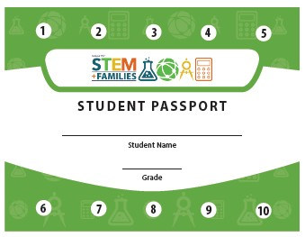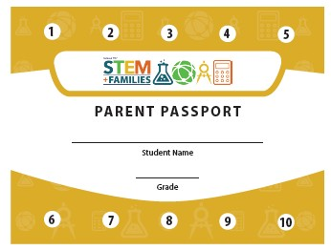

  - There are 10 numbered stars on the passports, one for each of the 10 stations (both students and parents should visit each of the 10 corresponding game stations).

  - The goal is for parents and their children to participate in each experiment together. After a parent and child complete an experiment at a station, the station facilitator will make a mark/initial/slash over the corresponding numbered star on the passports (i.e., after the student and parent complete the experiment at Station #2, the facilitator would write their initials over the #2 star on both the student and parent passport).

  - Attendees do not need to do the stations in order.

  - Once the attendees have a passport with all stars marked, they should go to the Rewards Table to trade in their passports for goody bags (for students) or to qualify for a giveaway (adults)!

Volunteer Facilitator Guide
  - You should receive your station facilitator guide from your PTA Leader before the event date.

  - Read the steps for your station before attending the event.

  - Along with the facilitator guides that volunteers will use at the experiment stations; we have also included a hand-out with experiment instructions that adults and family members can use at the experiment stations

  - Make sure to ask any questions you have on how to help parents and students successfully complete your station.

For PTA Volunteers to Know and Remember
  - You should plan on being at the event 30 minutes early to receive direction and assignments.

  - You may be facilitating one of the experiments. Don’t worry, there will be printed instructions at every station. Please take a few moments to familiarize yourself with yours.

  - Along with the facilitator guides that volunteers will use at the experiment stations; we have also included a hand-out with experiment instructions that adults and family members can use at the experiment stations

  - When students and family members come to your station, please make sure they have gotten their passports from the welcome table.

  - Safety First! If your experiment requires safety goggles, please make sure that all participants are wearing the goggles at all times from start to finish of your station.

  - Parents and children should be participating in the experiments together! If you see a parent standing around watching their student, please suggest that they join in the fun!

  - One of the stations (#10) is a SURVEY asking participants about their experience. Participants should complete at least 5 stations before filling out the survey. If participants come to Station #10 with fewer than 5 stars, please ask them to complete at least 5 stations before completing the survey at Station #10.

  - The adult give-away may be done as a drawing at the end of the event, if there is time. Alternatively, the drawing may be done after the event. If this happens, a PTA representative will contact the winner at the information provided on the passport.

  - If you feel like you need help or a quick break, please ask another volunteer and they can co-facilitate or temporarily stand in for you.

- Most importantly—have fun too!

