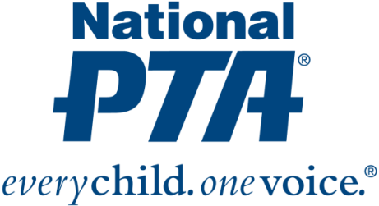
{Insert PTA Logo}

Contact:
{Insert Name and Contact Info from PTA and Bayer}

{NAME OF PTA} Awarded Grant to Engage Families in Science Education

Grant supports STEM + Families initiative to increase student access to STEM experiences

{City, State} (Date)—National PTA and the Bayer USA Foundation have awarded {Name of PTA} with a $1,000 grant to engage families in science education. {Name of PTA} is one of only 30 local PTAs nationwide selected to receive a grant through the STEM + Families initiative. The grant recognizes {Name of PTA’s} leadership and commitment to increasing access to STEM—particularly science—experiences for {Name of city} children and families.

“We know—and decades of research proves—that families play a critical role in children’s academic success. We also know that parents and guardians have the biggest influence on a child’s educational and career decisions,” said Jim Accomando, president of National PTA. “Family engagement is essential to strengthen STEM education, bridge the STEM gap and help all children realize their fullest potential. We’re thrilled to empower {Name of PTA} with resources to engage families in science education.”

STEM + Families is a national effort to engage entire families in STEM experiences at school, at home, in the community and with digital learning environments to support their students’ success in STEM. The goal of the initiative is to fill a critical gap in STEM education, increase access to STEM experiences for all students and inspire the next generation of STEM professionals. National PTA launched STEM + Families with the founding support of the Bayer USA Foundation. Through the effort, 100,000 STEM experiences will be delivered to families nationwide by 2018.

With the grant from National PTA and Bayer, {Name of PTA} will:
- Engage families using hands-on learning opportunities and science experiences at science festivals in collaboration with Bayer’s Making Science Make Sense initiative
- Educate families about science literacy and science careers and empower them to support their children’s success in science
- Connect families and students to science enrichment and professional mentorship opportunities

{Insert quote from PTA President or School Principal}

For more information about the STEM + Families initiative, visit PTA.org/STEM.

About PTA
PTA® comprises of families, students, teachers, administrators and business and community leaders devoted to the educational success of children and the promotion of family engagement in schools. PTA is a registered 501(c)(3) nonprofit association that prides itself on being a powerful voice for all children, a relevant resource for families and communities, and a strong advocate for public education. Membership in PTA is open to anyone who wants to be involved and make a difference for the education, health and welfare of children and youth. For more information, visit PTA.org.

About Bayer
Bayer: Science For A Better Life
Bayer is a global enterprise with core competencies in the Life Science fields of health care and agriculture. Its products and services are designed to benefit people and improve their quality of life. At the same time, the Group aims to create value through innovation, growth and high earning power. Bayer is committed to the principles of sustainable development and to its social and ethical responsibilities as a corporate citizen. In fiscal 2016, the Group employed around 115,200 people and had sales of EUR 46.8 billion. Capital expenditures amounted to EUR 2.6 billion, R&D expenses to EUR 4.7 billion. These figures include those for the high-tech polymers business, which was floated on the stock market as an independent company named Covestro on October 6, 2015. For more information, go to www.bayer.us.

