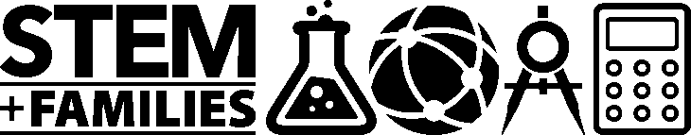

National PTA Pilot Event: STEM + Families

STEM = Science, Technology, Engineering & Math

Who: All 3rd, 4th & 5th Grade Bevis Students and Families
(All students must be accompanied by an adult)
When: May 18th, 6:00-8:00 p.m. in the MPR/Cafeteria
What: An exciting new STEM program being developed by National PTA!
Bevis has been selected as a PILOT school to do an early test of the STEM + Families (Math) program before it rolls out nationally. PTA’s goal is to engage families together in STEM experiences. Come nurture
your student’s love of STEM through a night of interactive math games and activities.
PLUS: There will be great door prizes and an ice cream social!
PTA does not endorse any commercial entity, product, or service. No endorsement of Mathnasium is implied.

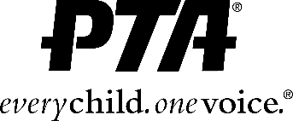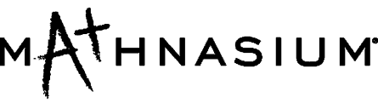

STEM + Families (Math) Founding Sponsor

National PTA Pilot Event: STEM + Families

STEM = Science, Technology, Engineering & Math

Who: All 3rd, 4th & 5th Grade Bevis Students and Families
(All students must be accompanied by an adult)
When: May 18th, 6:00-8:00 p.m. in the MPR/Cafeteria
What: An exciting new STEM program being developed by National PTA!
Bevis has been selected as a PILOT school to do an early test of the STEM + Families (Math) program before it rolls out nationally. PTA’s goal is to engage families together in STEM experiences. Come nurture
your student’s love of STEM through a night of interactive math games and activities.
PLUS: There will be great door prizes and an ice cream social!
PTA does not endorse any commercial entity, product, or service. No endorsement of Mathnasium is implied.

STEM + Families (Math) Founding Sponsor

