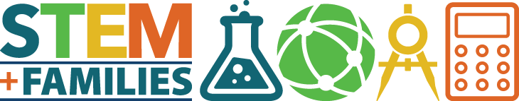

Academy for Enriched Sciences PTA’s
STEM + Families Math Games Night
A National PTA Pilot Event
Friday, May 12, 5:30 - 7:30 pm

All attendees receive dinner (free!)
Plus: Door Prizes! (Board Games, Destination Science Camp, and Mathnasium tuition!)

Due to our school’s excellent reputation and our active PTA, National PTA has chosen AES to be the first-ever math pilot site for a new STEM + Families program rolling out nationwide next year!

STEM + Families is meant to engage families together in fun STEM experiences. So, please make every effort to join us as we put AES in the national spotlight and to enjoy a night of interactive games with your child.

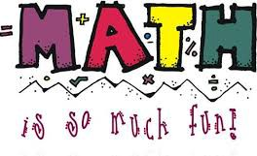

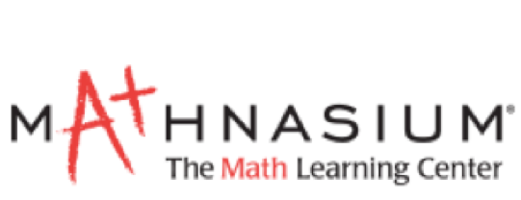

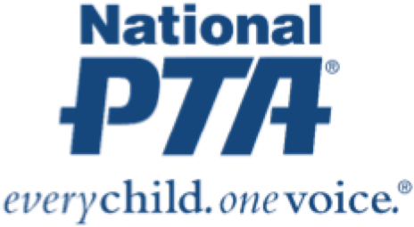STEM + Families (Math) Founding Sponsor

PTA does not endorse any commercial entity, product, or service. No endorsement is implied of Mathnasium.

