Welcome to the National PTA Reflections Student Entry Portal. Please use these directions as you use the platform to advance entries to the National level for review. Remember, you can submit up to 30 entries for national review. You can submit one entry per category per division.
Creating an Account 1
Creating Entries 2
Advancing Entries 7
Downloading Entries 9

Creating an Account
If you had a previous account, to log in choose “Log In” in the upper right corner. Complete the account information. If you have forgotten your password, choose “Forgot your Password” and follow with instructions to set a new password.
To create an account, choose “Register” in the upper right corner. Register with your Facebook, Twitter, or Google account. You can also complete the fields and select “Create Account” at the bottom of the page. Upon registering your account, please email Reflections@PTA.org to have NPTA establish the correct user permissions.
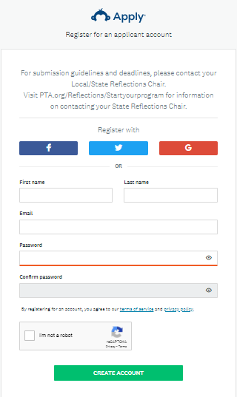

Creating Entries
To create applications, log into your account and choose Applicant.
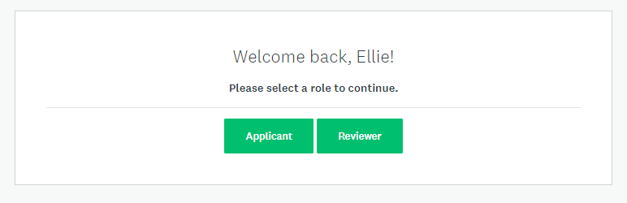
If you are a new user, you will have no existing applications on the site. Please email Reflections@PTA.org if you see entries that you do not recognize.
- Click View Programs. Then click MORE under the Student Entry Portal program.
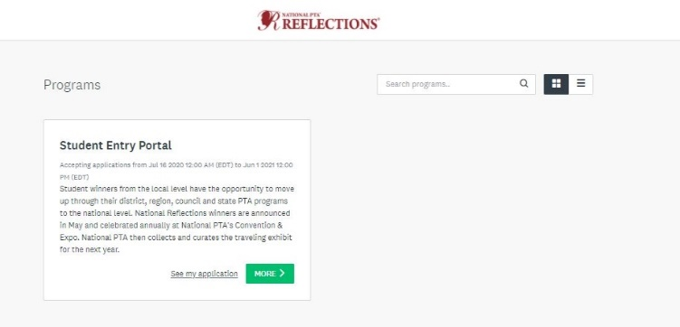
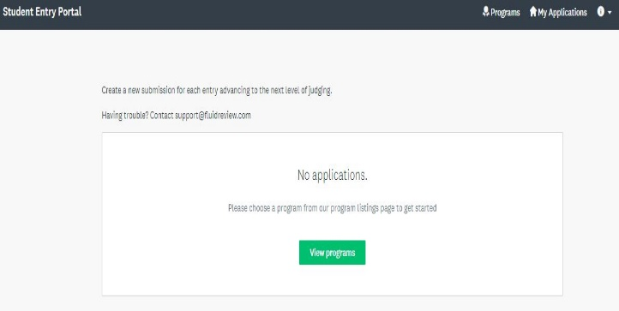
- Click Apply.
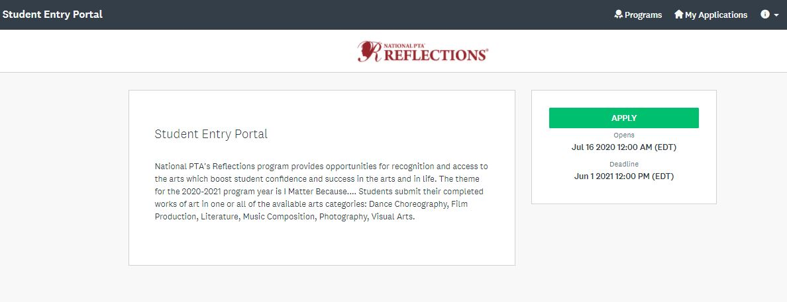

- Enter the applicant’s First and Last Name as prompted.
5. Click Entry Form (2020).
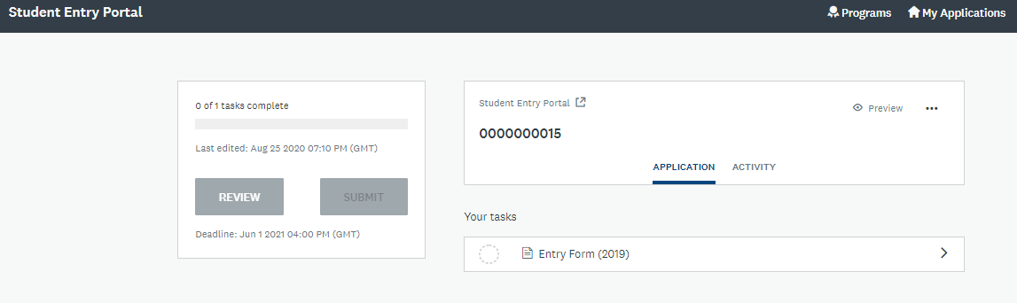

6. Next, you must upload the student artwork (Dance or Film Video, Music audio and Notation, Visual Art or Photography Image). Please reference the files accepted by the platform to ensure you can upload your Reflections entries. Click Upload box.
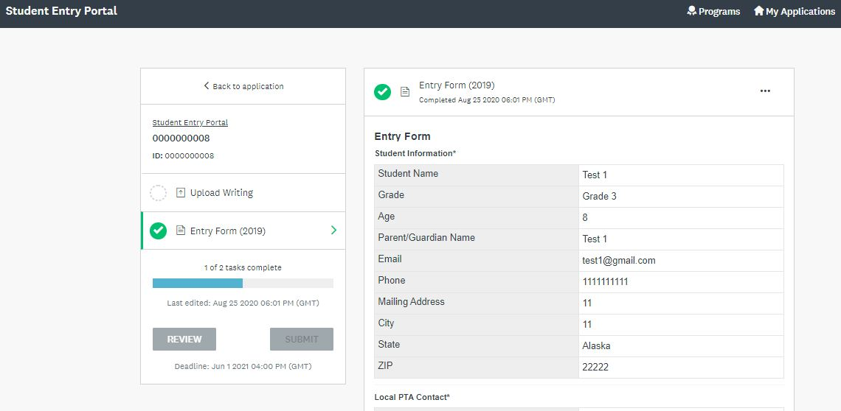

7. Click Mark Complete.
8. Click Submit. You will be prompted to Review or Submit the entry. Once submitted, an entry cannot be edited. Be sure to review your entry before submitting.
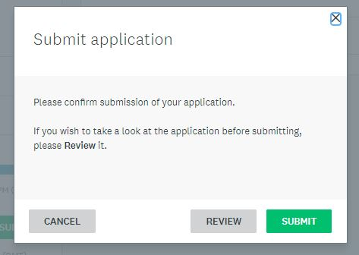
In the case where you've already created an application on the site and wish to create a new one:
- Click Programs in the top in the top right corner
- Click MORE > for the program you wish to apply for.
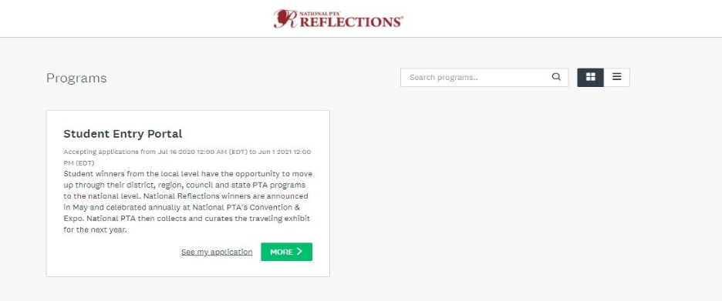
- Click Apply.
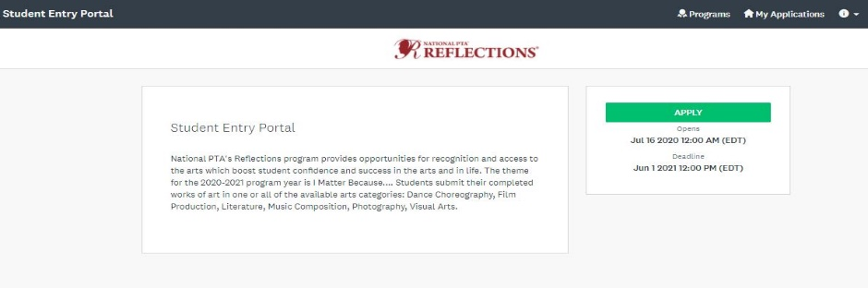

- Enter the applicant’s First and Last Name as prompted.
- Click Entry Form (2020).

- Next, you must upload the student artwork (Dance or Film Video, Music audio and Notation, Visual Art or Photography Image). Please reference the files accepted by the platform to ensure you can upload your Reflections entries. Click Upload box.

- Click Mark Complete.
- Click Submit. You will be prompted to Review or Submit the entry. Please note: You cannot edit an entry once you choose to submit it. Make sure you review the entry to ensure all the information entered is correct. If you need to make edits to a submission, please work with National PTA at Reflections@PTA.org.
- To view all applications, click My Applications in the top in the top right corner

Advancing Entries

To advance entries to the National Qualifying Round:
- Log into your account and choose Reviewer.
- On the Review Dashboard, choose Start.
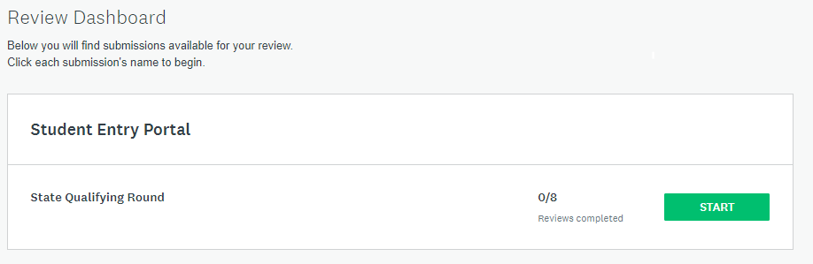
- You will need to advance each entry individually. To do so, you can either choose Continue Reviewing or START.
- On the application review pages, you will need to respond to the question “Should this application move to the National qualifying round?” If you are entering the top 30 winning applications for your state, choose Yes. Then choose, Mark As Complete. You will be prompted to confirm your review submission, choose Yes.
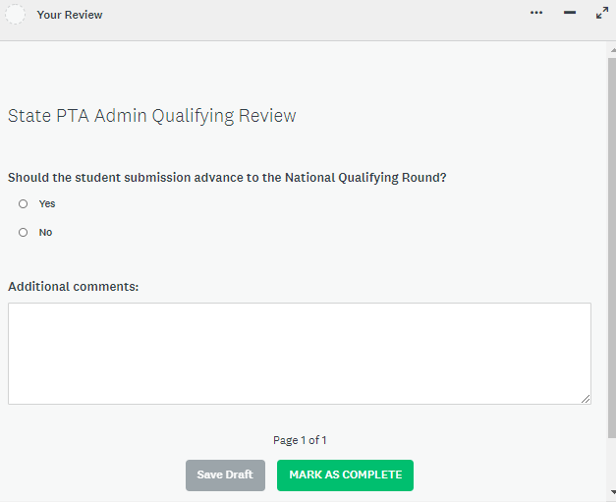

- To advance other entries, choose Student Entry Portal - State Qualifying Round in the upper left corner to return to the original collection of entries.
- To verify which entries you have advanced to the National Qualifying Round, choose Review Dashboard in the upper right corner. On the next page, select National Qualifying Round.

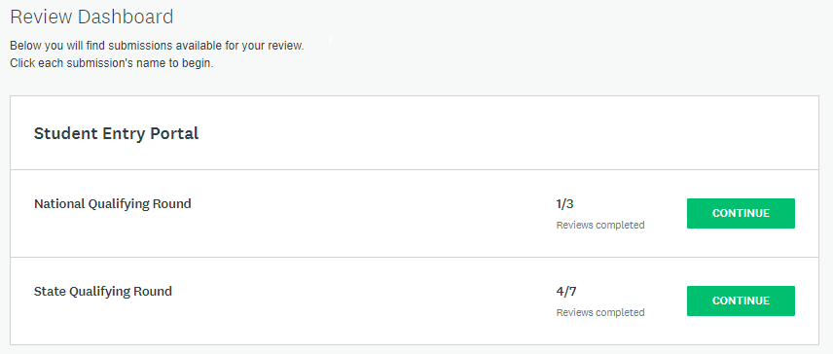

Downloading Entries
As the State Reflections Chair, you have access to all entries in the State Qualifying Round.
- To download entries, choose entries individually or all together by choosing the squares on the left-hand side.
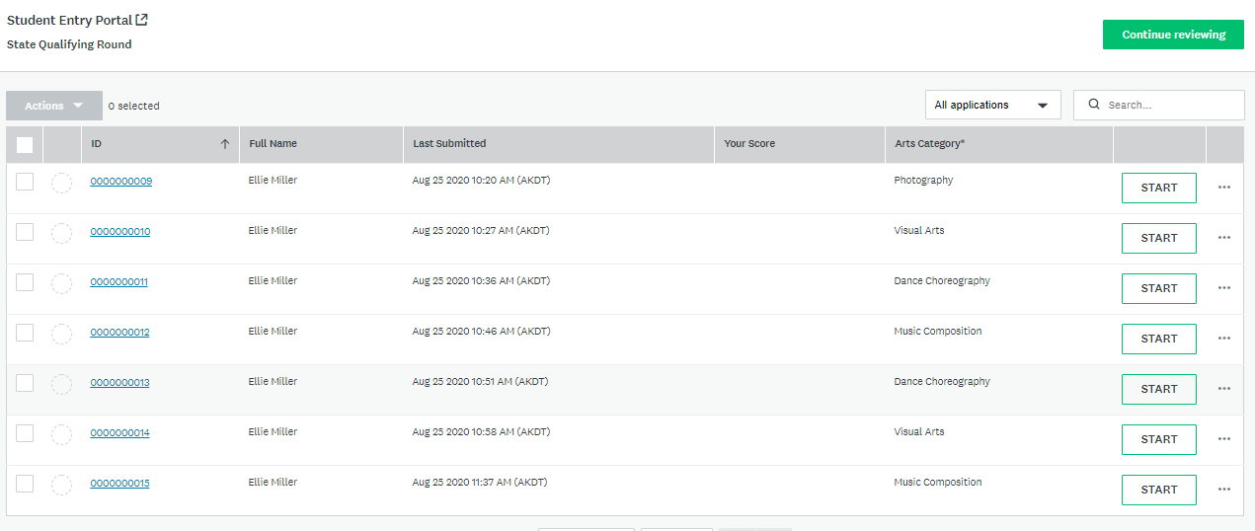
Choose this box to select ALL entries.
Choose these boxes to select individual entries.

- Once you have selected the entries, you choose Download application
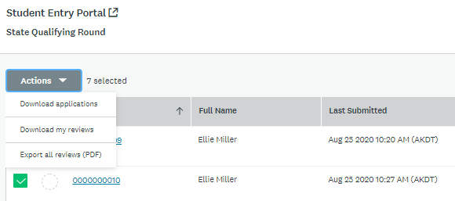

- You will be prompted to choose your Download Options.
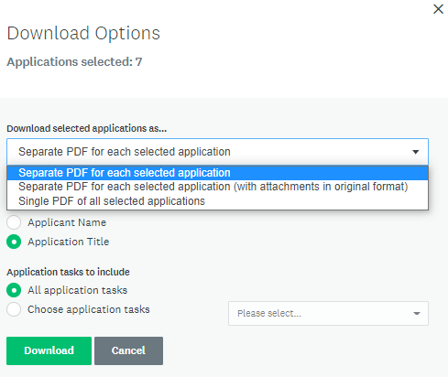
  - You can choose Separate PDF for each selected application, Separate PDF for each selected application (with attachments in original format), or Single PDF of all selected applications.
  - Choose Applicant Name for easily identifying applications.
  - You can download specific Student Entry Form tasks. To download all information, choose All application tasks. To download entries or forms separately, choose application tasks and the select what you want to download.
