Welcome to the National PTA Reflections Student Entry Portal. Please use these directions as you use the platform to create entries for the Reflections program. Be sure to coordinate with your State Reflections Leadership to ensure you are following all required steps and procedures.
Creating an Account 1
Creating an Entry – No Existing Applications 2
Creating an Entry – Existing Applications 5

Creating an Account
If you had a previous account, to log in choose “Log In” in the upper right corner. Complete the account information. If you have forgotten your password, choose “Forgot your Password” and follow with instructions to set a new password.
To create an account, choose “Register” in the upper right corner. Register with your Facebook, Twitter, or Google account. You can also complete the fields and select “Create Account” at the bottom of the page.
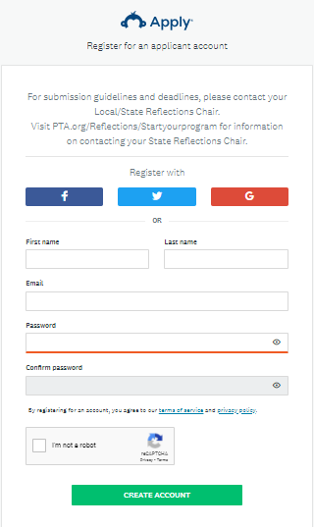

Creating an Entry – No Existing Applications

As a new user, you will have no existing applications on the site. Follow the instructions below to create a new application.
- Click View Programs.
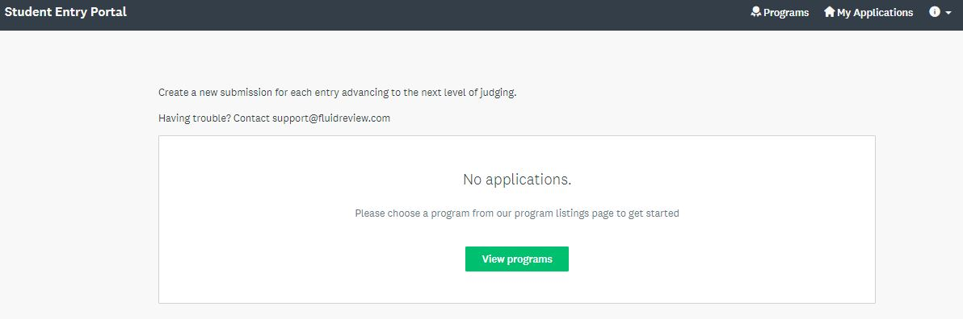
- Click MORE under the Student Entry Portal.
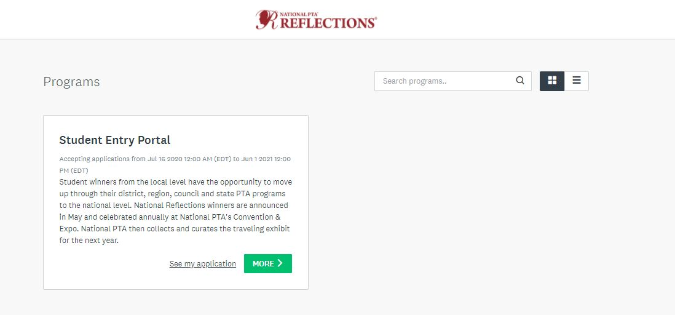

- Click Apply.
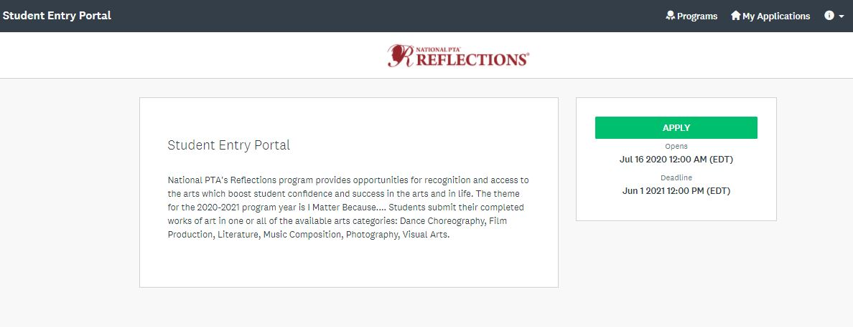
- Enter the applicant’s First and Last Name as prompted.
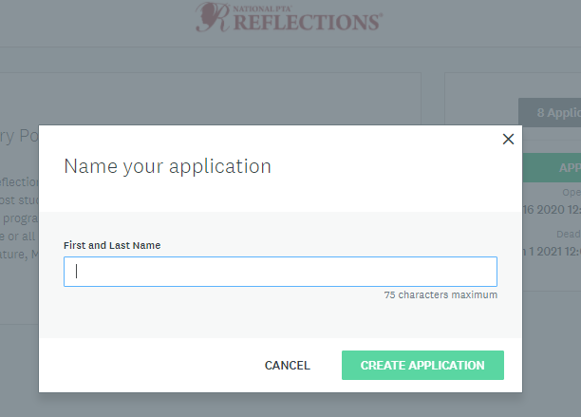
Populating the new application:
- Click Entry Form (2020).
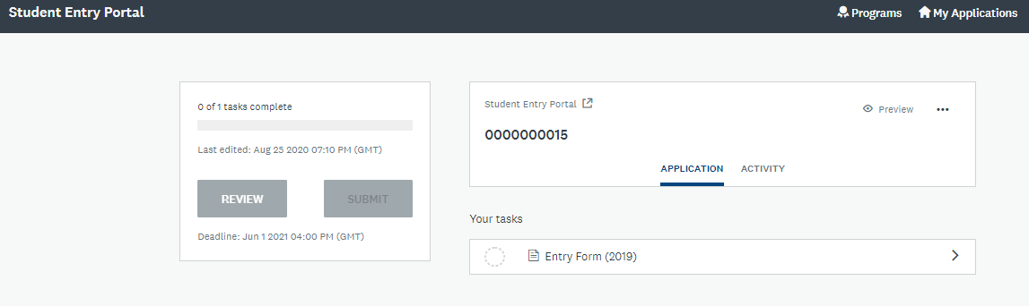

- Next, you must upload the student artwork (Dance or Film Video, Music audio and Notation, Visual Art or Photography Image). Please reference the files accepted by the platform to ensure you can upload your Reflections entries. Click Upload box.
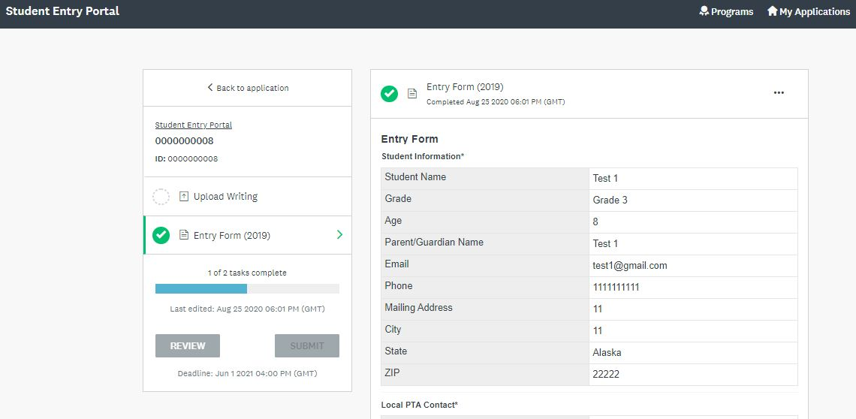
- Click Mark Complete.
- Click Submit. You will be prompted to Review or Submit the entry. Please note: You cannot edit an entry once you choose to submit it. Make sure you review the entry to ensure all the information entered is correct. If you need to make edits to a submission, please work with your State PTA Reflections leadership.
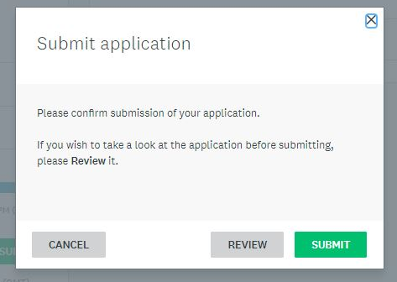
- To view all applications, click My Applications in the top in the top right corner
If you're experiencing difficulties creating more than one application, you can reach out to the administrators of the site. If you are still experience issues, please contact your State Reflections Chair so they can liaise on your behalf.

Creating an Entry – Existing Applications

In the case where you've already created an application on the site and wish to create a new one:
- Click Programs in the top in the top right corner.
- Click MORE > for the program you wish to apply for.
- Click Apply.

- Enter the applicant’s First and Last Name as prompted.
Populating the new application:
- Click Entry Form (2020).
- Next, you must upload the student artwork (Dance or Film Video, Music audio and Notation, Visual Art or Photography Image). Please reference the files accepted by the platform to ensure you can upload your Reflections entries. Click Upload box.
- Click Mark Complete.
- Click Submit. You will be prompted to Review or Submit the entry. Please note: You cannot edit an entry once you choose to submit it. Make sure you review the entry to ensure all the information entered is correct. If you need to make edits to a submission, please work with your State PTA Reflections leadership.
If you're experiencing difficulties creating more than one application, you can reach out to the administrators of the site. If you are still experience issues, please contact your State Reflections Chair so they can liaise on your behalf.

