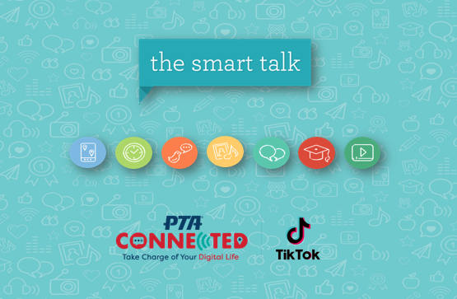

[Introduce yourself]

Before we look at how we can use The Smart Talk and hear from our speaker – let’s get up and move a bit:

Stand if you have used a computer, laptop, tablet or smartphone today

Stand if you know your child used a computer, laptop or tablet today

Stand if your family takes silly selfies together

Stand if your child has their own device or access to a family device

Stand if you have at least one family ground rule about device use

As you can see most of us in this room are on devices and our kids are too. When we look at research from across the country we continue to see this to be true, the latest studies show that 98% of children under the age of 8 have access to some sort of smart mobile device, such as computer, laptop, tablet, smartphone or smarthome/speaker.

[Grab your reader’s attention with a great quote from the document or use this space to emphasize a key point. To place this text box anywhere on the page, just drag it.]

1

To give you a quick preview of today’s topics… we’re going to hear from X about X, talk about the Smart Talk tool that National PTA has developed in partnership with Symantec. Then, I’m going to give you an overview of additional resources that we point to from many of our trusted partners and finally, I’d like to engage you all in some discussion and Q&A.

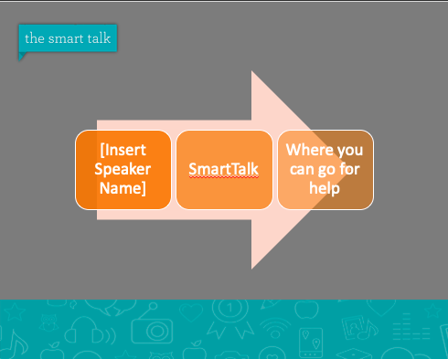

2

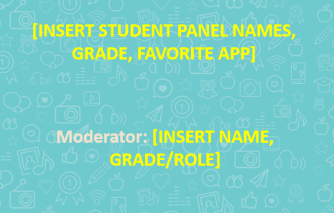

I am now pleased to welcome our panel of students to discuss social media and digital safety.

[Insert student information]

3



Many of us have probably seen our students on TikTok but been confused by what it is. In 15-60 second clips, users present their creative ideas through various content types, such as dance, music, comedy, beauty or travel. Our students are creating content and interacting with friends in creative and novel ways. Check out this funny TikTok by Will Smith who uses the platform to create a rose out of dumplings.

4

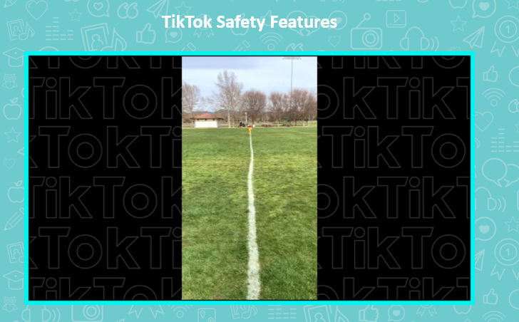

The TikTok Community Guidelines are an important code of conduct for a safe and friendly environment. Violation of the guidelines may result in your account and/or content being removed.

Users can choose from a variety of personal settings to ensure that their content can only be seen by the group of people they determine and that only selected people can contact them. The Digital Wellbeing settings allows you to set time limits on the app so that our students are only using the app during designated times and only for a certain amount of time each day. Restricted mode provides a function that hides content that is not suitable for all age groups, so you can feel comfortable having your child browse the app without coming across inappropriate content.

**[Watch video]**

A lot of reputable social media apps have similar privacy settings and explanatory videos like this one for you to explore in the safety and privacy section of the app.

5

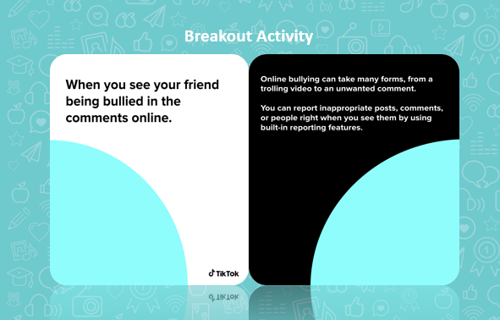

Get into groups of two or three parents and their kids. Each group will be given a deck of cards with scenarios. You will play out these internet safety scenarios and design a skit of the best way to react if the scenario were to happen you. After you’ve worked through a couple, we will come back together to discuss and act out some of these scenarios if we have some brave volunteers! We also encourage you to go home and record your skits on TikTok so families can be creative together!

**[Bring attendees back together after 10 minutes and have them share out some of their scenarios]**

6

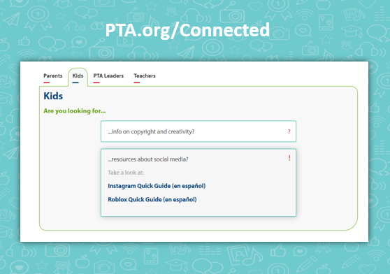

There is a lot of information out there about best practices for digital safety. National PTA has looked through tons of these resources and identified the best ones to help answer parent’s questions and address online concerns all in one place. When you get home, head to PTA.org/connected to check out all of the free resources National PTA has put together for your easy access.

There is also a section dedicated to all of National PTA’s sponsors who are subject matter experts in digital safety. National PTA works with the Internet Crimes Against Children Task Force, National Center for Missing and Exploited Children, Connect Safely, Common Sense Media and more to provide parents with resources to keep your children safe and how to connect with them online in a positive, productive way.

We will look at some of those resources together.

7

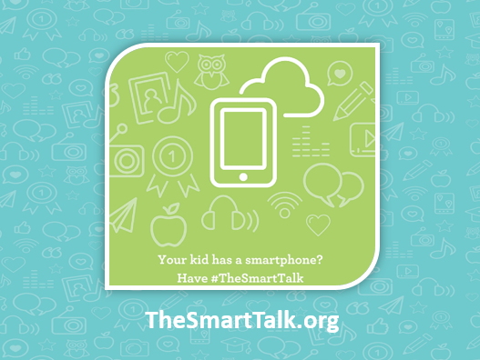

One of the tools you will find here is The Smart Talk, created by National PTA this website helps families walk through questions on topics related to internet safety that establish family boundaries and rules for device use and behavior.

We are going to take some time to look at The Smart Talk together. Take your phones out and go to TheSmartTalk.org

8

The Smart Talk walks families through a conversation in five different sections.

- Safety & Privacy

- Screen Time

- Social Media & Respect

- Apps & Downloads

- Texting & Calling

Since we don’t have enough time right now to have this conversation, click on one of these topics and then click get me started.

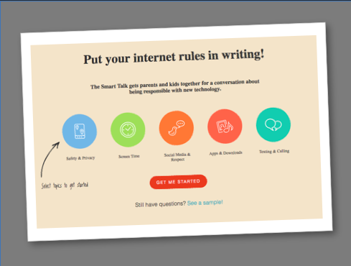

9

If you selected screen time, you should see something that looks like this on your screen. The Smart Talk is a lot more fun and interactive than most online agreement forms. Each section is set-up similarly to this.

We know that every family is different, so this tool does not prescribe for you what you should be doing but rather helps you decide together with your family what rules and norms you want to set and then hold yourself accountable for.

Throughout the series of questions you can click “Bonus reading” (the person reading the book icon) for tips on certain subjects such as secure passwords and more information about social media.

Take a minute right now, to set a reminder to have this conversation (you can even tackle it slowly in five different conversations!) with your family after tonight is over!

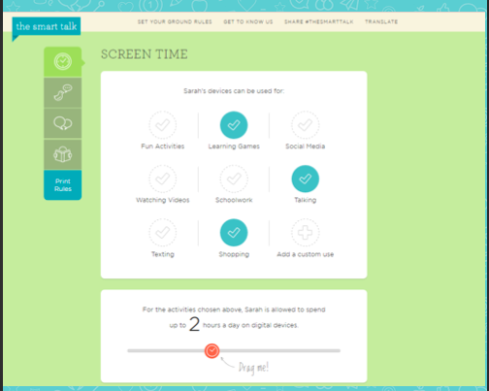

10

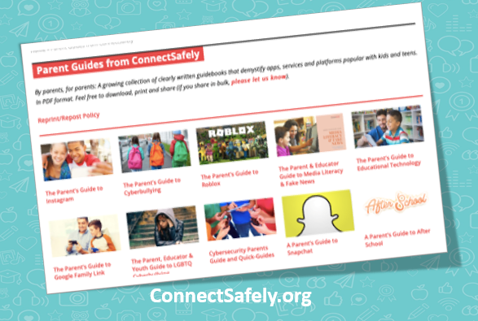

Let’s take a moment to look at some of the organizations who National PTA partners with to provide you the most up to date online safety support.

Connect Safely has partnered with National PTA for over five years and hosts the National Safer Internet Day Event.

Connect Safely creates Quick Guides you can use as a reference guide, like the TikTok guide we used tonight, for tips and tools that will keep you safe online. There are nearly a dozen of these quick guides ranging from online shopping to plagiarism to social media. These are a great way to learn the important information quickly and they are easy for kids to understand, too!

Additionally, ConnectSafely also has many articles and blogs about current tech issues to help keep parents on top of popular apps and sites.

11

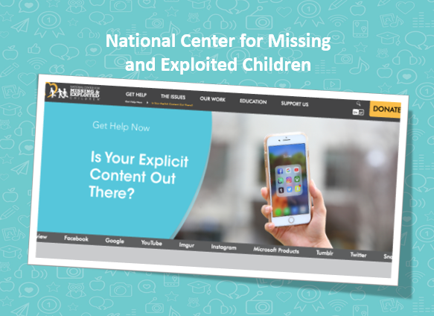

The National Center for Missing and Exploited Children works hard to keep children safe from internet abuse. I recommend you explore their entire page, but one resource I want to highlight here is their tool to remove explicit content of your children online. If you find an inappropriate photo of your child online, you can go to their webpage to be connected to a case worker who will ensure removal of this photo from internet platforms.

12

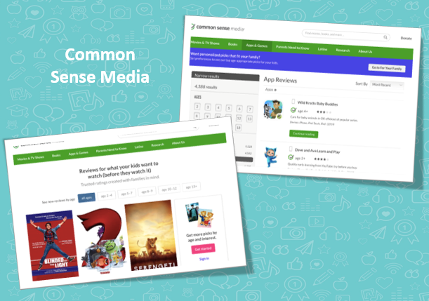

Finally, Common Sense Media is a great resource for parents who want to make sure that what your kids are watching or playing are safe and age appropriate. Common Sense Media does the hard work of reviewing movies, shows and games by age range to ensure that your child is watching age-appropriate content so that you can feel good about what you’ve got on your family’s television.

13

Let’s take a moment to take some questions from the audience.

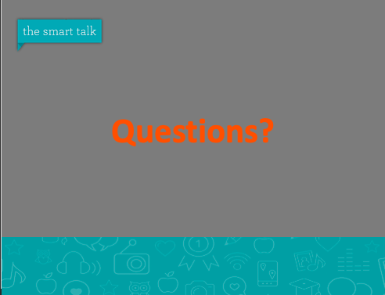

14