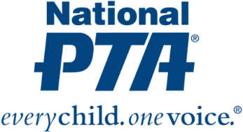
{Insert PTA Logo}

Contact:
{Insert Name and Contact Info for PTA}

{NAME OF PTA} Helps Families Navigate the Digital World

{City, State} (Date)— {Name of PTA} is helping families navigate the digital world by hosting a Smart Talk conversation at their school in conjunction with Safer Internet Day, which will be celebrated {Insert Date}. The Smart Talk, sponsored by Symantec, recognizes {Name of PTA’s} leadership and commitment to fostering open and honest conversations within families that instill healthy online habits.

“It is essential that families have open, ongoing conversations about technology use and being responsible and safe in the digital world,” said Leslie Boggs, past president of National PTA. “National PTA is pleased to equip {Name of PTA} with resources to engage families in this critical dialogue and promote safer and more responsible habits online, particularly as part of Safer Internet Day.”
The Smart Talk is a free, interactive tool that helps families have conversations about digital well-being and technology use and helps guide parents and kids in getting on the same page about how their family will handle screen time, devices, social media and other digital decisions.

{Insert quote from PTA president or school principal}

The Smart Talk tool is part of National PTA’s PTA Connected initiative, which is designed to deepen the understanding and knowledge of parents, families and teachers about digital safety tools and resources; mobilize PTAs, schools and communities to engage families around best practices and shared learning; and generate collective impact. For more information about PTA Connected, visit PTA.org/Connected. For parents looking to begin the conversation today, get tips and more information on device and internet accountability, visit TheSmartTalk.org.

About PTA
PTA® comprises millions of families, students, teachers, administrators and business and community leaders devoted to the educational success of children and the promotion of family engagement in schools. PTA is a registered 501(c)(3) nonprofit association that prides itself on being a powerful voice for all children, a relevant resource for families and communities, and a strong advocate for public education. Membership in PTA is open to anyone who wants to be involved and make a difference for the education, health and welfare of children and youth. For more information, visit PTA.org.

