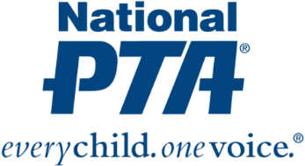
{Insert PTA Logo}

Contact:
{Insert Name and Contact Info for PTA}
{NAME OF PTA} Awarded Google and National PTA Grant to Address Digital Safety

{City, State} (Date)— {Name of PTA} has been awarded a $1,000 grant from National PTA and Google to host a Be Internet Awesome Family Workshop at their school and empower parents with resources to help their children be safe and responsible online. {Name of PTA} is one of only 75 local PTAs nationwide selected to receive a grant from Google and National PTA.

“Parenting in the digital age is complex. The Be Internet Awesome Family Workshops provide parents with an opportunity to openly explore their excitements and worries about raising children in the connected world and walk away with information and action plans to facilitate discussions at home,” said Leslie Boggs, president of National PTA. “National PTA is pleased to equip {Name of PTA} with resources to help every family Be Internet Awesome.”

At the Be Internet Awesome workshop, families will:
- Learn about online safety tools and how to better navigate the internet
- Grow their understanding of digital well-being
- Engage with one another in meaningful conversations about raising children in an online world

All materials provided at the Be Internet Awesome Family Workshop will be available in English and Spanish.

{Insert quote from PTA President or School Principal}

The Be Internet Awesome Family Workshop and grant program are part of National PTA’s PTA Connected initiative, which is designed to deepen the understanding and knowledge of parents, families and teachers about digital safety tools and resources; mobilize PTAs, schools and communities to engage families around best practices and shared learning; and generate collective impact. For more information about PTA Connected, visit PTA.org/Connected.
About PTA
PTA® comprises millions of families, students, teachers, administrators and business and community leaders devoted to the educational success of children and the promotion of family engagement in schools. PTA is a registered 501(c)(3) nonprofit association that prides itself on being a powerful voice for all children, a relevant resource for families and communities, and a strong advocate for public education. Membership in PTA is open to anyone who wants to be involved and make a difference for the education, health and welfare of children and youth. For more information, visit PTA.org.

