Template Press Release
Remove this text and update the highlighted sections of the template to notify your local press about your grant and event.
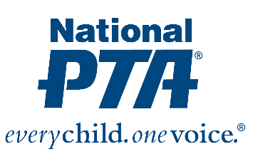

[INSERT LOCAL PTA LOGO]

Contact:
{Insert Name and Contact Info from PTA }

{NAME OF PTA} Awarded Grant from National PTA and Facebook to Address Digital Safety

{City, State} (Date)—National PTA® has awarded {Name of PTA} with a $1,000 grant to host a Digital Families Community Event at their school between Jan. 1 and May 1, 2019. During the event, families will have honest conversations about important issues including digital literacy, safety and citizenship.
{Name of PTA} is one of 200 local PTAs nationwide selected to receive a grant through the PTA Connected initiative, which works to empower parents and families with resources and research to equip them to be safer online. The grant recognizes {Name of PTA’s} leadership and commitment to setting technology ground rules as more kids go digital.
“Our goal is for parents and students to have an open, evolving conversation about how to make positive, safe decisions when using digital tools,” said Jim Accomando, National PTA. “We want parents and families to be able to take charge of their digital life and feel empowered to make smarter decisions about accessing information for good use.”

{Insert quote from PTA President or School Principal}

For more information about PTA Connected, visit PTA.org/Connected.

About PTA
National PTA® comprises of families, students, teachers, administrators and business and community leaders devoted to the educational success of children and the promotion of family engagement in schools. PTA is a registered 501(c)(3) nonprofit association that prides itself on being a powerful voice for all children, a relevant resource for families and communities, and a strong advocate for public education. Membership in PTA is open to anyone who wants to be involved and make a difference for the education, health and welfare of children and youth. For more information, visit PTA.org.

