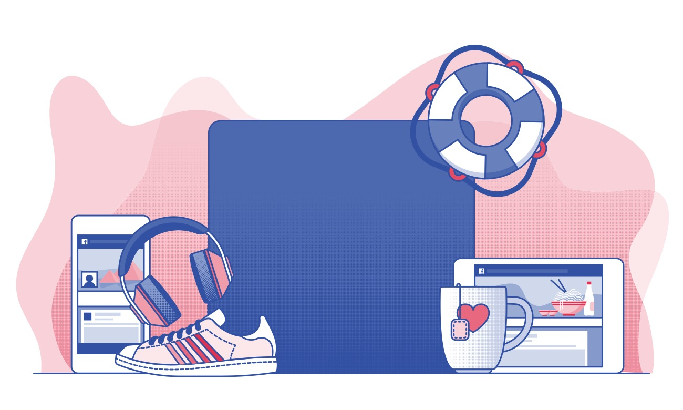

April 11, 2019 6:00 pm

Register @ https://djvdigitalfamilies.eventbrite.com

Have you talked with your kids about online safety? Now’s the time.

Join us for hands-on parent and student activities that help you practice together.

*Refreshments will be served & door prizes for families that stay for the entire event*

**Dorothy J. Vaughan Academy of Technology PTA**

**Digital Families Community Event**