Facilitator’s Guide: Build Up and Belong In Person Program
As technology becomes more prevalent in our lives and the lives of our children, we must navigate new territory. This session was designed to facilitate meaningful discussion about digital dilemmas, specifically related to community and belonging, that many people face.

About this Session:
- Designed for teens and their parents/caretakers to attend together.
- Lasts 60-75 minutes depending on how much time you allot for discussion and questions.
- Includes collaborative discussion; teens talk to teens, adults talk to adults, and teens discuss with their caregivers at different points in the session.
- The activities do not have “right” or “wrong” answers; the facilitator should emphasize the importance of listening to each other without judgment.

Session Outcomes:
- Open lines of communication about digital life within families and communities
- Listen to and understand teen/adult perspectives about digital life
- Learn something new that can foster positive relationships in digital communities

Participant Handouts:
- Teen scenario handout
- Adult scenario handout
- Tips Sheet

FACILITATOR’S SCRIPT: This script accompanies the Build Up and Belong session agenda and presentation.
 | Talking Points and Notes for Facilitator
Slide 1  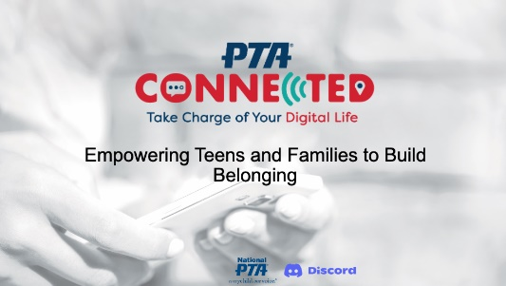 | Say: Welcome to the PTA Connected Build Up and Belong session! My name is {insert your name and PTA role.}  This session is part of the PTA Connected initiative which aims to connect families with tools, research, and support around digital parenting.  PTA has partnered with Discord to bring this session to life for families all across the nation.  {click to next slide}
Slide 2  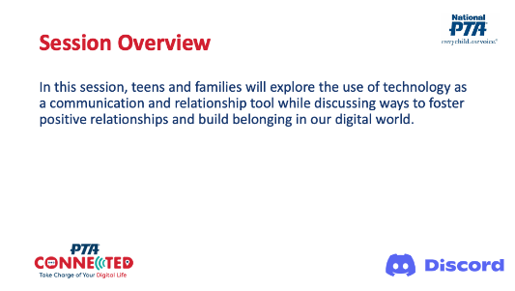 | Say: Now, more than ever, we live technology-rich lives. Many of us share the same ups and downs while navigating digital life. Though in some ways, teens and parents have very different experiences.  No matter our age, we lean on technology as a communication tool, and in this way, technology can also be considered a relationship tool.  Tonight we’ll explore the use of technology as a communication and relationship tool, and discuss ways to build belonging and have positive relationships in our digital world.  This will be an interactive session with lots of opportunities for us to talk to and learn from each other.  {click to next slide}
Slide 3  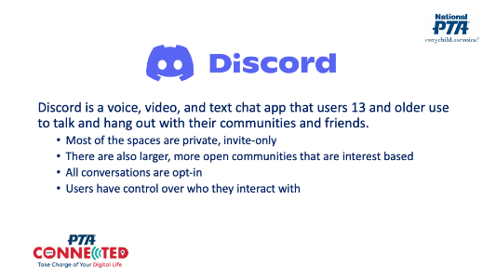 | Say: How many of you are familiar with the app, Discord?  {Ask participants to raise their hands. If participants are not familiar, this slide will introduce the app.}  Discord is a voice, video, and text chat app that users 13 and older use to talk and hang out with their communities and friends.  Most of the spaces…or what Discord calls “servers”…are private, invite-only channels for groups of people to stay in touch and spend time together.  There are also larger, more open communities that focus on specific topics like Minecraft or Fortnite. All conversations are opt-in, so users have control over who they interact with.  {click to next slide}
Slide 4  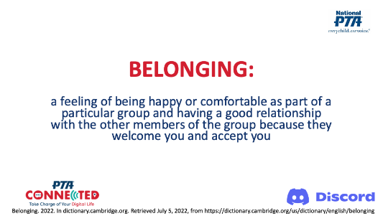 | Say: What do we mean by “belonging”?  According to the Cambridge Online Dictionary, belonging means: a feeling of being happy or comfortable as part of a particular group and having a good relationship with the other members of the group because they welcome and accept you.  When we use technology, the “other members of the group” may be people we know and love. We could also think about “the group” as all the people who share our digital spaces, whether we know them personally or not. It is up to group members to create a welcoming and accepting environment for all.  {click to next slide}
Slide 5  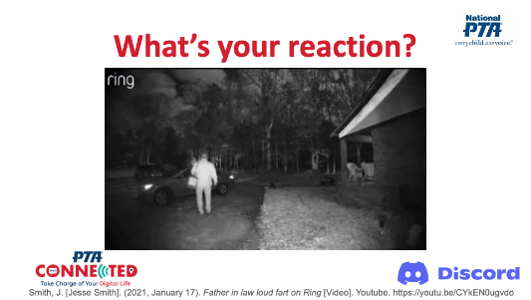 | Say: How many of you have a Ring Doorbell or similar technology that records what happens outside your home?  The Ring Doorbell has prompted some interesting and unexpected video footage. In fact, doorbell “bloopers” have popped up on TikTok and YouTube. Let’s look at one example.  {show video}  {Watch for audience reactions. Many participants will find the video amusing. You may also ask for a couple volunteers to share their thoughts/reaction.}  Like most of you, my first reaction was a mixture of surprise and humor. The man on camera didn’t know he was being recorded and felt free to let loose.  {click to next slide}
Slide 6  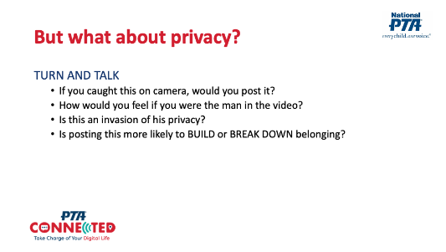 | Say: But what about this man’s privacy?  Turn to a partner and talk about these questions:  - If you caught this on camera, would you post it?  - How would you feel if you were the man in the video?  - Is this an invasion of his privacy?  - Is posting this more likely to build or break down belonging?  {Set the timer for 2 minutes.}  Say: Do I have any volunteers that want to share how they answered each of these questions?  {Read each question one at a time. Ask for a different volunteer to answer each question.}  {click to next slide}
Slide 7  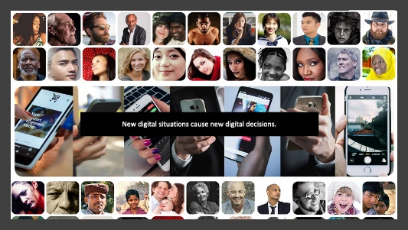 | Say: Technology changes the way we do things. Before the Ring Doorbell, we weren’t recording what people did on our front steps. But now, many of us do.  The new technology brings about new situations for us to think about. In this case, we now have to think about privacy and how our choices about what to share or not share impact relationships and belonging.  {click to next slide}
Slide 8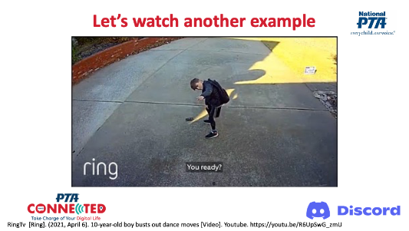 | Say: Now that we’re thinking about privacy, let’s watch one more video.  {show video}  {click to next slide}
Slide 9  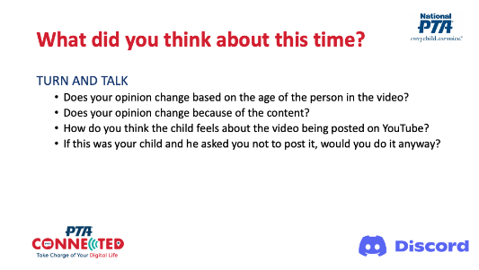 | Say: Turn and talk to your partner again:  - Does your opinion change based on the age of the person in the video?  - Does your opinion change because it’s cute dancing instead of embarrassing footage?  - How do you think the child feels about the video being posted on YouTube?  - If this was your child and he asked you not to post the video, would you do it anyway?  {set the timer for 2 minutes.}  Say: Do I have any volunteers that want to share how they answered each of these questions?  {Read each question 1 at a time. Ask for a different volunteer to answer each question.}  {click to next slide}
Slide 10  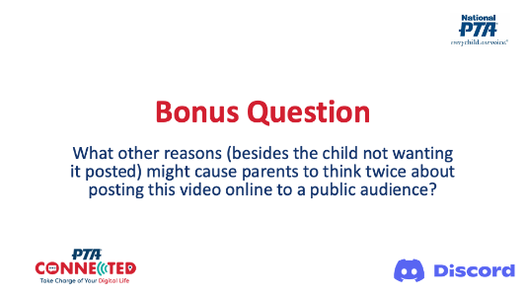 | Say: The child’s feelings are just one aspect to consider.  Can you think of other reasons that parents may think twice about posting this video online to a public audience?  {Call on a few participants to respond. They may say things related to online safety and keeping their child’s personal information and image private.}  {click to next slide}
Slide 11  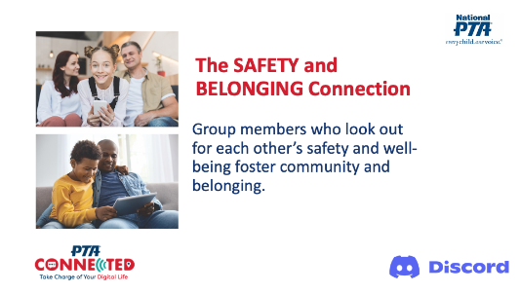 | Say: Safety and belonging go hand in hand because when group members look out for one another, it demonstrates a sense of community.  {click to next slide}
Slide 12  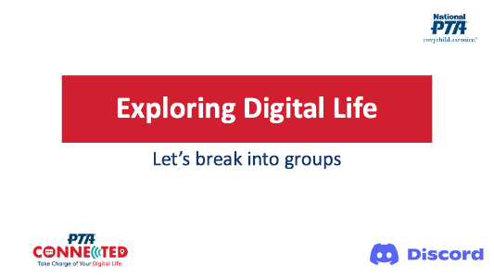 | Say: Navigating privacy, safety and community can be tricky, and technology can complicate things even further. At times, we can find ourselves having to make tough decisions.  We have a handout of tricky digital life scenarios - one for teens and one for adults. You will have a chance to work with a partner or two to decide what advice you would give the characters in each scenario. Teens, you’ll partner up with other teens. Parents, you’ll be with other parents. {Note: Depending on the number of attendees at the event, ask them to get into groups of 2-4.}  There are no right or wrong answers, but it is important to know why you decide what you do. You will have 20 minutes to discuss each of these scenarios.  {Set a timer for 20 minutes. Give people 2-minute and 1-minute warnings}  {Note: This activity includes 6 scenarios. Some groups may discuss all 6; others may only get to a few depending on how their conversations unfold. It’s not important for all groups to discuss all 6 scenarios. If groups finish very early, you can prompt them to further articulate their reasoning, or you can have them make up their own scenarios.}  {At the end of the 20 minutes, have families sit together again.}  {Click to next slide}
Slide 13  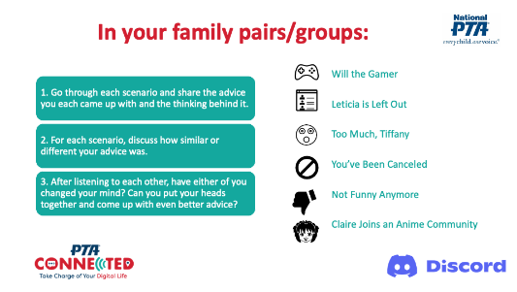 | Say: For the past 20 minutes, teens and adults have been looking at the same scenarios. Teens were asked to think about what advice they’d give a friend in each scenario, and parents were asked what advice they would give their teen in the same scenarios.  Now it’s time for family members to share the advice you came up with for each scenario. What’s most important about this discussion is explaining your thinking, especially when your advice is much different than the advice given by your family partner.  Listening to each other’s perspectives can help teens and parents to understand each other better and build trust in each other’s digital decision making.  - Go through each scenario and share the advice you each came up with and the thinking behind it.  - For each scenario, also discuss how similar or different your advice was.  - After listening to each other, have either of you changed your mind? Can you put your heads together and come up with even better advice?  You have 8 minutes for this discussion.  {Set the timer for 8 minutes.}  {At the end of 8 minutes, click to next slide.}
Slide 14 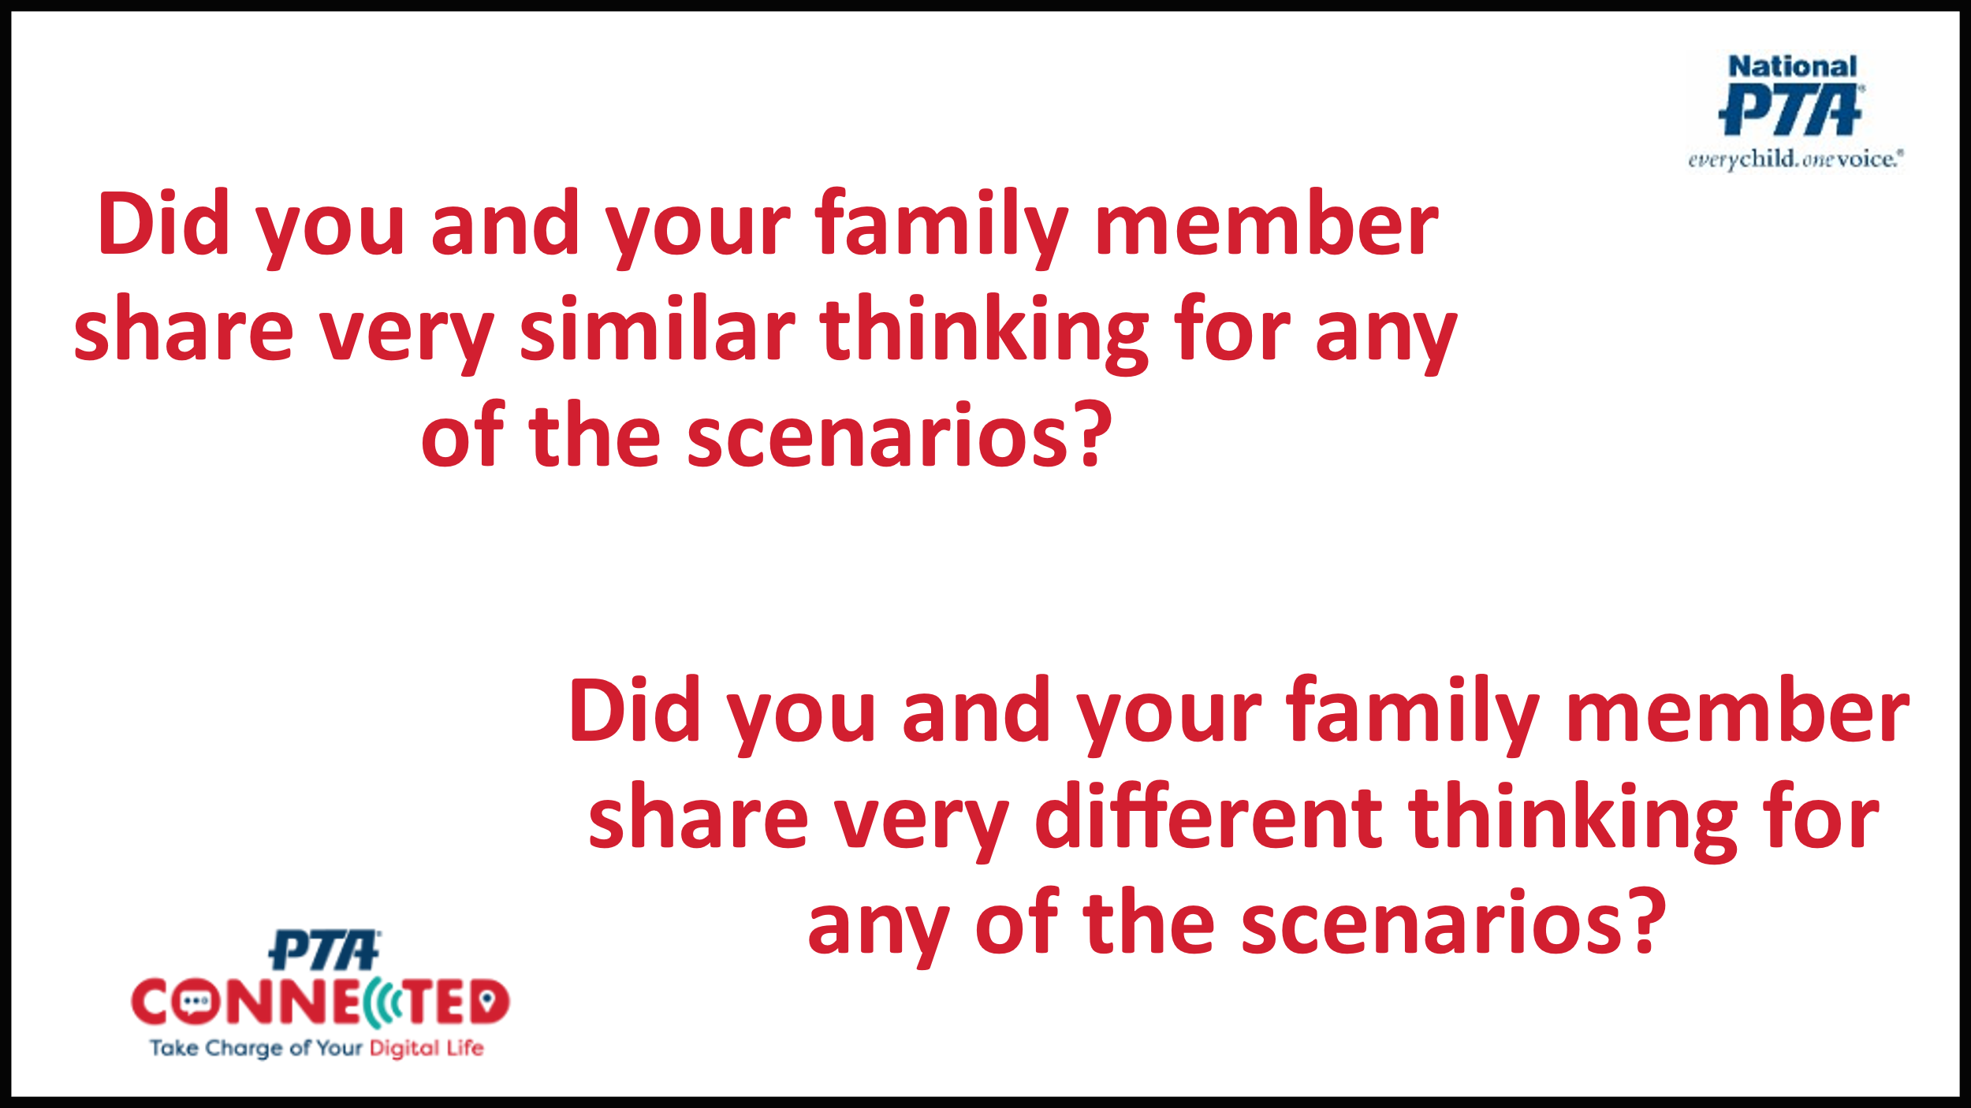 | Say: Were there any scenarios where you and your family member had very similar thinking? Does anyone want to share examples of this?  {Call on 1-3 volunteers to share.}  Say: Were there any scenarios where you and your family member had very different thinking? Does anyone want to share examples of this?  {Call on 1-3 volunteers to share.}  {click to next slide}
Slide 15  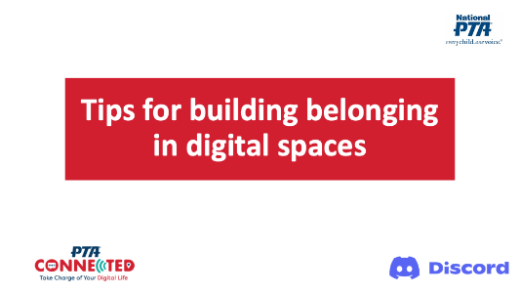 | Say: Next, we’re going to talk through some tips for building belonging in digital spaces.  {click to next slide}
Slide 16  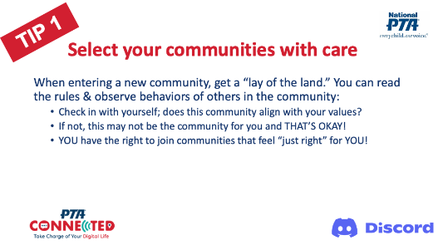 | Say: One of the scenarios featured a new student, Will, who joined an online game to make friends, but ended up feeling uncomfortable with racial slurs and derogatory language that other teens were using in the platform.  This scenario illustrates why it is important to select our communities with care.  When we engage in a new community, we can get a feel for it by first reading the rules and observing interactions for a while. We can ask ourselves how well it meets our needs and how comfortable we feel there. We don’t have to remain members of every community we try out. We get to CHOOSE what online spaces feel just right.  {click to next slide}
Slide 17  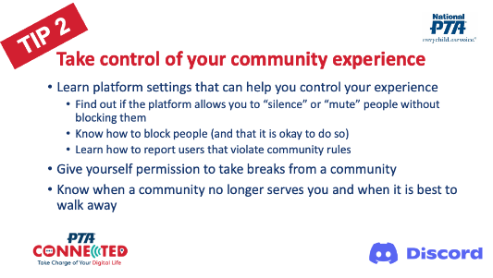 | Say: It’s also important to feel empowered to manage our community experience.  For example, we can use various settings that are built into platforms to hide content or block users. Some platforms allow us to identify content we don’t want to see. And almost every platform has a way to report users that violate community guidelines.  Deciding when to take breaks and when to walk away from communities that no longer serve us is also a way for us to take control of our community experience.  {click to next slide}
Slide 18  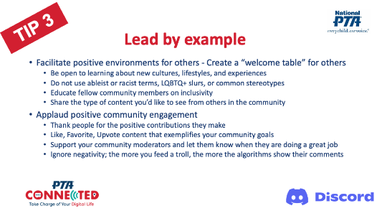 | Say: Another scenario that you reviewed featured Alex and Jaime who started an online community for friends to hang out and share some laughs. One of the community members began posting sensitive content that not everyone found funny.  Whether we are official community leaders, participants, or general social media users, we can all lead by example. We can be purposeful about how we welcome others through the language we use and the content we post. We can reflect on how our words and actions make members feel comfortable and promote a sense of belonging.  We can also reinforce other community members who are contributing in positive ways and sharing content that we like.  {click to next slide}
Slide 19  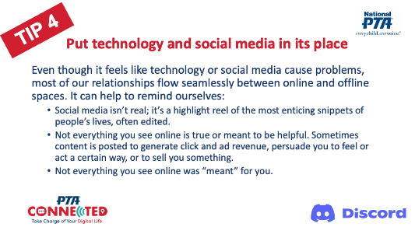 | Say: Sometimes technology and social media can make us feel bad. It happens to all of us, and it’s important that we don’t blame ourselves or make ourselves worse for feeling bad.  Putting social media in its place is a reminder that what we see online is often not real, not true, or not meant for us personally, even though it sometimes feels that way.  {click to next slide}
Slide 20  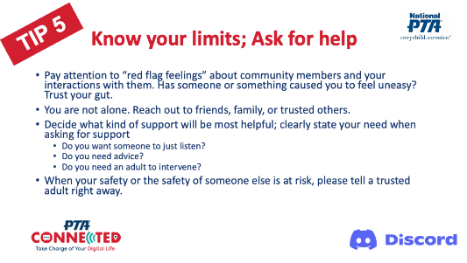 | Say: It is natural to want to solve our own problems. Adults and teens both struggle to ask for help even though we know others will support us. When we do lean on others, we should let them know if we need someone to simply listen, to give advice, or to intervene.  Who you go to for support may depend on the severity of the situation. In one of the scenarios, Claire received DMs from a new online friend and wasn’t sure how much to share with him. At this point, it might be okay to talk to a friend about it. But when the online friend got angry and threatened to come to Claire’s house, the situation became far more serious.  When anyone’s safety is at risk, trusted adults should be pulled in to help problem solve and contact proper authorities, as needed. Pay attention to your gut and trust those red flag feelings!  {click to next slide}
Slide 21  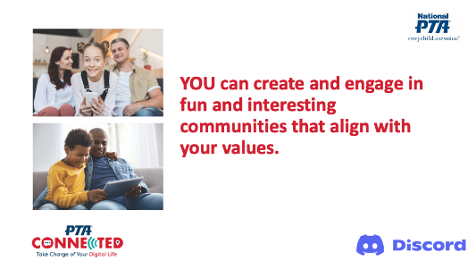 | Say: These tips are just a few that can help us feel empowered to create and participate in communities that are fun and engaging.  {Let families know they will receive a printout of these tips to take home, if applicable. They can also be emailed after the session.}  {click to next slide}
Slide 22  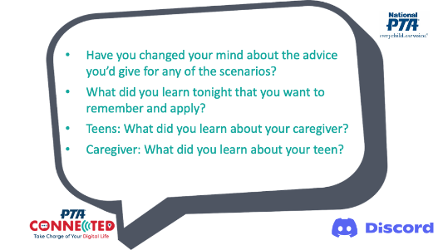 | Say: To wrap this up, let’s take three minutes to talk to our family member one more time:  - Have you changed your mind about the advice you’d give for any of the scenarios?  - What did you hear tonight that will be helpful to remember and apply?  - What is one thing you learned about each other?  {set the timer for 3 minutes.}  Say: Do I have any volunteers that want to share how they answered each of these questions?  {click to next slide}
Slide 23  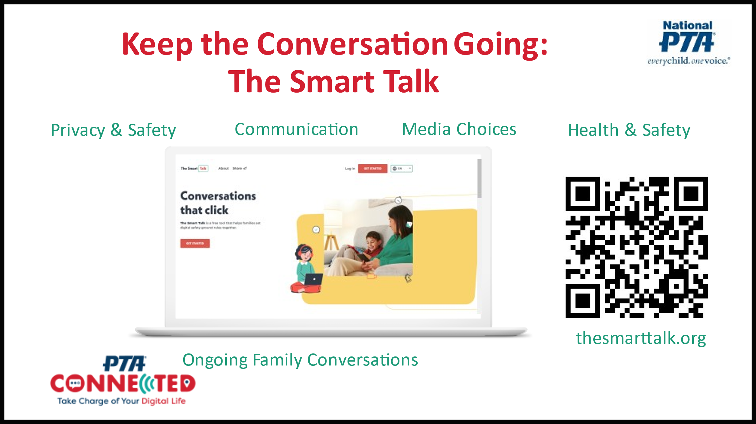 | Say: Hopefully this session helped open some lines of communication about digital life, but the conversation shouldn’t stop here!  For some of us, we need a reminder of the rules we set and maybe even some help to remember all the different aspects of online safety that we should be talking about. Having The Smart Talk helps families do this.  Developed in partnership between National PTA and Norton, The Smart Talk is another online tool that helps parents and caregivers have proactive, positive conversations with their kids. Using a series of guided questions, this online tool allows kids ages 5-18 to actively participate in setting limits around device use, digital safety, privacy, communication, health and wellness, and media choices.  The end result is a personalized family technology agreement that is created based on individual responses.  Go to smarttalk.org or click on the QR code here to get to the site. We’ll also send the link in an email after this session.  {click to next slide}
Slide 24  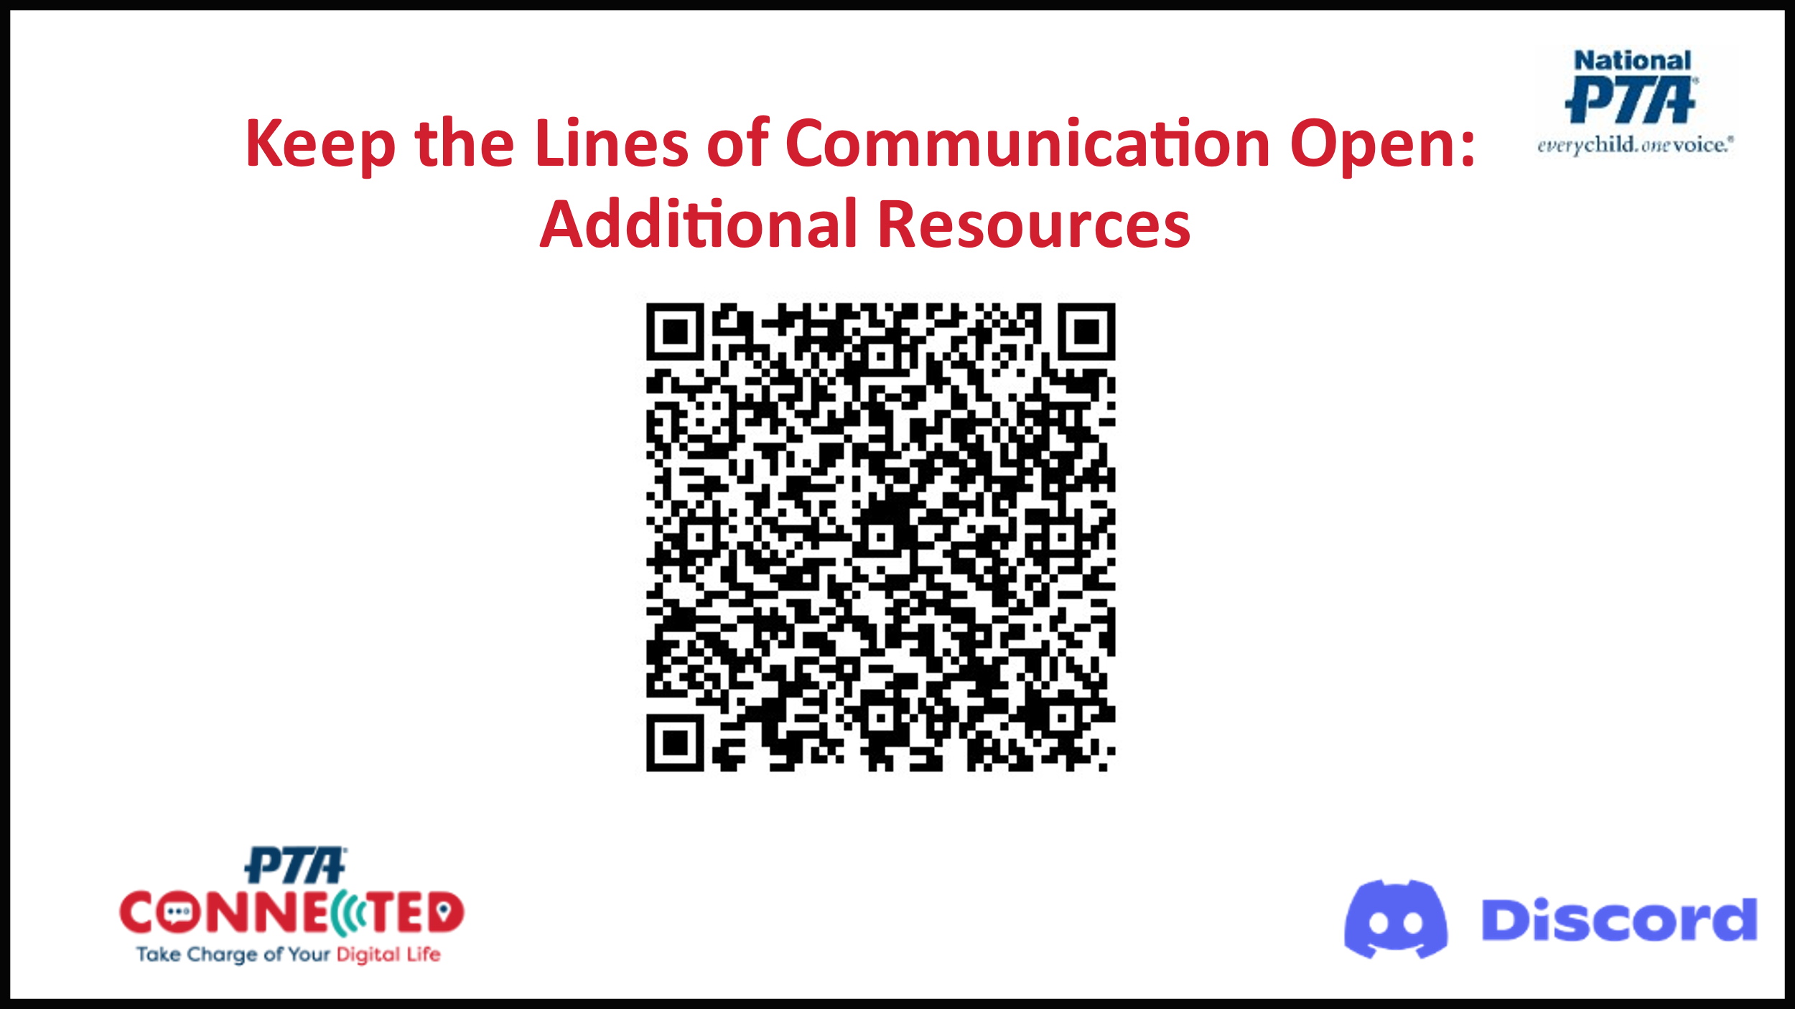 | Say: We’ve put together a list of additional resources to keep you learning and talking as a family. You can click on this QR code to see them now. We will also be emailing them to all participants after this session.  {click to next slide}
Slide 25 | Say: We hope this session has given everyone a lot to think about in terms of digital communication, relationships, and belonging.  This concludes our Build Up and Belong session.  - Call to action: Start today fostering positive relationships and building belonging in our digital world.  - Share information about any upcoming technology sessions/events/activities  - Ask everyone to complete evaluation. {Note: participants can click on the QR code to access the survey, or it can be emailed after the session.}  Thank you so much for coming!

