Student Handout for the Healthy Hydration Program

Materials Needed

Sugary Beverage Activity | Sugary beverage cut-outs of the different beverages.  ½ pound of granulated sugar  5 Clear cups  A measuring teaspoon  Nestlé® Pure Life® water bottle
Infused Water Activity | Water in a cup or pitcher  Any fruit you have in the house  A knife  A plate or cutting board

Facts About Water
Only 50% of kids aged six to 19 are getting enough water.
The human body is composed of about 60% water on average, and almost every major system in the body depends on it. The percentage of water in your body depends on age. Children are composed of more water than adults, and as we age, the percentage decreases.
Children are active! They are always on the move, from school to dance lessons to soccer practice and more. When they sweat, they are losing water. We lose water in many other ways, like breathing and going to the bathroom. In order to keep our bodies regulated, we need to replenish the water we’ve lost.
Drinking enough water does more than just satisfy your thirst. Water keeps our bodies running efficiently!
Other fun facts: babies have more water than adults, and elderly people have less water composition than the average adult! Also, all cells require water to survive, and cells make up different systems in the body, therefore water helps all systems in the body.

Why is it important to drink water?

How much sugar is in our beverages?

This is a demonstration to learn all about the sugar that can be in our beverages. Below are the directions and materials for the activity. In addition, there are questions and additional fun facts.

Directions
- Label and cut the graphics for each plastic cup with the following:
  - Soda/pop
  - Orange juice
  - Energy drink
  - Chocolate milk
  - Water
- Measure into each cup the amount of sugar for that type of beverage.
- Guess which cup matches the correct sugary beverage.

Materials
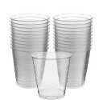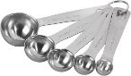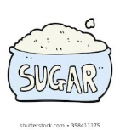

½ pound of granulated sugar
5 clear cups
1 measuring teaspoon
1 bottle of Nestlé® Pure Life® water
Sugary Beverage Cut-Outs

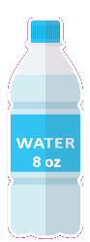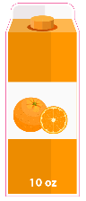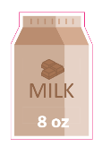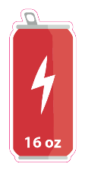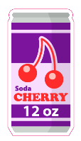
Questions
What surprised you?

What did you notice about the amount of sugar in the beverages?

Which beverage do you drink the most? Does this activity change the way you think about sugar sweetened beverages? Are there changes your family should make?

Did you know?
- Drinking just one sugar sweetened beverage per day often meets or exceeds the daily recommended added sugar limit.
- Sugar-sweetened beverages provide few or no key nutrients and are full of empty calories. They don’t provide any key nutrients your body needs.
- Water has zero added sugar, so it is a great alternative to sugar-sweetened beverages.

Water Tracker
Here is a water tracker for your family. Hang it on your refrigerator and then track how much water you and your family drink every day. It's important to drink water throughout the day. Consult with your health care provider to calculate your daily hydration needs. How many cups do you drink? Feel free to draw more cups if needed.

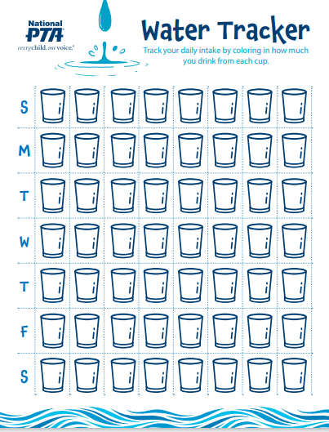

Fruit Infused Water
Make fruit infused water. It is a delicious way to help you drink water throughout the day!

Directions:
- Cut up the fruit
- Put it in the water
- Enjoy!

Ingredients:
- Water in a cup or pitcher
- Any fruit you have in the house
- A cutting board and a knife
Choice Board

Use this board on the following page to discuss ways to hydrate as a family. Put this page on your refrigerator or in another high-traffic area of your home. As a family, discuss what you want to do and how you want to do it. You should complete six out of the eight choices below in the next two weeks. There may be prizes for completion!

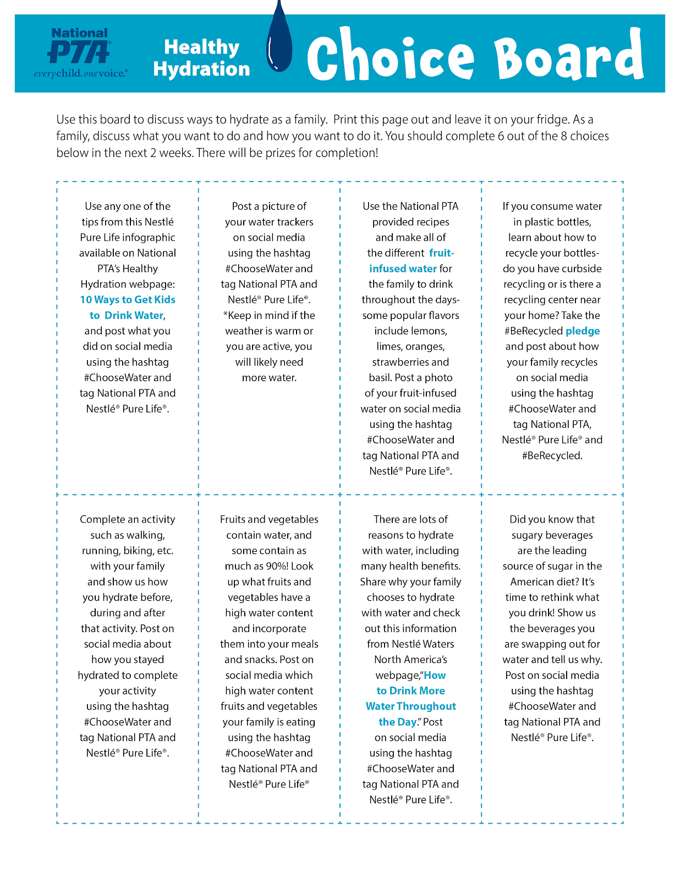What Changes Do You and Your Family Want to Make?

What did you drink yesterday? Did you drink water throughout the day yesterday?

What did you drink today? Did you drink water throughout the day today? How much water did you drink?

How do you want to make sure that you drink more water during the day?

What do you need to do to make sure that you drink more water during the day?

What can you do to make sure water is the easy choice throughout the day?

How is your family planning to instill long-lasting healthy habits?

Let’s Get Moving
Part of healthy living is exercise. Commit to taking 20 minutes every day as a family and get moving. It is important to exercise and make sure that you stay hydrated by drinking water before, during and after exercising.

- Grab your shoes! Walk around the neighborhood.
- Grab your helmet! Bike around the neighborhood.
- Blast your music! Dance in your room. Upload a video!
- Put on gloves! Go on a recycling walk! Pick up any recyclables you see!

Additional Recipes

Strawberry Basil Infused Water
Serving size: 15-20
- 18-24 sliced strawberries
- 3 cups of basil leaves
- 1 gallon of cold water
- Ice
Mix ingredients in a 1-gallon pitcher 1-2 hours before serving.

Cucumber Mint Infused Water
Serving size: 15-20
- 1 cup fresh mint leaves
- 1.5 cucumbers, peeled and thinly sliced
- 1 gallon of cold water
- Ice

Mix ingredients in a 1-gallon pitcher 1-2 hours before serving.
Tips:
- For more flavor, gently mash some of the mint with a wooden spoon.
- Lemon and lime are tasty additions to this recipe.

