Caretaker Guide to Participating in the Healthy Hydration Program at Home

This guide will help you lead your family through this Healthy Hydration program. You can give the “Student Guides” to your children to do alongside you (they’re more like worksheets!)

Program Goals

- Explore the important role water plays in our lives.
- Encourage children and families to explore and make healthy lifestyle changes.
- Make drinking water fun!

Table of Contents
- Table of Contents
- Facts About Water
- How much sugar is in our drinks?
- Water Tracker
- Fruit Infused Water
- Choice Board
- What Changes Do You and Your Family Want to Make?
- Let’s Get Moving
- Additional Recipes
- Sugary Beverage Cut-Outs

Frequently Asked Questions for Caretakers
What is included in this guide?
In this guide, you will find resources to use as you facilitate this program. Included are instructions for the fruit-infused water and the sugary beverage demonstration, the choice board, and the link to the Water Tracker handout.

As a family, you can learn about healthy hydration and the importance of choosing water. In addition, there is a handout for your children to use to follow along. In the handout, you will find blank spaces for your family to write about what they have learned and to answer questions.

How should I facilitate this event for my family?
This program is an opportunity for your family to learn about the importance of drinking water and maintaining a healthy lifestyle. In this program, each family will learn the importance of healthy hydration, make fruit-infused water, participate in a sugary beverage demonstration, explore a choice board and engage in a health-related movement activity.

This guide has all materials and resources for each part of the program. Each family does not need to follow this guide in the order that the guide is written—the activities can be done in any order.

In addition, for the sugary beverage demonstration, there is a video, see here: Sugary Beverage Video. You can watch the video as a family instead of conducting the sugar demonstration. Or, as the caretaker, you can watch the video to familiarize yourself with the demonstration that you can do with your children. The video is a resource for you to use.

Should I let my child conduct the activities?
Each activity is designed for children to do with your family, so everyone should be involved!

How long will this take?
This program can be completed in the timeframe that works best for you. Each family can go through the whole program at once, which will take about 45 minutes. Alternatively, a family can do each activity in this program over multiple days.

How do I share pictures/videos of my family participating?
While you are conducting the activities, make sure to take lots of pictures and videos. You have a couple of options for sharing these pictures/videos. You can email them to your local PTA—if you choose this option, you must also send a signed media release form (template here: Media Release Form). This allows the PTA to share these pictures/videos publicly and with National PTA. Or you can post the pictures/videos on social media and tag your PTA—in this case, you don’t need to submit a signed media release form for your PTA to be able to share them publicly and with National PTA.

How can I share other feedback?
You are asked to complete a participant survey at PTA.org/Survey to share your experience. This will help both your local PTA and National PTA improve these types of programs.

Where can I find additional resources?
In addition to the program, there are recipes for fruit-infused water beverages included. You can also find the link to the Water Tracker handout here: Water Tracker.

Materials Needed

Sugary Beverage Activity | Sugary beverage cut-outs of the different beverages. These can be found at the end of this guide.  ½ pound of granulated sugar  5 Clear cups  A measuring teaspoon  Nestlé® Pure Life® water bottle
Infused Water Activity | Water in a cup or pitcher  Any fruit you have in the house  A knife  A plate or cutting board

Facts About Water
Only 50% of kids aged six to 19 are getting enough water.
The human body is composed of about 60% water on average, and almost every major system in the body depends on it. The percentage of water in your body depends on age. Children are composed of more water than adults, and as we age, the percentage decreases.
Children are active! They are always on the move, from school to dance lessons to soccer practice and more. When they sweat, they are losing water. We lose water in many other ways, like breathing and going to the bathroom. In order to keep our bodies regulated, we need to replenish the water we’ve lost.
Drinking enough water does more than just satisfy your thirst. Water keeps our bodies running efficiently!
Other fun facts: babies have more water than adults, and elderly people have less water composition than the average adult! Also, all cells require water to survive, and cells make up different systems in the body, therefore water helps all systems in the body.

Ask your family: Why is it important to drink water?

Possible answers: Because our bodies need water. Most kids aren’t getting enough water. Most of the systems in our body depend on water. When we sweat, we need to replenish what we lose.

How much sugar is in our beverages?
This is a demonstration to learn all about the sugar that can be in our beverages. Below are the directions and materials for the activity. In addition, there are questions and additional fun facts. Alternatively, there is a video you can watch to learn about how much sugar is in each of the beverages that we drink!
Directions
- Print the sugary beverage graphics (found at the end of this guide). This can be done before your family gathers to do this activity.
- Label and cut the graphics for each plastic cup with the following:
  - Soda/pop
  - Orange juice
  - Energy drink
  - Chocolate milk
  - Water
- Measure the amount of sugar for that type of beverage into each cup.
- Have your family guess which cup matches the correct sugary beverage.

Materials
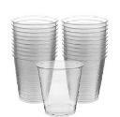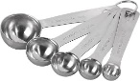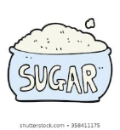

- ½ pound of granulated sugar
- 5 clear cups
- 1 measuring teaspoon
- 1 bottle of Nestlé® Pure Life® water
- Sugary Beverage Cut-Outs
Measurements
- Soda/pop – 12 oz can; 10 tsp (30 grams)
- 100% orange juice – 10 oz serving; 7 tsp (28 grams)
- Energy drink – 16 oz can; 13.5 tsp (54 grams)
- Chocolate milk – 8 oz box; 5.5 tsp (22 grams)
- Water – 8 oz bottle, 0 grams

*Measurement Guidelines: 4 grams of sugar = 1 teaspoon
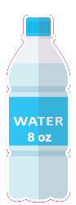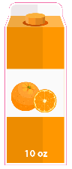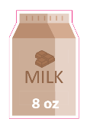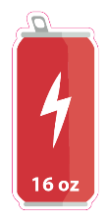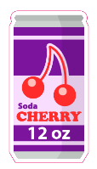

Questions
What surprised you?

Potential answers: Water has no sugar, there is a lot of sugar in other drinks, soda has the most sugar.

What did you notice about the sugar amounts in the beverages?

Potential answers: Soda has the most sugar, juice has a lot of sugar, even chocolate milk has sugar.

Which beverage do you drink the most? Does this activity change the way you think about sugar sweetened beverages? Are there changes your family should make?

Share these facts: Did you know?
- Drinking just one sugar sweetened beverage per day often meets or exceeds the daily recommended added sugar limit.
- Sugar-sweetened beverages provide few or no key nutrients and are full of empty calories. They don’t provide any key nutrients your body needs.
- Water has zero added sugar, so it is a great alternative to sugar-sweetened beverages.
Water Tracker
Here is a water tracker for your family– open this link Water Tracker. You can see a sample below. Print it out, hang it on your refrigerator and then track how much water you and your family drink every day. It's important to drink water throughout the day. Consult with your health care provider to calculate your daily hydration needs. How many cups do you drink? Feel free to draw more cups if needed.

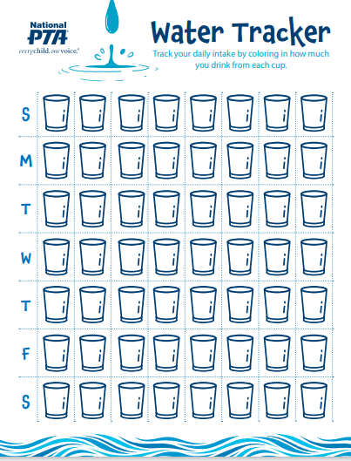

Fruit Infused Water
Make fruit infused water. It is a delicious way to help you drink water throughout the day!

Here is a video link to watch about fruit infused water: https://youtu.be/vpJ0p8GaXaQ

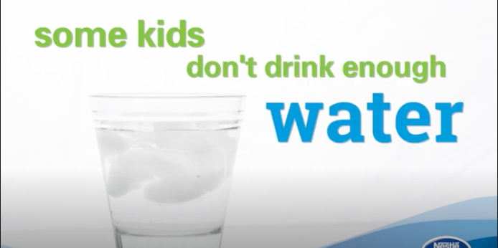
Directions:
- Cut up the fruit
- Put it in the water
- Enjoy!

Ingredients:
- Water in a cup or pitcher
- Any fruit you have in the house
- A cutting board and a knife
Choice Board

Use the board on the following page to discuss ways to hydrate as a family. Print this page and leave it on your refrigerator. As a family, discuss what you want to do and how you want to do it. You should complete six out of the eight choices below in the next two weeks. There may be prizes for completion!

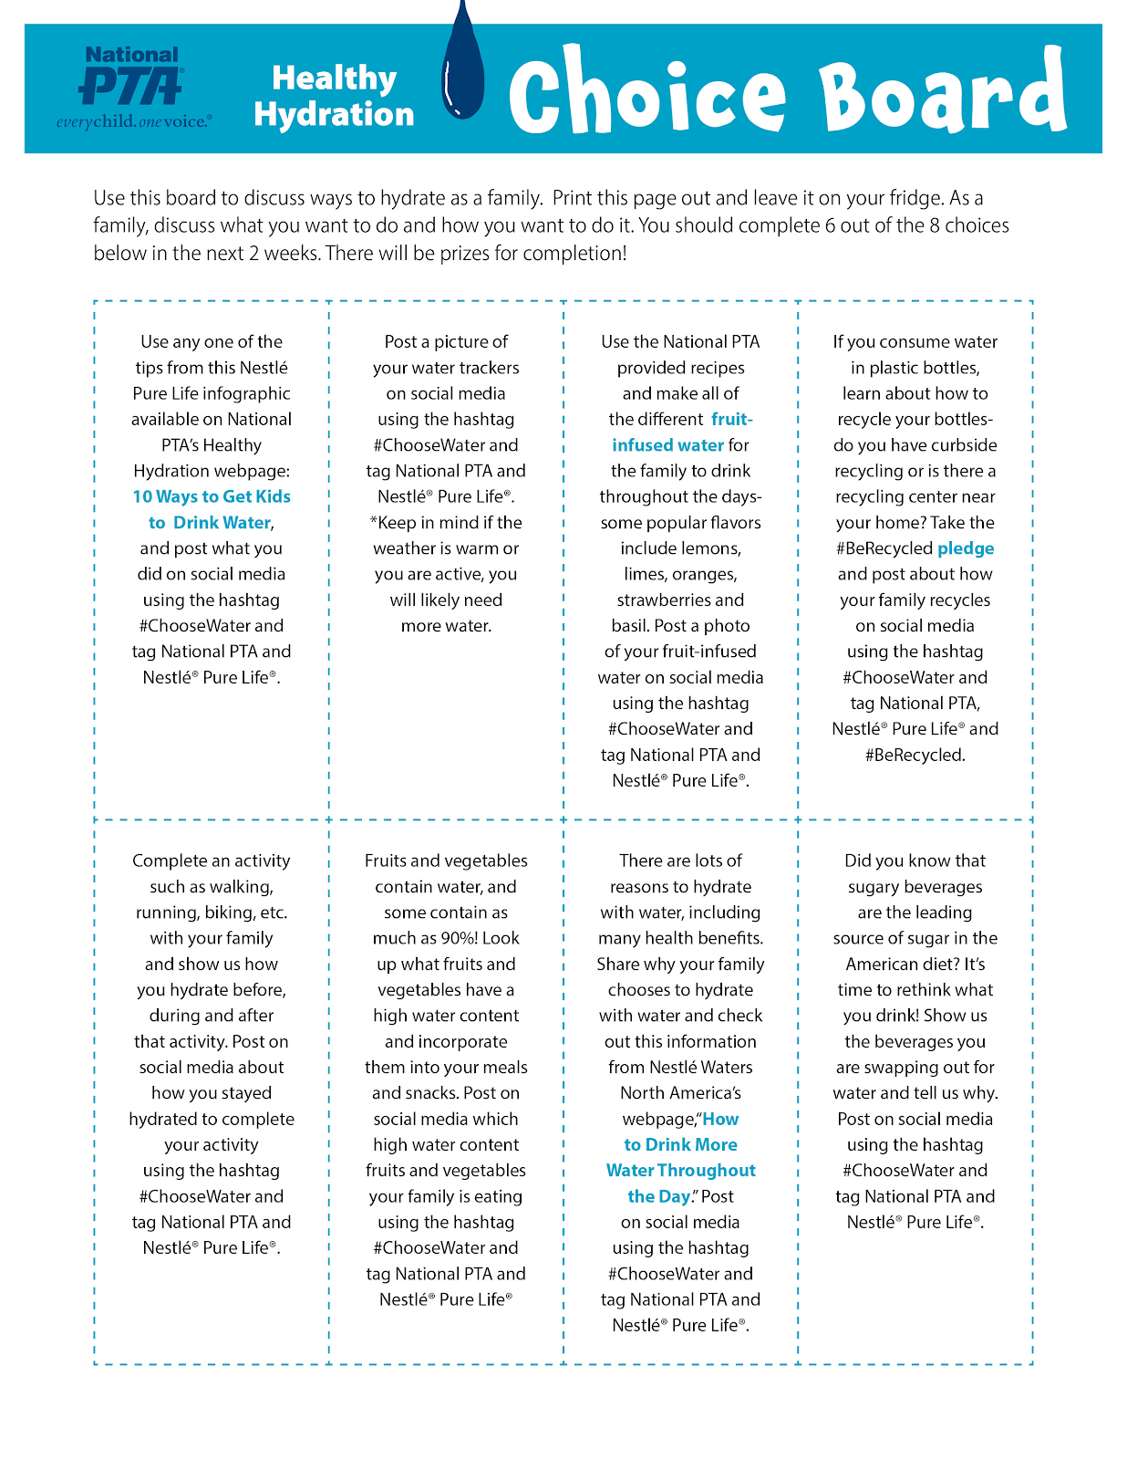

What Changes Do You and Your Family Want to Make?

Have conversations with your family about your drinking habits. Ask the following questions (your children can write their answers on their handout).

- What did you drink yesterday? Did you drink water throughout the day yesterday?
- What did you drink today? Did you drink water throughout the day today? How much water did you drink?
- How do you want to make sure that you drink more water during the day?
- What do you need to do to make sure that you drink more water during the day?
- What can you do to make sure water is the easy choice throughout the day?
- How is your family planning to instill long-lasting healthy habits?

Let’s Get Moving
Part of healthy living is exercise. Commit to taking 20 minutes every day as a family and get moving. It is important to exercise and make sure that you stay hydrated by drinking water before, during and after exercising.

- Grab your shoes! Walk around the neighborhood.
- Grab your helmet! Bike around the neighborhood.
- Blast your music! Dance in your room. Upload a video!
- Put on gloves! Go on a recycling walk! Pick up any recyclables you see!

Additional Recipes

Strawberry Basil Infused Water
Serving size: 15-20
- 18-24 sliced strawberries
- 3 cups of basil leaves
- 1 gallon of cold water
- Ice

Mix ingredients in a 1-gallon pitcher 1-2 hours before serving.

Cucumber Mint Infused Water
Serving size: 15-20
- 1 cup fresh mint leaves
- 1.5 cucumbers, peeled and thinly sliced
- 1 gallon of cold water
- Ice

Mix ingredients in a 1-gallon pitcher 1-2 hours before serving.
Tips:
- For more flavor, gently mash some of the mint with a wooden spoon.
- Lemon and lime are tasty additions to this recipe.

Sugary Beverage Cut Outs

