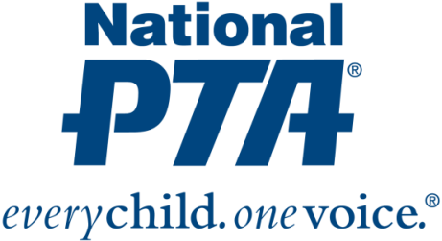
{Insert PTA Logo}

Contact:
{Insert Name and Contact Info}

{NAME OF PTA} Awarded Grant to Engage Families in Physical Education

{City, State} (Date)—National PTA and Goya-Move have awarded {Name of PTA} with a $1,000 grant to host a “Get Off Your Apps” physical activity event for {Name of city} children and families. {Name of PTA} is one of only 15 local PTAs nationwide selected to receive a grant. The grant recognizes {Name of PTA’s} leadership and commitment to helping families build more active, healthy lifestyles.

“While technology has opened up a world of opportunities and has many benefits, it is important that families spend time away from their devices and participate in physical activity. Physical activity and physical education are essential to student success and to set the stage for children for a healthy lifestyle into adulthood,” said Jim Accomando, president of National PTA. “We are pleased to recognize the efforts and dedication of {Name of PTA} and provide the association with resources to engage families in fun, physical activities and games to inspire active, healthy living.”

During the “Get Off Your Apps” physical activity event, {Name of PTA} will {Insert activities to be conducted}.

{Insert quote from PTA President or school principal about the event, grant and importance of this effort.}

The “Get Off Your Apps” event and grant program are part of National PTA’s Healthy Lifestyles initiative. The initiative provides PTAs with education and tools to partner with schools and advocate for healthy changes in physical activity and nutrition. In a healthy school:
- All students have opportunities to be physically active on a regular basis.
- All students have access to regular physical education.
- All foods, beverages and snacks sold or served meet National School Nutrition Standards.
- District-wide wellness policies are developed, implemented and evaluated with input from students, parents, staff and interested community members.

For more information about National PTA’s Healthy Lifestyles initiative, visit PTA.org/HealthyLifestyles.

About PTA
PTA® comprises of families, students, teachers, administrators and business and community leaders devoted to the educational success of children and the promotion of family engagement in schools. PTA is a registered 501(c)(3) nonprofit association that prides itself on being a powerful voice for all children, a relevant resource for families and communities, and a strong advocate for public education. Membership in PTA is open to anyone who wants to be involved and make a difference for the education, health and welfare of children and youth. For more information, visit PTA.org.

