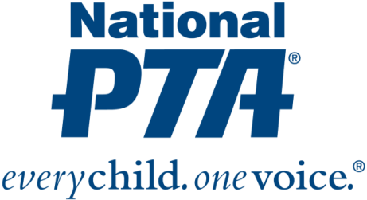
{Insert PTA Logo}

*MEDIA ADVISORY*
{Name of PTA School} to Participate in Family Reading Experience

WHAT:
{Name of PTA} will participate in National PTA’s Family Reading Experience to celebrate National Reading Month. National PTA has partnered with Reading Is Fundamental (RIF) to provide interactive reading activities to engage the whole family.
{Name of PTA} is committed to strengthening family engagement and building family-school partnerships to support student success and school improvement efforts.

WHY:
A recent study shows that one-third of public school fourth graders score below basic levels on reading exams and two-thirds of low-income families in the U.S. have no age appropriate books in their homes for children. Children develop a love of reading when parents are consistently involved, especially children between the ages of 7-11 who are graduating from picture books to chapter books. At this age they are beginning to explore everything that reading has to offer. In fact, parental involvement and access to books has a greater impact on kids’ reading skills than household income.

WHEN:
{Day and time of Family Reading Experience}

WHERE:
{Name and address for location(s) of event}

WHO:
{List key attendees, such as PTA, school, district and community leaders}

CONTACT:
{Name and contact information for PTA}

About PTA
PTA® comprises of families, students, teachers, administrators and business and community leaders devoted to the educational success of children and the promotion of family engagement in schools. PTA is a registered 501(c)(3) nonprofit association that prides itself on being a powerful voice for all children, a relevant resource for families and communities, and a strong advocate for public education. Membership in PTA is open to anyone who wants to be involved and make a difference for the education, health and welfare of children and youth. For more information, visit PTA.org.

