#PTABackToSchool
SOCIAL MEDIA TOOLKIT

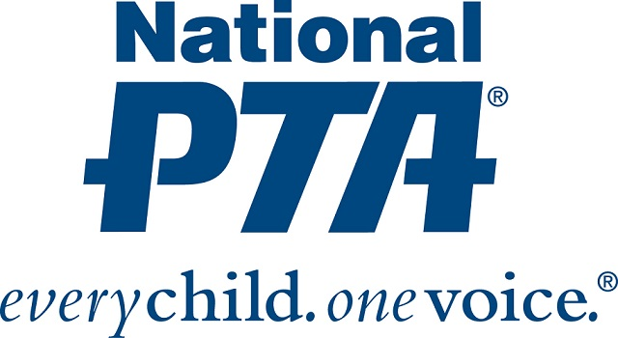

CAMPAIGN CONCEPT
Mission:
National PTA has partnered with Office Depot for a back to school campaign that climaxes the week of September 17th through September 21st. Each day will be designated a theme with Monday as “PTA Leader Day,” Tuesday as “Parent Day,” Wednesday as “Student Day,” Thursday as “Teacher Day” and Friday as “National PTA/Office Depot Day.” The goal is to provide valuable information and resources to PTA leaders, parents, students and teachers that will have a positive effect on their new school year.
Social Media Plan:
The hashtag for this campaign is #PTABackToSchool and it should be used on all posts related to the campaign. National PTA will be posting about #PTABackToSchool prior to September 17th and at high frequency the week of September 17th. We encourage everyone, regardless if they are affiliated with PTA or not, to support the campaign with their own positive messaging and resources using the hashtag #PTABackToSchool. The following pages will also offer some sample messaging and graphics that can be used.
Rules:
1.) All posts connected to the #PTABackToSchool campaign must be abstained of vulgar language or negativity.
2.) All posts connected to the #PTABackToSchool campaign must be aligned with the mission.
3.) All posts connected to the #PTABackToSchool campaign that use any of the provided graphics with Office Depot’s logo on it must mention Office Depot as a National PTA Sponsor. On Facebook and Instagram please use the partnership feature to do this and list Office Depot.

PTA LOCAL LEADERS
Twitter and Instagram Posts:
Parents! @NationalPTA has what you REALLY need this school year! From shopping guides and healthy eats to parent-teacher conference tips. It’s all available at PTA.org/BackToSchool #PTABackToSchool

Teachers! @NationalPTA has what you REALLY want this school year! From family engagement tips to school safety guidelines, it’s all at PTA.org/BackToSchool #PTABackToSchool

Monday, September 17th Only!
INSTAGRAM TAKEOVER!!! PTA leaders, share or comment on Instagram about your #PTABackToSchool experience.
@NationalPTA might even repost you! Don’t forget the hashtag #PTABackToSchool

Tuesday, September 18th Only!
FACEBOOK TAKEOVER!!! Hey Parents, share your amazing back to school moments with @NationalPTA on Facebook by using the hashtag #PTABackToSchool. @NationalPTA might even repost you especially if you’re using the “PTA B2S” Facebook Frame!

Wednesday, September 19th Only!
MEME-a-THON!!! Today @NationalPTA will post some hilarious #PTABackToSchool related memes. Enjoy and be sure to check out PTA.org/BackToSchool

Thursday, September 20th Only!
THROWBACK THURSDAY!!! Big hair, old school wear and “back in my day” everywhere! @NationalPTA wants to see your #tbt back to school pictures from past years. Tag @NationalPTA and #PTABackToSchool so they can repost you!

Friday, September 21st Only!
Take an active role in your child’s education. Join and/or donate to @NationalPTA! #PTABackToSchool PTA.org

PTA LOCAL LEADERS
Facebook Posts:
Parents! National PTA has what you REALLY need this school year! From shopping guides and healthy eats to parent-teacher conference tips. It’s all available at PTA.org/BackToSchool #PTABackToSchool

Teachers! National PTA has what you REALLY want this school year! From family engagement tips to school safety guidelines, it’s all at pta.org/PTABackToSchool #PTABackToSchool

Monday, September 17th Only!
INSTAGRAM TAKEOVER!!! PTA leaders, share or comment on Instagram about your #PTABackToSchool experience. National PTA might even repost you! Don’t forget the hashtag #PTABackToSchool

Tuesday, September 18th Only!
FACEBOOK TAKEOVER!!! Hey Parents, share your amazing back to school moments with National PTA on Facebook by using the hashtag #PTABackToSchool. National PTA might even repost you especially if you’re using the “PTA B2S” Facebook Frame like me!

Wednesday, September 19th Only!
MEME-a-THON!!! Today National PTA will post some hilarious #PTABackToSchool related memes. Enjoy and be sure to check out PTA.org/BackToSchool

Thursday, September 20th Only!
THROWBACK THURSDAY!!! Big hair, old school wear and “back in my day” everywhere! National PTA wants to see your #tbt back to school pictures from past years. Tag National PTA and #PTABackToSchool so they can repost you!

Friday, September 21st Only!
Take an active role in your child’s education. Join and/or donate to National PTA! #PTABackToSchool PTA.org

GRAPHICS
Facebook Frame:

Step 1:
Go to www.facebook.com/profilepicframes

Step 2:
Search “PTA B2S”

Step 3:
Select the frame by “Darrell Pta”

Step 4:
Click “Use as Profile Picture”

Step 5:
Tag National PTA

GRAPHICS
Twitter or Facebook Any Day:
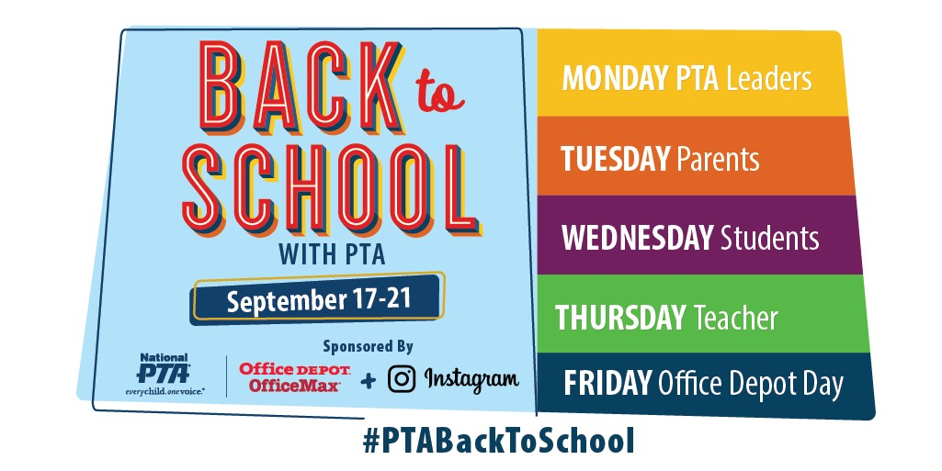
GRAPHICS
Instagram Any Day:
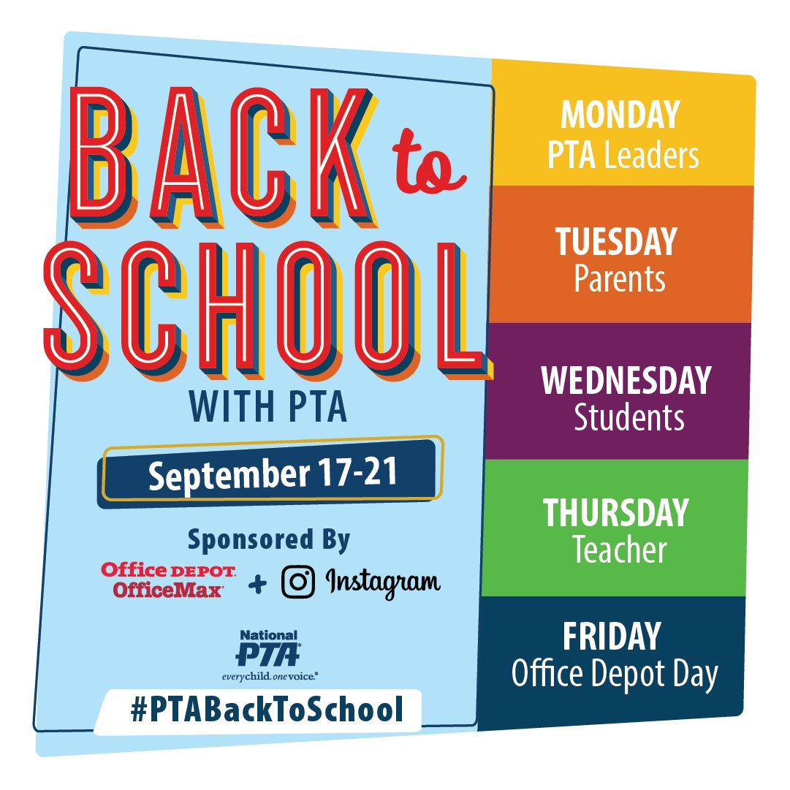
GRAPHICS
Twitter or Facebook September 17th:

GRAPHICS
Instagram September 17th:

GRAPHICS
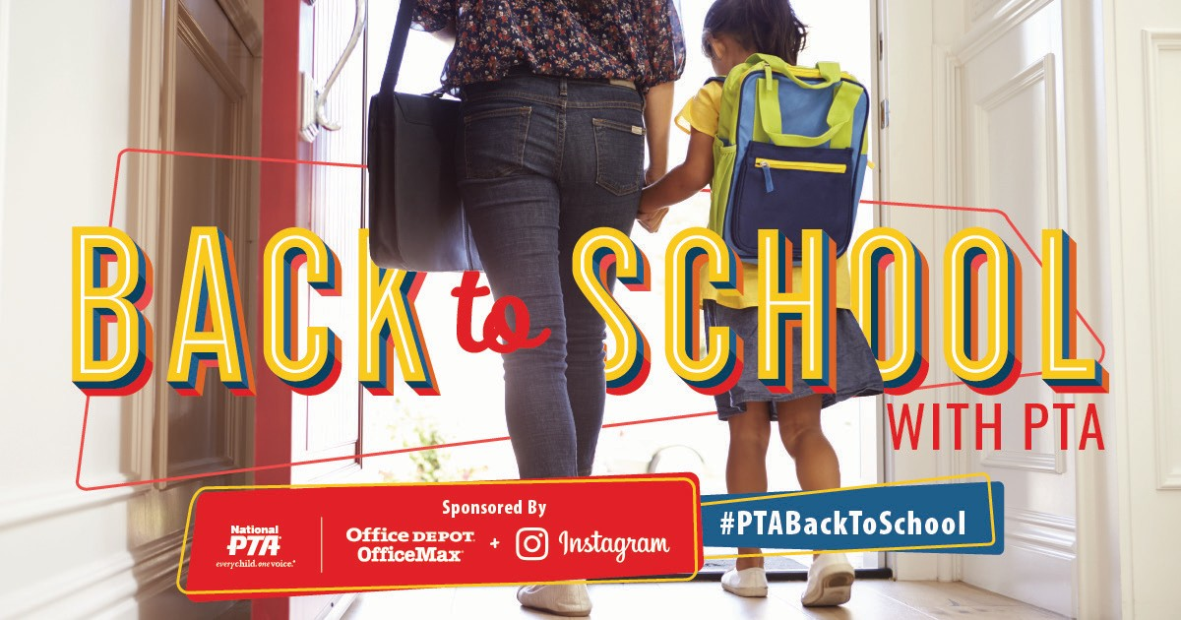
Twitter or Facebook September 18th:

GRAPHICS
Instagram September 18th:

GRAPHICS
Twitter or Facebook September 19th:
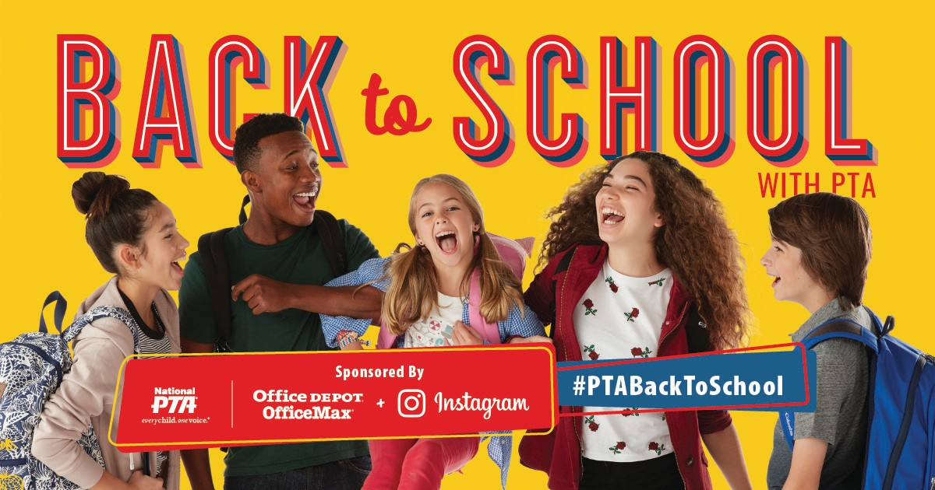
GRAPHICS
Instagram September 19th:

GRAPHICS
Twitter or Facebook September 20th:
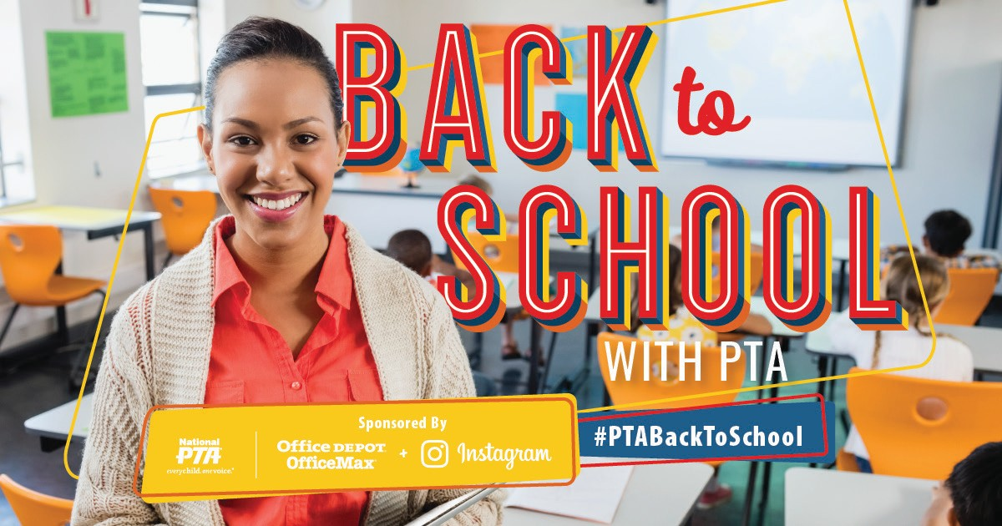
GRAPHICS
Instagram September 20th:

