Season 3, Episode 34: Inside the Principal’s Office
with Dr. Tayarisha Batchelor

Overview
Below are sample social media posts, a newsletter blurb and graphics you can use to promote episode 34 of National PTA’s Notes from the Backpack podcast. If you create your own social media posts, please tag National PTA and/or use the podcast hashtag #BackpackNotes. Thank you for your support and for helping us promote season 3 of the podcast!

Facebook
The new episode of National PTA’s Notes from the Backpack podcast features a principal’s perspective on fostering family engagement during COVID-19.

Listen to the conversation with Dr. Tayarisha Batchelor, principal of @Rawson STEAM school in Hartford, Conn. PTA.org/PodcastEp34 #BackpackNotes

LinkedIn
The new episode of National PTA’s Notes from the Backpack podcast features a principal’s perspective on fostering family engagement during COVID-19.

Listen to the conversation with Dr. Tayarisha Batchelor, principal of Rawson STEAM school in Hartford, Conn. PTA.org/PodcastEp34 #BackpackNotes

Twitter
The new episode of @NationalPTA’s #BackpackNotes features a principal’s perspective on fostering family engagement during COVID-19 with @TstoneTG - principal of @rawsonSTEAM in Hartford, Conn. Listen here: PTA.org/PodcastEp34

Instagram
The new episode of @National PTA’s Notes from the Backpack podcast features a principal’s perspective on fostering family engagement during COVID-19.

Listen to the conversation with Dr. Tayarisha Batchelor, principal of @Rawson STEAM school in Hartford, Conn. PTA.org/PodcastEp34 #BackpackNotes

Newsletter Blurb
Getting a call from the principal’s office doesn’t always have to be negative. Tune in to the latest episode of National PTA’s podcast, Notes from the Backpack to hear tips from Dr. Tayarisha Batchelor, principal of Rawson STEAM school in Hartford, Conn., on how you and your child’s principal can work together to support your child’s learning and development. Start listening at PTA.org/PodcastEp34 and share this episode using the social media toolkit!

Graphics

Facebook, LinkedIn and Twitter
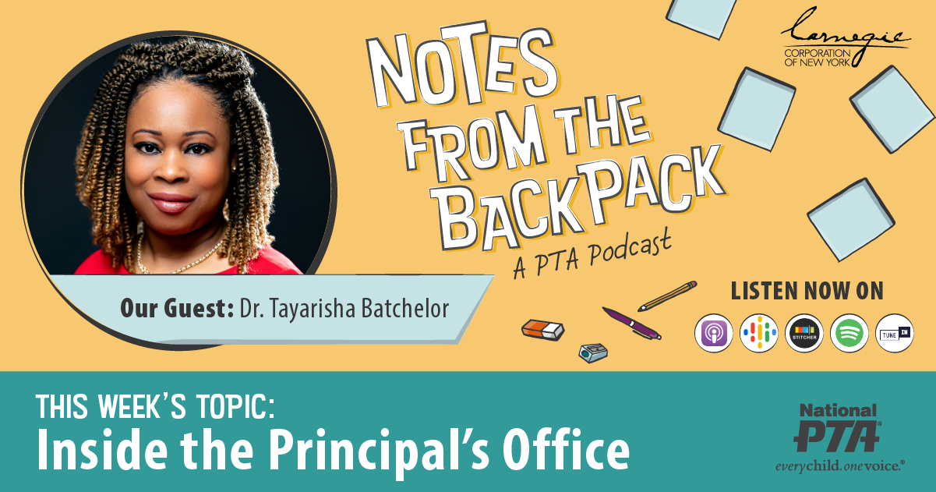

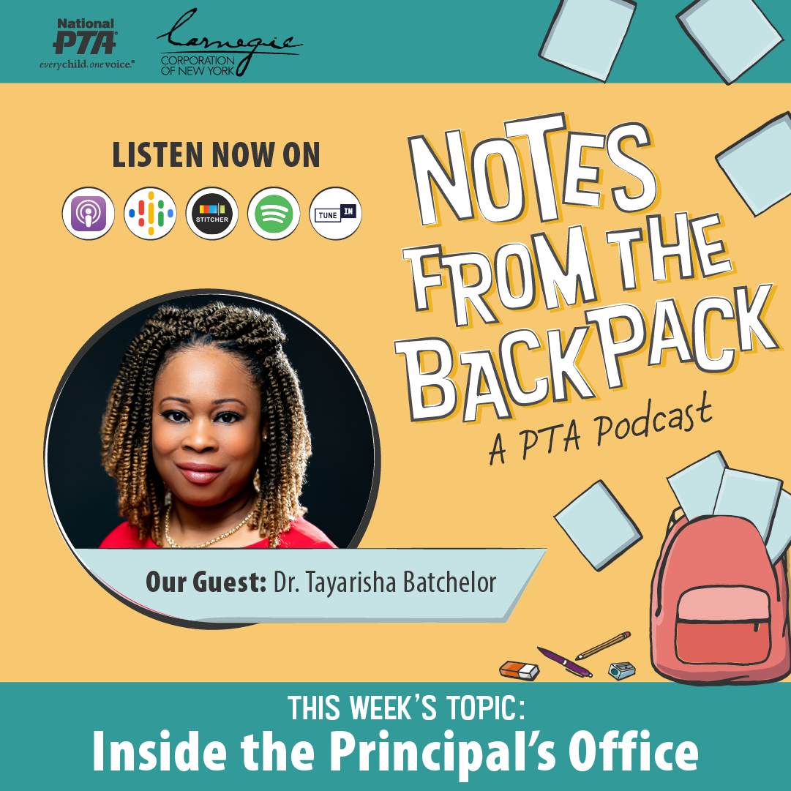
Instagram

