Season 3, Episode 33: Raising Kids Who Embrace Race
with Melissa Giraud and Andrew Grant-Thomas

Overview
Below are sample social media posts, a newsletter blurb and graphics you can use to promote episode 33 of National PTA’s Notes from the Backpack podcast. If you create your own social media posts, please tag National PTA and/or use the podcast hashtag #BackpackNotes. Thank you for your support and for helping us promote season 3 of the podcast!

Facebook
The latest episode of National PTA’s Notes from the Backpack podcast is all about discussing race and racial justice with your family.

Listen to the conversation with Melissa Giraud and Andrew Grant-Thomas of EmbraceRace for a great discussion on teaching children about social justice in a diverse world. PTA.org/PodcastEp33 #BackpackNotes

LinkedIn
The latest episode of National PTA’s Notes from the Backpack podcast is all about discussing race and racial justice with your family.

Listen to the conversation with Melissa Giraud and Andrew Grant-Thomas of EmbraceRace for a great discussion on teaching children about social justice in a diverse world. PTA.org/PodcastEp33 #BackpackNotes

Twitter
Do you want to talk to your kids about race and racism, but not sure where to start? Get expert tips from Melissa Giraud and Andrew Grant-Thomas of @RaceEmbrace in the latest episode of @NationalPTA’s podcast, #BackpackNotes. PTA.org/PodcastEp33

Instagram
The latest episode of @National PTA’s Notes from the Backpack podcast is all about discussing race and racial justice with your family.

Listen to the conversation with Melissa Giraud and Andrew Grant-Thomas of @EmbraceRace for a great discussion on teaching children about social justice in a diverse world. PTA.org/PodcastEp33 #BackpackNotes

Newsletter Blurb
Do you want to talk to your kids about race and racism, but not sure where to start? We can help! Get expert tips in the latest episode of the National PTA Podcast, Notes from the Backpack. Love the episode? Leave a 5-star review to help spread the word!

Graphics

Facebook, Twitter and LinkedIn

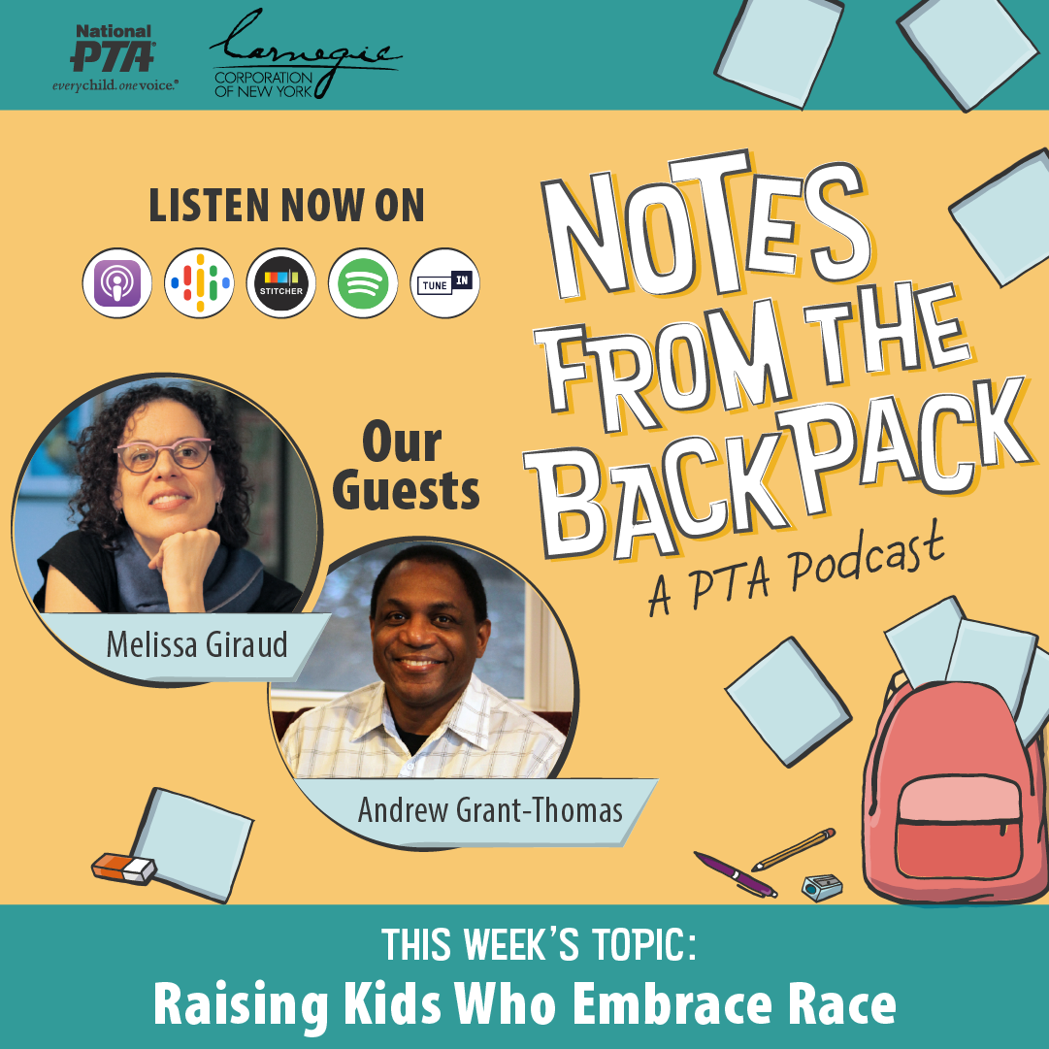
Instagram

