Season 3, Episode 30: Exploring Learning Differences During COVID-19
with Amanda Morin

Overview
Below are sample social media posts, a newsletter blurb and graphics you can use to promote episode 30 of National PTA’s Notes from the Backpack podcast. If you create your own social media posts, please tag National PTA and/or use the podcast hashtag #BackpackNotes. Thank you for your support and for helping us promote season 3 of the podcast!

Facebook

The latest episode of National PTA’s Notes from the Backpack podcast features a discussion on how to successfully navigate the COVID-19 school year with children with learning differences.

Listen to the conversation with Amanda Morin, senior writer for @understood at PTA.org/PodcastEp30 #BackpackNotes

LinkedIn

The latest episode of National PTA’s Notes from the Backpack podcast features a discussion on how to successfully navigate the COVID-19 school year with children with learning differences.

Listen to the conversation with Amanda Morin, senior writer for @understood at PTA.org/PodcastEp30 #BackpackNotes

Twitter
On the latest episode of #BackpackNotes, @NationalPTA and Amanda Morin of @UnderstoodOrg discuss the COVID-19 school year for children with learning differences. Listen now at PTA.org/PodcastEp30

Instagram
The latest episode of National PTA’s Notes from the Backpack podcast features a discussion on how to successfully navigate the COVID-19 school year with children with learning differences.

Listen to the conversation with Amanda Morin, senior writer for @understoodorg at PTA.org/PodcastEp30 #BackpackNotes

Newsletter Blurb
Is your child struggling with schoolwork more than usual? Not sure if it’s due to the pandemic or if you’re seeing the signs of a learning difference? You’re not alone! Listen to the latest episode of National PTA’s Notes from the Backpack podcast to get advice from the experts on helping your kids stay organized, read social cues, manage distractions and more. Love the episode? Leave a 5-star review to help spread the word!

Graphics

Facebook, Twitter and LinkedIn
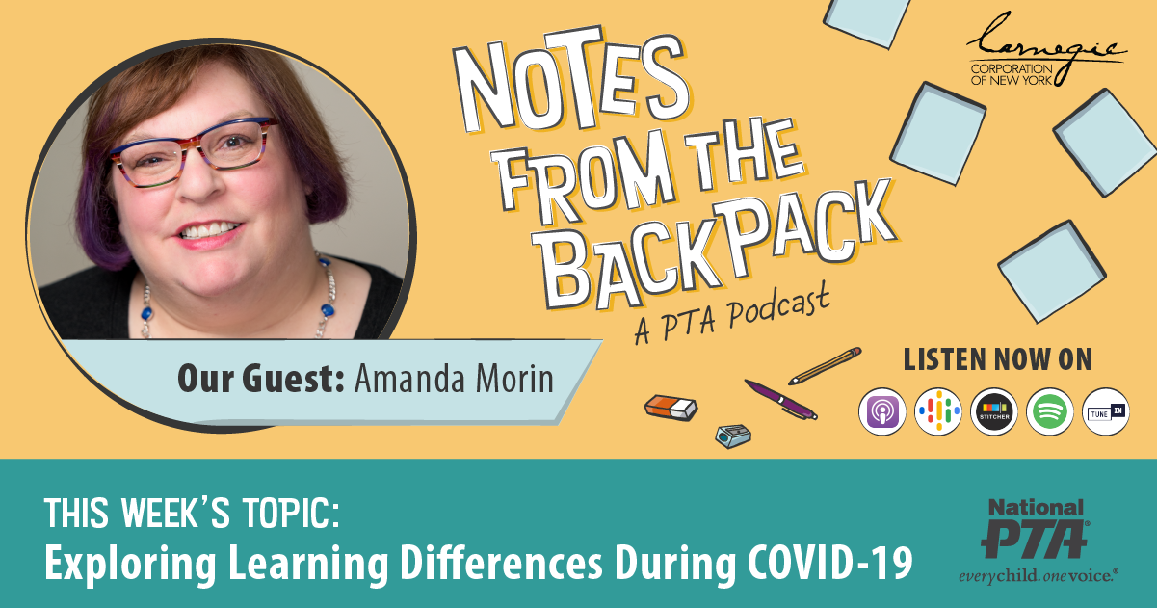

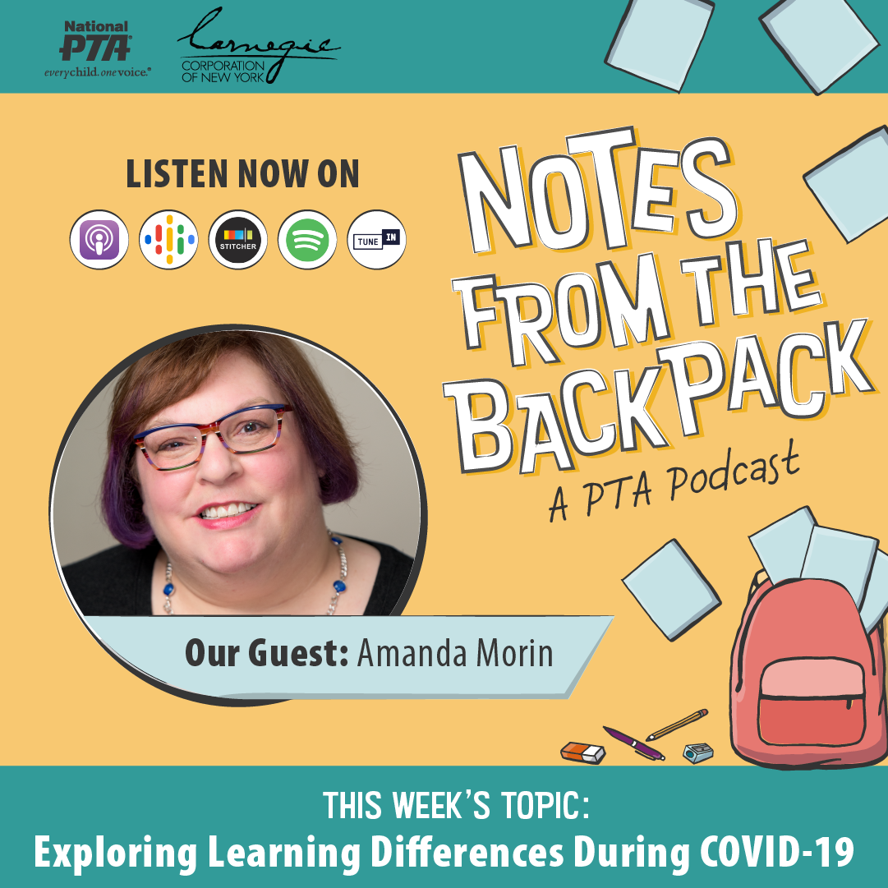
Instagram

