Season 3, Episode 28: Prioritizing COVID-19 Relief & Recovery
with Ralph Smith

Overview
Below are sample social media posts, a newsletter blurb and graphics you can use to promote episode 28 of National PTA’s Notes from the Backpack podcast. If you create your own social media posts, please tag National PTA and/or use the podcast hashtag #BackpackNotes. Thank you for your support and for helping us promote season 3 of the podcast!

Facebook
The latest episode of National PTA’s Notes from the Backpack podcast discusses #COVID19 relief and recovery efforts for families of varying needs.

Listen to the conversation with Ralph Smith, managing director of @Campaign for Grade-Level Reading, an organization committed to supporting kids in attaining grade-level reading skills by third grade. PTA.org/PodcastEp28 #BackpackNotes

Linkedin
The latest episode of @NationalPTA’s Notes from the Backpack podcast discusses #COVID19 relief and recovery efforts for families of varying needs.

Listen to the conversation with Ralph Smith, managing director of Campaign for Grade-Level Reading, an organization committed to supporting kids in attaining grade-level reading skills by third grade. PTA.org/PodcastEp28 #BackpackNotes

Twitter
On the latest #BackpackNotes, @NationalPTA discusses #COVID19 relief & recovery for families of varying needs. Listen to the convo with Ralph Smith of @readingby3rd, an org committed to supporting kids in reaching grade-level reading skills by 3rd grade. PTA.org/PodcastEp28

Instagram
The latest episode of @NationalPTA’s Notes from the Backpack podcast discusses #COVID19 relief and recovery efforts for families of varying needs.

Listen to the conversation with Ralph Smith, managing director of Campaign for Grade-Level Reading, an organization committed to supporting kids in attaining grade-level reading skills by third grade. PTA.org/PodcastEp28 #BackpackNotes

Newsletter Blurb

This week on Notes from the Backpack: A PTA Podcast, National PTA spoke with expert Ralph Smith to get his perspective on the impact COVID-19 is having in the hardest hit communities. Start listening! Also, don't forget to check out the toolkits National PTA is creating to help you spread the word about each episode.

Graphics

Facebook, Twitter and LinkedIn
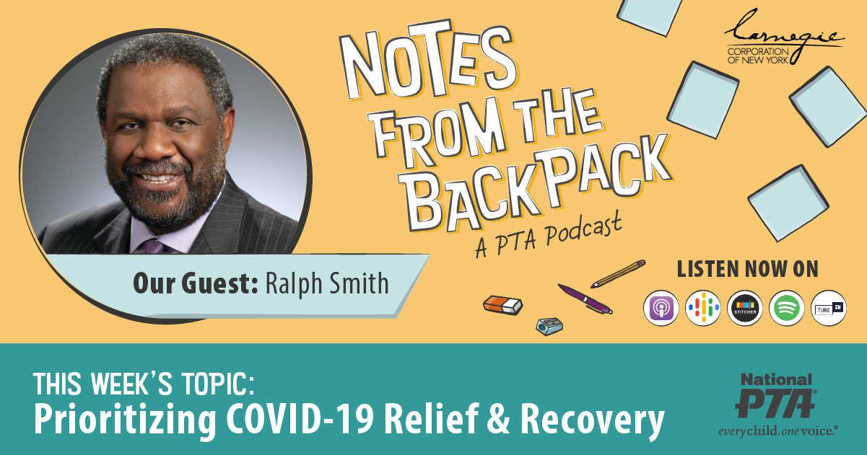

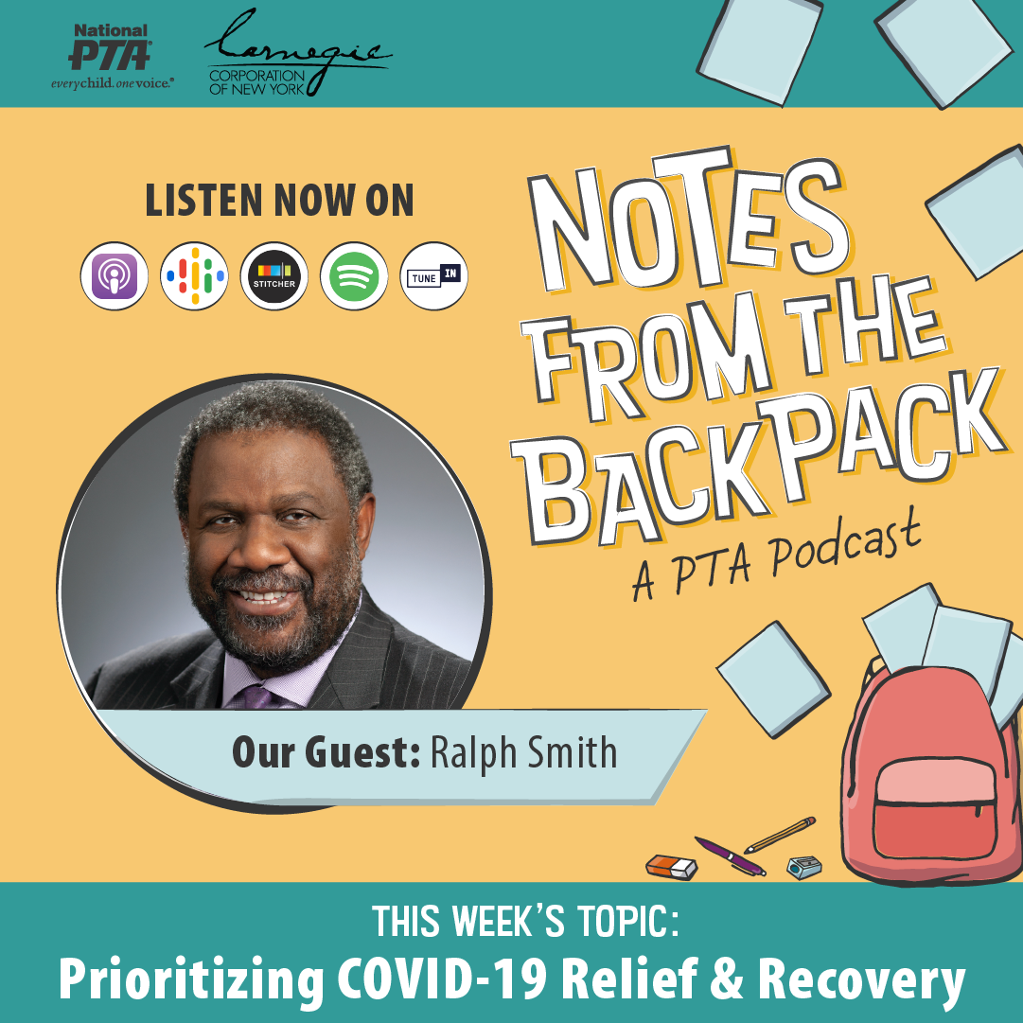
Instagram

