Season 3, Episode 27: Navigating Online Resources During COVID-19
with Merve Lapus

Overview
Below are sample social media posts, a newsletter blurb and graphics you can use to promote episode 27 of National PTA’s Notes from the Backpack podcast. If you create your own social media posts, please tag National PTA and/or use the podcast hashtag #BackpackNotes. Thank you for your support and for helping us promote season 3 of the podcast!

Facebook & LinkedIn
Online learning has become the new normal for children today. But are you using the right digital resources to help your kids succeed? For insider tips on the best educational tools for your child, check out the latest episode of National PTA’s Notes from the Backpack podcast with Merve Lapus, vice president of outreach and national partnerships for Common Sense Media. Listen now at PTA.org/PodcastEp27 #BackpackNotes

Twitter
Online learning has become the new normal. When it comes to your kids' education are you using the right digital resources? For insider tips, check out the latest episode of @NationalPTA’s #BackpackNotes podcast with @molapus of @CommonSenseEd at PTA.org/PodcastEp27

Instagram
Online learning has become the new normal for children today. But are you using the right digital resources to help your kids succeed? For insider tips on the good, bad and the ugly of online learning resources, check out the latest episode of National PTA’s Notes from the Backpack podcast with Merve Lapus, vice president of outreach and national partnerships for Common Sense Media. Listen now at PTA.org/PodcastEp27 #BackpackNotes

Newsletter Blurb
Let National PTA's award-winning podcast be your steady companion as you navigate this new school year! Check out the most recent episode featuring Common Sense Media expert Merve Lapus to learn how you can help your child sort through the good, the bad and the ugly of online learning resources.

Notes from the Backpack: A PTA Podcast is available on: Apple Podcasts, Google Podcasts, Stitcher, Spotify and TuneIn. Just search for "Notes from the Backpack" on your favorite podcast app.

Graphics

Facebook & Twitter

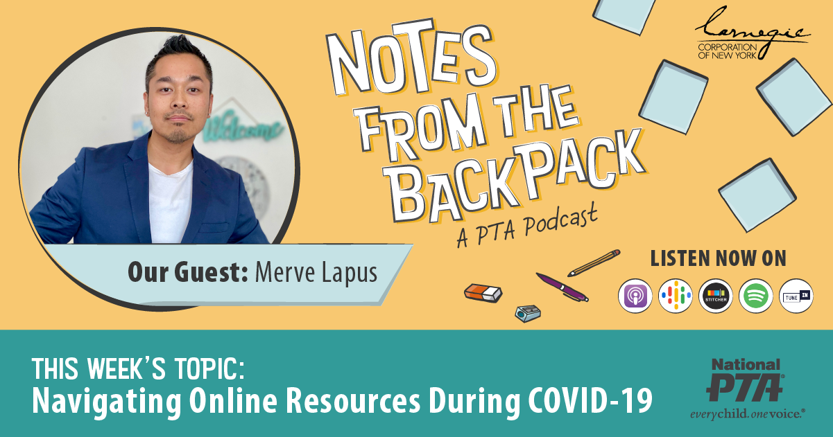

Instagram

