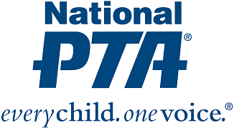

CONSENT TO PHOTOGRAPH/PERMISSION TO USE PHOTOGRAPH OR VIDEO

I grant to National PTA, littleBits, and their representatives and employees the right to take photographs and/or video of me and my family in connection with this PTA event. I authorize National PTA and littleBits, its assigns and transferees to use and publish the same in print and/or electronically.
I agree that National PTA and littleBits may use such photographs or videos of me and my family with or without my name for any lawful purpose, including for example such purposes as publicity, illustration, advertising and web content.

I have read and understand the above:

Signature: ______________________________________________________

Printed Name: _______________________________________________________

Date: ________________________________________________________

