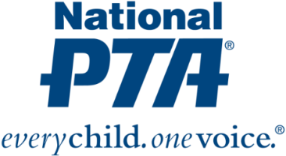
[Local PTA Logo]

*MEDIA ADVISORY*
[Name of PTA] to Host an Invention Night for [Name of City] Families

Families to engage in fun, hands-on inventions to foster children’s understanding of
and excitement for STEM

WHAT:
On [Date], [Name of PTA] will host an Invention night at [Name of Location]. During the event, families will participate in fun, hands-on invention activities to inspire students’ interest in technology and invention and promote awareness of STEM education and careers.

[Name of PTA]’s invention night is part of National PTA’s STEM + Families initiative. STEM + Families is focused on engaging entire families in STEM experiences at school, at home, in the community and with digital learning environments to empower them to support student success in STEM and inspire their children to pursue STEM careers. The goal of the initiative is to fill a critical gap in STEM education, increase access to STEM experiences for all students and inspire the next generation of STEM professionals.

STEM + Families is supported by littleBits, which specializes in making technology kits that are fun, easy-to-use and infinitely creative. [Name of PTA] was awarded a grant from National PTA and littleBits to educate and engage [Name of City] families in STEM activities focused on technology. [Name of PTA] was one of only 20 PTAs across the country selected to receive a grant.

WHEN:
[Day and time of math night]

WHERE:
[Name and address for location of event]

WHO:
[List key attendees who will be participating, including PTA leaders, littleBits leaders, school and district leaders, government leaders, and community leaders]

CONTACT:
[Name and contact information for PTA]

About PTA
PTA® comprises of families, students, teachers, administrators and business and community leaders devoted to the educational success of children and the promotion of family engagement in schools. PTA is a registered 501(c)(3) nonprofit association that prides itself on being a powerful voice for all children, a relevant resource for families and communities, and a strong advocate for public education. Membership in PTA is open to anyone who wants to be involved and make a difference for the education, health and welfare of children and youth. For more information, visit PTA.org.

About littleBits
Founded in September 2011 by Ayah Bdeir, an engineer and interactive artist, littleBits is the New York-based education startup that invented the electronic building block. These magnetic “Bits” snap together to turn ideas into inventions, transforming the way kids learn so they can grow up to be tomorrow’s changemakers -- no matter their age, gender, race, nationality, or ability. Up to 40 percent of the kids using littleBits kits are girls, which is four times the industry average. An alumna of the MIT Media Lab, Ayah’s TED talk: “Building Blocks that Blink, Beep and Teach” about littleBits has garnered more than one million views. littleBits has sold millions of kits in over 70 countries. For more information, visit www.littleBits.com.

