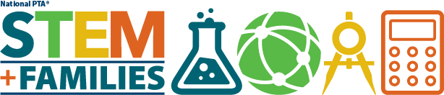

SAMPLE INVITATION LETTER TO PARENTS
Greetings parents/guardians of [Insert School Name],

Did you know that careers in science, technology, engineering and mathematics (STEM) are growing more than twice as fast as the rest of the job market? You already know how valuable the STEM topics are to your child’s future success . . . but do you know how much fun they can be?

Come find out at [Insert PTA Name]’s STEM + Families Invention Night event, sponsored by littleBits at [Insert Time] on [Insert Date] at [Insert Location]! This Invention Night will be a fun, hands-on event that sparks a passion for STEM through invention and play for BOTH students and their families.

You and your child will explore … inspire … empower … and educate yourselves about how much fun building inventions can be. You will also learn simple things you can do at home to foster your student’s interest in STEM. Most importantly, you will get the chance to connect with other families while you and your children learn and play together.

Research shows that family engagement leads to greater student success. Students with engaged parents are more likely to earn higher grades, attend school more regularly, have better social skills and go on to college. We are very excited to see family engagement come alive in our PTA STEM + Families program, and we hope to see you there!

Please read more about the event in the attached Save the Date!

Sincerely,
[Insert PTA President’s Name]

